Davert Project Deliverables

Powerpoint: attached “Davert_ppt.ppt”
Executive Summary: attached “Davert_summary.pdf”

Project Summary:
Since 2014, Sacramento Food Bank and Family Services has expanded to fill the need of a county-wide food bank and distribution center. Initially, SFBFS hosted 12 farmer’s market-style distribution sites at churches in Oak Park and Del Paso Heights. However, once Food Link (another food access organization) discontinued their operations in Sacramento, SFBFS also got the opportunity to purchase additional warehouse space in order to expand their operations. This enabled them to expand from 12 distribution locations to over 200 “partner agencies” across all of Sacramento County:
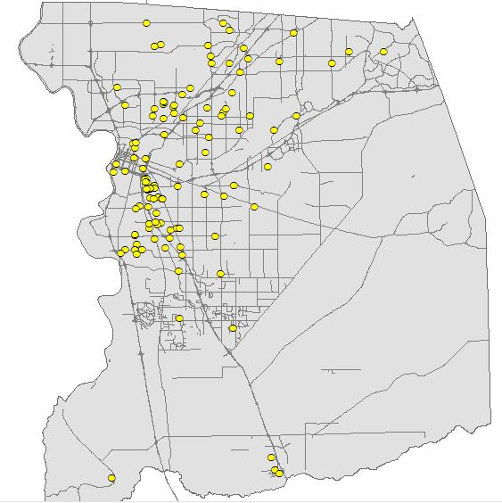
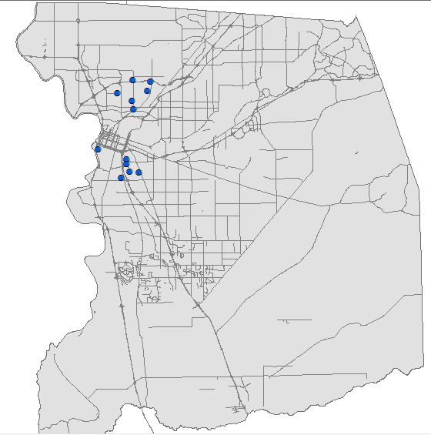

However, SFBFS has yet to develop a convenient way for clients and donors to query the locations and hours of these partner agencies. Instead, they have posted unqueryable PDFs on their website:
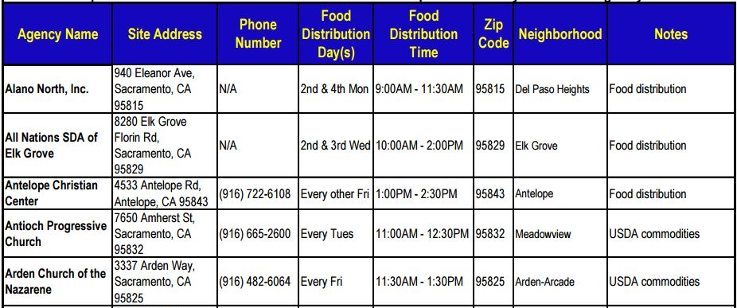
Project Purpose:
My goal was to parse out data from the PDF into queryable tables and create a Web Map App that would allow users to filter and query data based on neighborhoods, day of the week, week of the month, time, and type of service.

Methods:
Initially I parsed out the PDF table into several related tables:
- Sites (Unique ID = Site_ID) – each food pantry, church, school that participates as a partner agency with the food bank. Contains address and contact information.
- Events (Unique ID = Event_ID) – each event was a unique day/time combo. Each site could have multiple events – Monday at 5, Tuesday at noon, etc.
- Services - look-up table of all services provided by each type of partner agency. Examples: groceries for distribution, hot meals, after-school snack programs, healthy senior training, etc.
- Services_Site_Linking table – a many-to-many relationship table between all partner agencies and the multiple services provided at each one.

With this method, I found that in order to query the hours of operation for the locations, I would need to create a layer with stacked events, similar to the 311 calls that we worked with earlier in the semester. However, this resulted in as many as 31 “events” stacked on top of one another for certain sites that are open every day.

Instead, I decided to revert somewhat to a “messier” table structure with certain fields delimited by commas because this allowed me to use a single layer with individual sites. I created coded fields for querying and text fields for displaying in the pop-ups:

Days:
The original field read: “Open every 2nd and 4th Monday and Wednesday.” I preserved this for the display field and coded out the following columns:
Day: “M, W”
Week: “2, 4”

Times:
I had a difficult time getting times to properly display in ArcGIS online, so I created two text fields for displaying “Open” and “Close” times for the web app user, and created two numerical fields to use for querying:
Open: 10:00 AM
Close: 2:00 PM
Open_NUM: 1000
Close_NUM: 1400

Services:
I also delimited multiple services for each site with commas. Examples: “Distribution, meal, seniors” or “Distribution, snacks.”
I created 4 filters:
- Near Me – called “Near You”
- Filter – called “Days of Operation”
- Filter – called “Hours of Operation”
- Filter – called “Services”

I also adjusted the logos to be more intuitive:
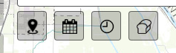
Near You
This filter was straight-forward. I set the buffer range from 1-5 miles and made the buffer transparent:
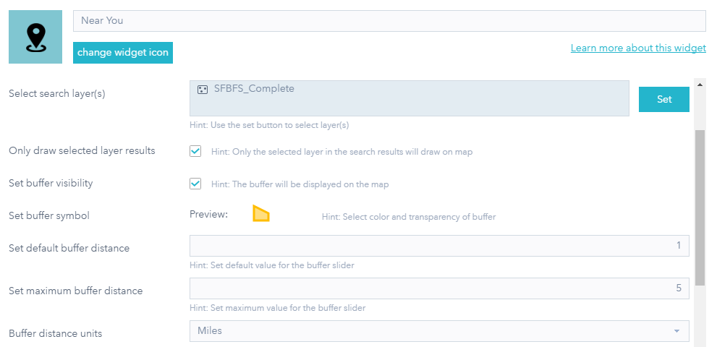

However, for the filters, I had some difficulties. Initially, I tried to create a separate filter for each day of the week, each week of the month, services, etc. While this resulted in a clearly labeled filter for the user to click without having to see the nuts and bolts behind the map, I was unable to change the operator from “And” to “or”, which resulted in no features on the map showing up if the user tried to select more than one day:
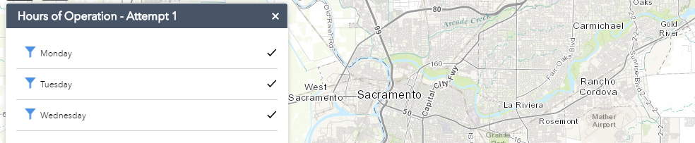
Instead, I had to use multiple filter sets with the “any” operator selected (AGOL uses “Any/All” instead of the Boolean “and/or”:

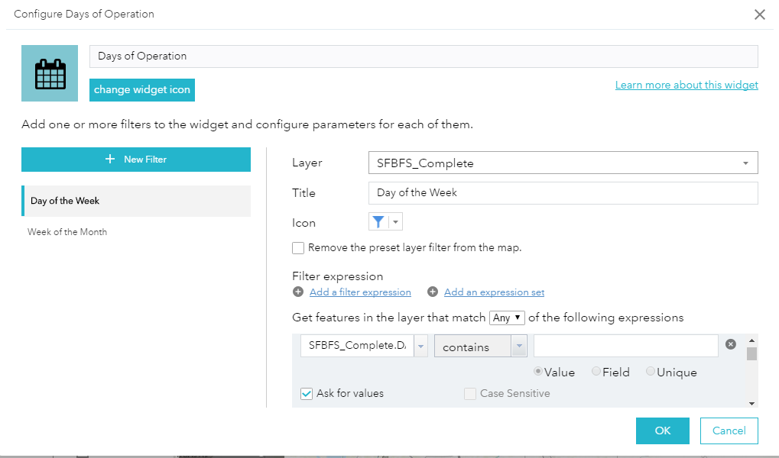

The only downside was that because I decided against the multiple event records for each site, I needed to use the “contains” operator and check the “ask for values” option in order to sort through the data. This requires the user to do more work, which I tried to remediate by typing prompts for what to type:

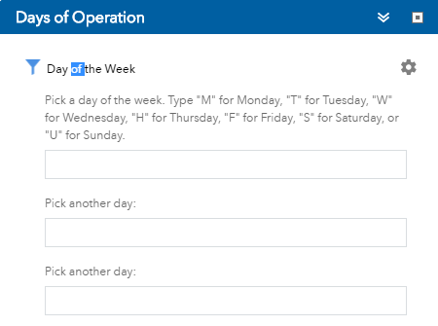
Over all, the app was generally successful but will require some additional tweaking in order to be more user-friendly. This kind of map would benefit from user testing and feedback and several iterations.
