Elena Davert
Davert.elena@gmail.com
Geography 375 – Final Project, Spring 2016

Summary
In order for parcels to participate in the Sustainable Agriculture Land Conservation (SALC) Program, property owners and land trusts must demonstrate that the parcel is at risk of conversion from agricultural to non-agricultural use. This risk can be demonstrated in one of 9 ways, agreed upon by the Strategic Growth Council, Department of Conservation, and Air Resources Board. These 9 risk factors are spatial in nature and are best illustrated using maps. Using Santa Clara County as an example, this project uses python scripts to create shapefiles that illustrate parcels eligible for two of the nine risk factors, as well as the effect of adjusting the parameters of one risk factor. The resulting shapefiles are then inserted into a map document and a second python script is used to automatically generate map PDFs for areas of interest.

Background
As an Environmental Planner with the CA Department of Conservation (DOC), I am working on developing a Python script for determining parcels eligible to participate in the Sustainable Agriculture Land Conservation (SALC) Program. The SALC Program is a component of the Strategic Growth Council's Affordable Housing and Sustainability Program (AHSC), which aims “to reduce greenhouse gas emissions through project that implement land use, housing, transportation, and agricultural land preservation practices to support infill and compact development.” The funding for the SALC program is awarded by the Strategic Growth Council, an extension of the Governor’s Office of Planning and Research, and the grants themselves are administered by the Division of Land Resource Protection (DLRP) within DOC.

Unlike the DOC’s other agricultural conservation programs (i.e. the Williamson Act Program (WA) and California Farmland Conservation Program) SALC is funded by the Greenhouse Gas Reduction Fund established in the Budget Act of 2014. While other programs have focused on comprehensive land use planning, SALC is tied to GHG quantification methodology mandated by the CA Air Resources Board (ARB). These quantification methods also come with strict requirements for funding eligibility based on “risk of conversion” to non-agricultural uses (chiefly residential or rural residential).

Purpose
In the SALC Application guidelines, applicants must demonstrate that agricultural land is subject to at least one of nine risk factors (listed on the next page). I would like to write scripts that will create shapefiles and maps that show the effects of changing the parameters within these risk factors (i.e. How many acres within a given county are eligible to participate in the program if we apply or adjust this risk parameter?).
I copy and pasted my original proposal below. Items removed from my plan are noted with strikethrough, and comments/additions to my plan are noted in red:
With a python script, I would like to achieve the following things:
- Dissolve all ag categories (A-1, A-20, etc.) within a county’s zoning ordinance or general plan using city and county data (available data varies by county) - -
- Export an “Ag” layer for that county
  - This proved much more difficult than I originally thought due to variations in agriculture definitions among all the cities and counties. Because I had to examine the data layers individually and note my decision to include particular categories in this analysis, I ended up creating these layers manually.
  - Also, I ended up adding “important farmland categories” derived from the Department of Conservations Farmland Mapping and Monitoring Program to my list of agricultural definitions. Final list: FMMP, zoning, and gen. plans.

Test the following Risk Factors:
- Risk 3: Query which ag parcels fall within the cities’ spheres of influence in that county
  - Export those parcels into an “At-Risk” layer
- Query which ag parcels fall within a buffer outside the cities’ SOIs (Risk #5)
  - Create a variable that allows me to easily adjust the buffer size
  - Export parcels to At-risk layer, and calculate acreage
- Use county zoning information to query “rural residential” parcels (Risk #7)
  - Query parcels that fall within a specific buffer
  - Export parcels, calculate acreage Risk 7 was removed so that I could incorporate a mapping element into this exercise
- Create a script to automatically generate maps for each urban area of interest (San Jose, Los Gatos, Morgan Hill, and Gilroy.

Excerpt from the SALC program guidelines for risks that I plan to evaluate:

“Valid options to demonstrate risk of conversion for which residential zoning can be used to calculate the number of extinguished development rights:
…
3. Agricultural land within a city’s Sphere of Influence or municipal service boundary and, if applicable, within the city’s urban growth boundary according to the city’s general plan;
…
5. Agricultural land within two miles of a city’s Sphere of Influence or municipal service boundary, or within two miles of an unincorporated area which is zoned for or contains residential development where the average lot size is two acres or less.”
Methods
First, I made a list of the shapefiles that I wanted to create for the various combinations of agriculture definitions and risk factors:

# | Agricultural Definition | Risk #
1 | Zoning | 3 – parcels within an urban sphere of influence
2 | Zoning | 5 – parcels within 2 miles of urban sphere of influence
3 | Zoning | 5 – parcels within 5 miles of urban sphere of influence
4 | FMMP land use | 3 – parcels within an urban sphere of influence
5 | FMMP land use | 5 – parcels within 2 miles of urban sphere of influence
6 | FMMP land use | 5 – parcels within 5 miles of urban sphere of influence
7 | General Plan | 3 – parcels within an urban sphere of influence
8 | General Plan | 5 – parcels within 2 miles of urban sphere of influence
9 | General Plan | 5 – parcels within 5 miles of urban sphere of influence

Then I made a list of shapefiles that I had either downloaded from the County, or created using city and county data. I used data from Santa Clara County for this project:

Source | Data
Santa Clara County | Urban spheres of influence – maintained by the LAFCo
Cities & County | Zoning data – compiled all county-wide ag zone polygons into one layer
Cities & County | General Plan - compiled all county-wide ag GP polygons into one layer
FMMP | Land use data from 2012 – all ag/rangeland polygons
Santa Clara County | Parcel data for entire county

I decided that the best tool to use to create the desired datasets would be Search by Location. Although I originally thought I would want to use Clip or Buffer. I realized Search by Location would be better for several reasons:

- By using the “has centroid within” parameter I could preserve the original parcel boundaries rather than clipping them to fit within an urban SOI. This provides a more realistic depiction since property valuations and conversions happen on a parcel basis.
- I could use buffer distances within the Search by Location tool rather than having to explicitly create a buffer for clip features.
- I could easily add to a selection or remove from a selection without generating any intermediate feature classes.

(Script on the next page)

At the beginning of Script 1, the user establishes variables for the input and output files, as well as the County, agriculture definition, and search distance:
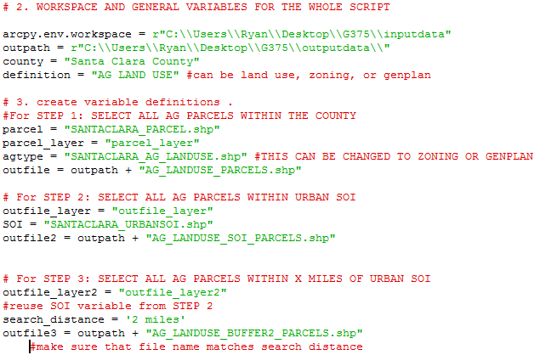

In the “Try” block, three steps create the three unique shapefiles:
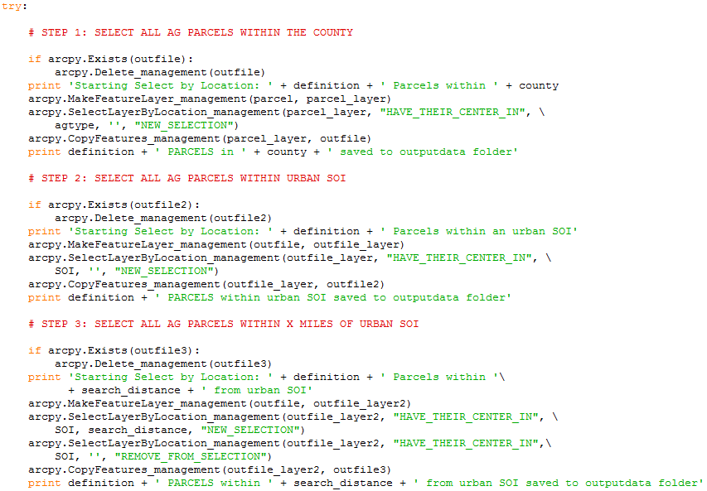
In Script 2, I used imported the mapping module and created PDF maps for all the urban spheres of influence within Santa Clara County. I also used “agdef” and “risk” variables at the beginning of the script to create file names for the PDFs later in the script. Looking back, this would be a valuable tool to use to rewrite Script 1 in order to reduce the amount of work required by the user to set up the input/output file names.
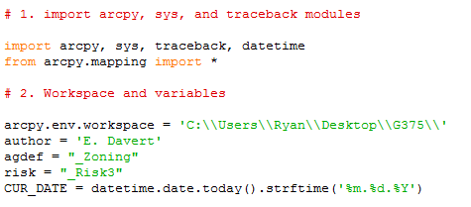
Once the workspace and variables were set, I used a Search Cursor to loop through the urban spheres of influence using the SOI polygon shapefile. Each map zooms in on an urban area of interest and creates a map with the appropriate city name. The Author and Date are also included in the map based on the variables at the beginning of the script.
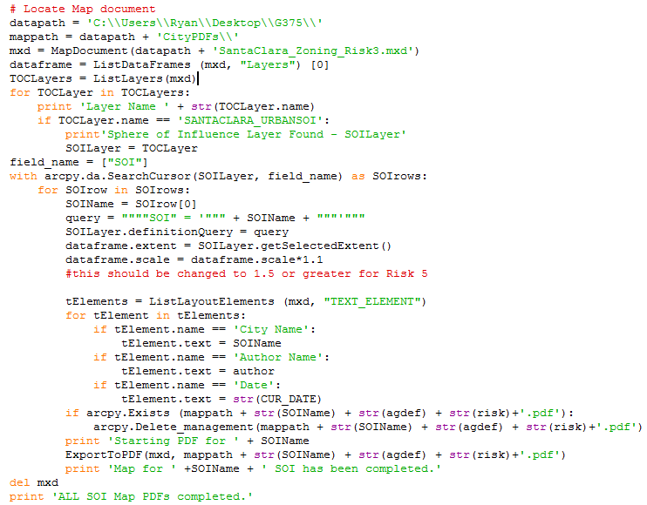
Sample Results
The next two pages are same result maps (they are images captured using screen shots, so please excuse the poor quality resolution):
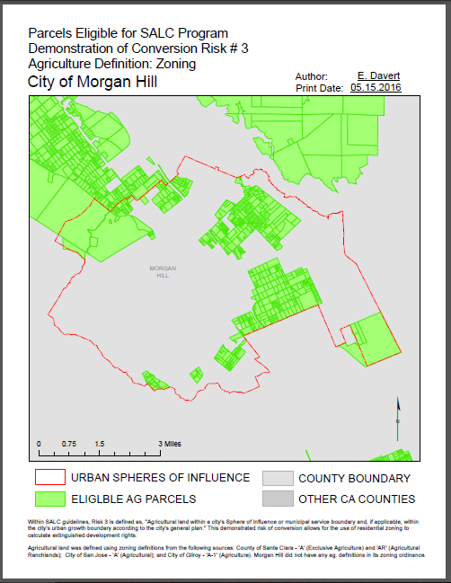
The bottom section reads:
“Within SALC guidelines, Risk 3 is defined as, "Agricultural land within a city's Sphere of Influence or municipal service boundary and, if applicable, within the city's urban growth boundary according to the city's general plan." This demonstrated risk of conversion allows for the use of residential zoning to calculate extinguished development rights.

Agricultural land was defined using zoning definitions from the following sources: County of Santa Clara - 'A' (Exclusive Agriculture) and 'AR' (Agricultural Ranchlands); City of San Jose - 'A' (Agricultural); and City of Gilroy - 'A-1' (Agriculture). Morgan Hill did not have any ag. definitions in its zoning ordinance.”
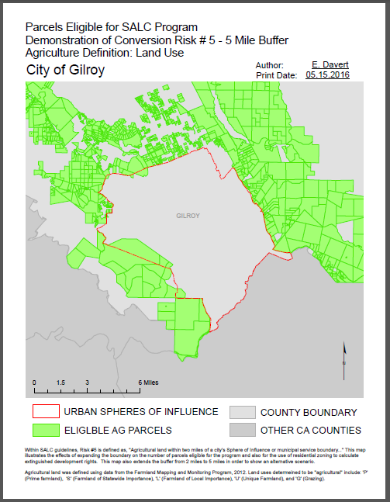
The bottom section reads:
“Within SALC guidelines, Risk #5 is defined as, "Agricultural land within two miles of a city's Sphere of Influence or municipal service boundary..." This map illustrates the effects of expanding the boundary on the number of parcels eligible for the program and also for the use of residential zoning to calculate extinguished development rights. This map also extends the buffer from 2 miles to 5 miles in order to show an alternative scenario.

Agricultural land was defined using data from the Farmland Mapping and Monitoring Program, 2012. Land uses determeined to be "agricultural" include: 'P'(Prime farmland), 'S' (Farmland of Statewide Importance), 'L' (Farmland of Local Importance), 'U' (Unique Farmland), and 'G' (Grazing).”
Ways to Improve

I found that this project could be improved in three major ways moving forward:

1) Improved use of variables
After using variables to create unique map PDF names, I realized that I could have done much more in terms of automating the naming of output files. Ideally, I would be able to create a script in which the user would only need to enter a county name, agricultural definition, and buffer distance. If I had had access to additional data (other than just Santa Clara County), I would have liked to experiment with an additional Search Cursor that could loop through multiple counties to produce shapefiles and associated maps.

2) Use more sophisticated map layouts
This type of analysis (comparing the effects of changing parameters) lends itself well to maps with multiple data frames. If I had had more time, I would have looked into creating comparison maps.

3) Summary Statistics
This project would also benefit from python scripts that could generate summary statistics and automatically populate tables for each county. I started researching this in the middle of the semester but was unable to complete it in time for the deadline for this project.

Over all I have thoroughly enjoyed getting familiar with Python and have found it to be a much more intuitive language than SQL. I look forward to incorporating simple scripts into my work and volunteer data analysis projects if possible.

