PROCESSING AND EXTRACTING THERMAL IMAGE DATA FOR HOUSEHOLD ENERGY EMISSION ANALYSIS

Ted Dang

Project Summary
Energy is used in to heat our homes. Until we figure out how to build a heat proof home, much energy in the form of heat is lost via leakage through the building envelope. The level of heat loss depends on tightness of building envelope, capacity of heating furnaces, frequency of use, etc….. As heat dissipates into the atmosphere, it heats up the surround area and creates variation in the land surface temperature (LST). This variation is captured by the thermal infrared sensor on board Landsat 8 satellite. This paper reports the steps in which thermal image data is processed and packaged into useful statistics for further analysis of household energy emission.

Purpose
The purpose of this project is to produce a data set of mean land surface temperature (LST) using remotely sensed thermal imagery. The data set captures the variations in LST (Figure 1) for further examinations. As variations LST are the results of many factors including near surface energy emission from factories, homes, and automobiles, closer examinations could reveal the relationship between spatial thermal pattern and social economic factors, industrial production, and traffic gridlocks. Better understanding of this relationship would allow formulation of mitigation strategies leading to more efficient use of energy

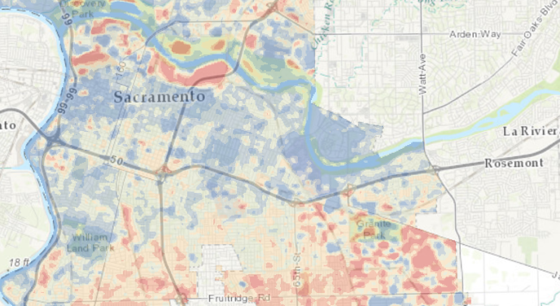
Figure 1

Parameters
To ensure the most suitable data is employed for analysis, the first step is to specify the criteria for image selection. The objective here is to obtain a thermal image with the least amount of interferences for the purpose. Since the focus of the analysis is on energy emission emanating from residential buildings, thermal image captured on a day with the least heat loss from industrial factories, commercial activities, and transportations is desirable. An image taken on a Sunday morning fits this requirement best when most factories are inactive, commercial offices are shuttered, and traffic gridlocks are at the lowest level. Sunday is also a day when people are mostly likely to be in their home. Thermal image taken on a cold day in the winter is preferred as winter is when heating furnaces are in use and energy emission is highest. Conveniently, deciduous trees also shed their leaves in the winter.
Accessing LANDSAT 8 data at www.earthexplorer.usgs.gov, thermal image taken on a winter day, Sunday December 28, 2013, was chosen. As shown in Figure 2 below, the scene is relatively cloud free indicating little temperature interferences. This fact is confirmed quantitatively with a value of 0.46% cloud cover in the scene’s metadata.

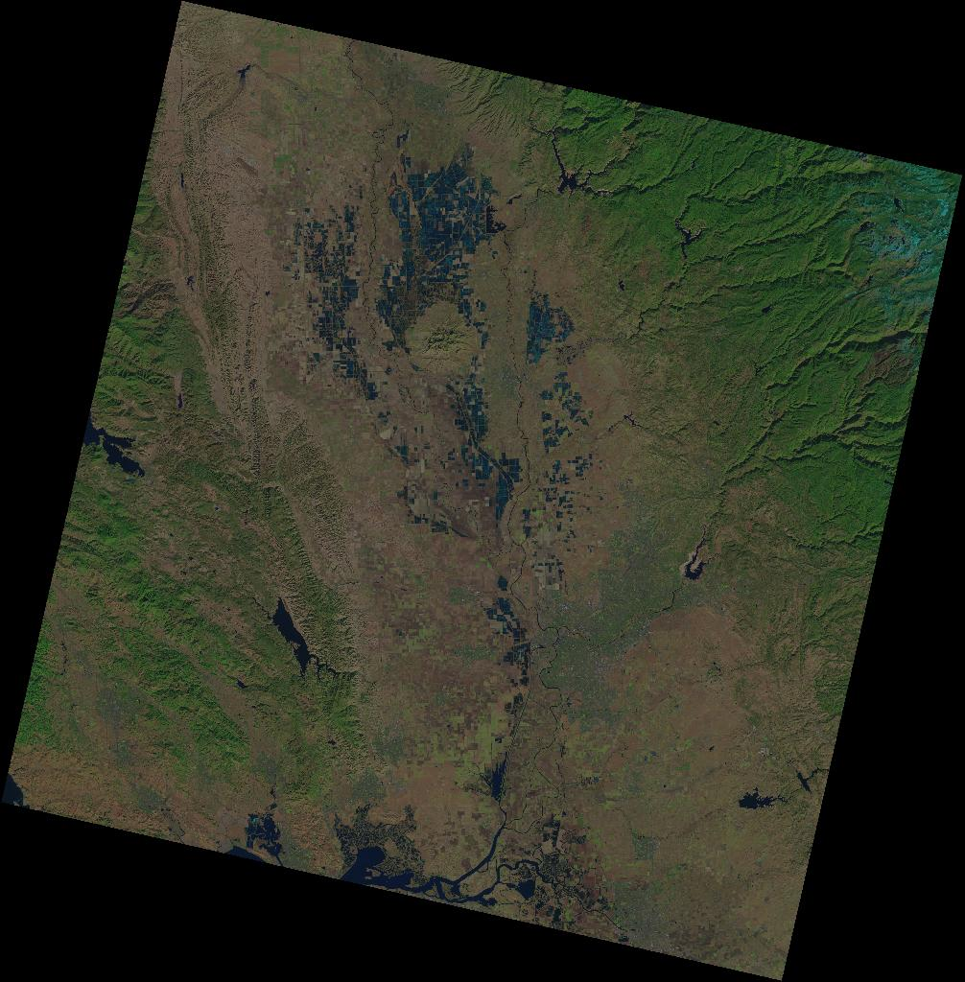
Figure 2

Methods
LANDSAT 8’s Thermal Infrared Sensor (TIRS) to collect thermal infrared wavelengths in two thermal bands (10 and 11). For this project, only thermal data from Band 10 are being used. As Band 11 has known quality problems, the USGS has recommended against using it for quantitative analysis at this time. Band 10’s thermal data provide sufficiently accurate land surface temperature making it possible for use in many areas of quantitative analysis. To use this data, the raw data must first be processed. Once processed, the data are still just pixel values in a raster. For the data to be useful in quantitative analyses, the processed data need to be extracted in useful mapping units where meaningful statistics can be derived.
THERMAL DATA PROCESSING
LANDSAT 8 collects thermal images of the Earth with each scene covering106 milewide by 114 mile long. At the pixel resolution of 100 meters and pixel depth of 16 bit integer, the uncompressed size for this grid comes to 114 megabytes. Along with new grids being produced with each successive raster operations, raster data sets take large amount of disk space. To make it manageable, the first step in processing this thermal data is to limit its geographic extent.

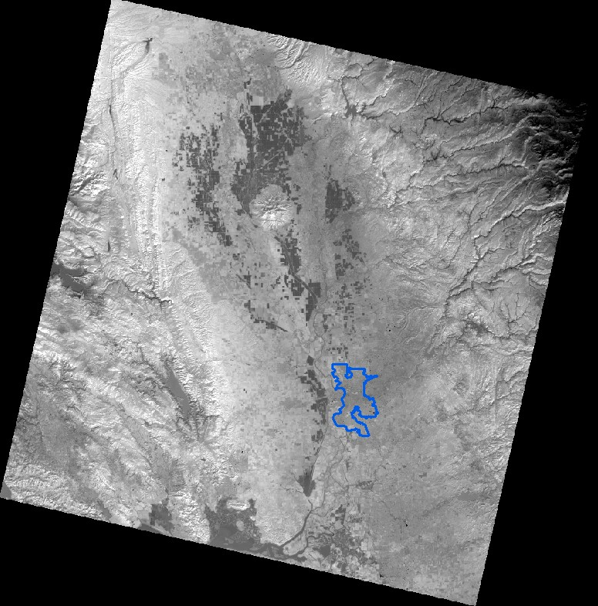
Figure 3
Since Sacramento is the area of study, a polygon shape file of the city boundary is being used to clip out a subset of the satellite image. Using the raster clip tool, a new smaller raster is produced. It has an uncompressed size 1.03 MB of storage which is more manageable, especially when more grids are to be produced from additional raster operations (Figure 3).
With a smaller and more manageable raster to work with, the next procedure is to derive temperature from the raw thermal data which are captured in digital numbers (DNs). This is a two-step process. Since raw data are captured in units of absolute radiance, the data must first be converted to Top of Atmosphere Radiance (TOAr) or spectral radiance. This is done using the raster calculator following the formula listed below and scaling factors provided in the image’s metadata file:
L_{λ} = M_{L}*Q_{cal} + A_{L}
where:
L_{λ} = Spectral radiance (W/(m2 * sr * μm))
M_{L} = Radiance multiplicative scaling factor for the band
A_{L} = Radiance additive scaling factor for the band
Q_{cal}= L1 pixel value in DN

The second step, also carried out in raster calculator, is to convert spectral radiance to brightness temperature, which is the effective temperature viewed by the satellite under an assumption of unity emissivity. Kelvin scale is the preferred unit of temperature measurement for many quantitative analyses. The conversion formula is as follows:
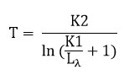
where:
T = TOA Brightness Temperature, in Kelvin.
L_{λ} = Spectral radiance (Watts/(m^{2*} sr * μm))
K1 = Thermal conversion constant for the band
K2 = Thermal conversion constant for the band

Figure 4 shows the result for this data processing procedure, manually classified in 5 classes for presentation purpose. Note that the pixel values are positive floating point numbers . This is important for statistical summary in the thermal data extraction procedure.

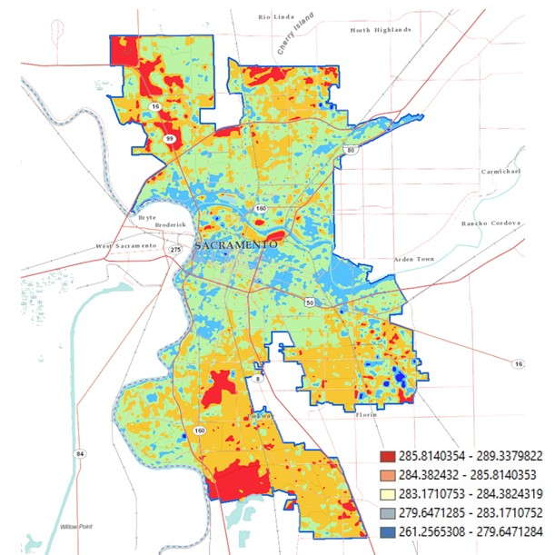
Figure 4

THERMAL DATA EXTRACTION
With the over arching objective of studying the relationship between spatial thermal pattern and social economic factors in mind, the data in the processed raster needs to be organized in a mapping unit that can be used in conjunction with economic and demographic data. As the most common and acceptable level of disaggregation for economic and demographic data is the census tract, it is thus logical to break the thermal raster into census tract mapping unit.
To do this, polygons making up census tracts for Sacramento city used as a mask to break up the thermal raster. Figure 5 below shows 138 census tracts that are either intercepting or completely contained within the city boundary. Also included in the figure are green spaces exist within the city.

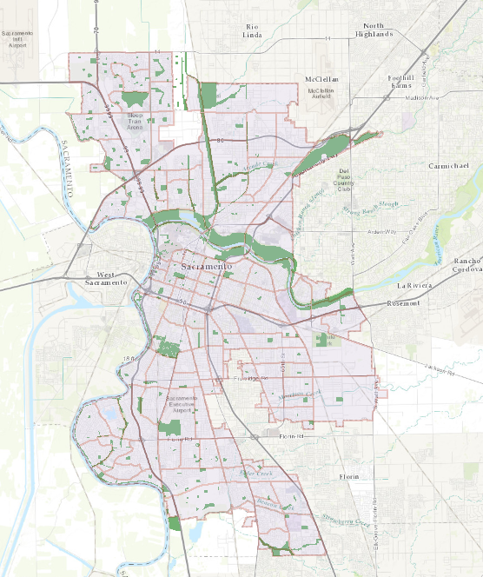
Figure 5

Green spaces may contain few structures but should not contain any residential buildings. Thus energy emitting from green spaces, or lack of, is not pertinent to the final study. Land surface temperature values for these areas need to be eliminated to prevent dilution of statistical values derived for the final selection of census tracts. Raster Erase tool was used to accomplish this task.
Also excluded from the final selection of census tracts are tracts in the downtown area where many closed-for-the-weekend commercial office buildings are located. Tracts adjacent to the two rivers converging in downtown Sacramento are also excluded. Large bodies of water emit no energy and have the tendency to lower the surface temperature of the surrounding areas. This step was completed with manual de-selection of polygons.
Figure 6 shows a vector shape file of 45 census tracts. Note the smaller polygons within the larger and more geometric census tracts are green spaces that have been erased. These are the final selection of census tracts to be served as a mask for thermal data extraction from the raster produced in previous step.

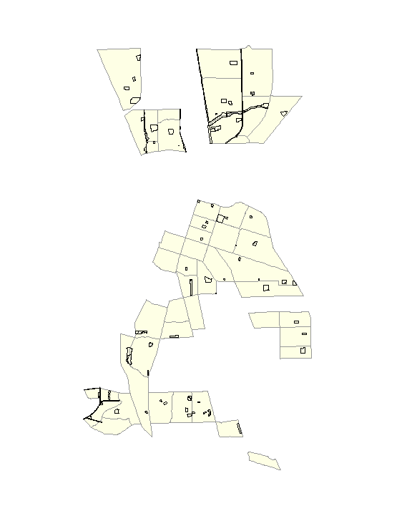
Figure 6
Using the Extract by Mask tool, this 45 census tract vector shape file acts as “cookie cutter” for the thermal image raster. The extracted raster shown in Figure 7 is difficult to see due to the gray scale representing the continuous pixel values. However, the pixel values are now organized in census tract mapping units making it possible to produce valuable statistics.
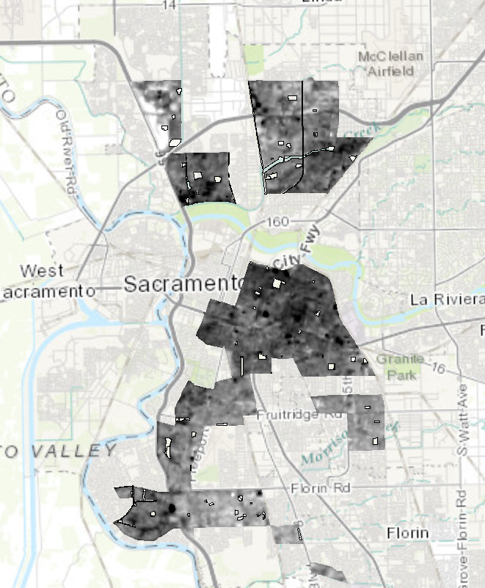
Figure 7

Results
The final thermal raster containing land surface temperature defined by census tracts can now be processed to produce valuable statistics. For illustration purpose, the mean land surface temperatures calculated for the 45 selected census tracts are shown in Table 1. This task was completed by using the Zonal Calculator tool.
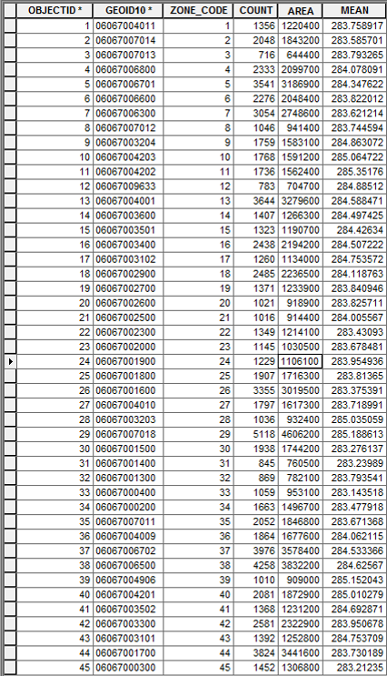
Table 1
By joining this table with shape file, mean surface temperature can be classified and displayed. As shown in Figure 8, there is a wide range of variation in surface temperature between these census tracts. It is the variation in temperature that is of interest to researchers.

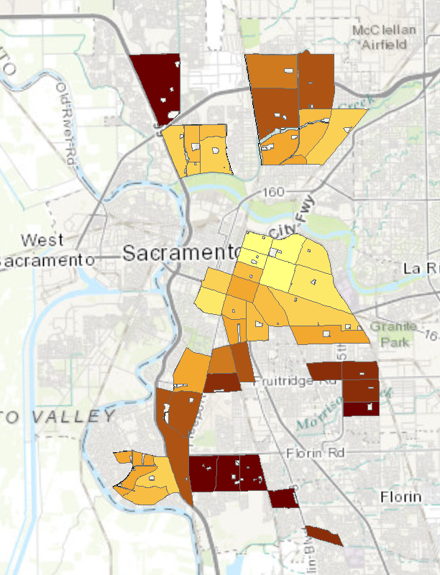
Figure 8

Challenges and Difficulties
After having completed this project, several challenges and difficulties come to mind. Foremost, thermal images of this quality and breath are limited to what is available via USGS remote sensing efforts. That means researchers do not get to choose when images are taken. For a study of household energy emission, ideally land surface temperature should be taken in the early evening when people are in their home and heat emitting appliances are in full used.
As with in many quantitative projects, data quality is always a challenge. It is more evident in open data from different sources. Especially for projects covering such a large area like this, lots of GIS data are needed and they do make the analysis more robust. However, shape file data collected at different time, different resolutions, for different purpose and quality may collectively degrade the quality of the analysis as well. Effort to include property parcel data from the tax assessor offices was wasted due to this challenge.
While this is a data collection project, a good understanding of thermal dynamics principles is necessary to produce a more quantitatively valuable final product. How energy and heat emit, transfer and dissipate can affect land surface temperature in multiple dimensions. Given more time and resources, extensive literature review and consultations with subject matter experts would reduce, if not eliminate, many unanswered questions.
References
Kim, Jun-Hyun, et al. "Neighborhood landscape spatial patterns and land surface temperature: an empirical study on single-family residential areas in Austin, Texas." International journal of environmental research and public health 13.9 (2016): 880.
Li, Xiaoxiao, et al. "Remote sensing of the surface urban heat island and land architecture in Phoenix, Arizona: Combined effects of land composition and configuration and cadastral–demographic–economic factors." Remote Sensing of Environment 174 (2016): 233-243.
Lillesand, Thomas, Ralph W. Kiefer, and Jonathan Chipman. Remote sensing and image interpretation. John Wiley & Sons, 2014.
Roy, David P., et al. "Landsat-8: Science and product vision for terrestrial global change research." Remote Sensing of Environment 145 (2014): 154-172.
USGS. Landsat 8 Data Users Handbook; USGS-Earth Resources Observation and Science: Sioux Falls, SD, USA, 2014.

