Costanza* Bathroom Buddy
My web map app is a conceptual network of crowd-sourced surveys of publicly-accessible restrooms in the city of Sacramento, CA. Ideally the end user would be able to use the application to locate bathrooms proximal to them (or a predetermined destination), determine the best option among them by inspecting the surveyed attributes, and receive directions for how to get to their choice. I created a survey in Survey123 (Figure 1) that requires the surveyor to populate attribute fields with values that describe the bathroom’s conditions at the time of the survey, which will be useful for informing the end-user’s decision.
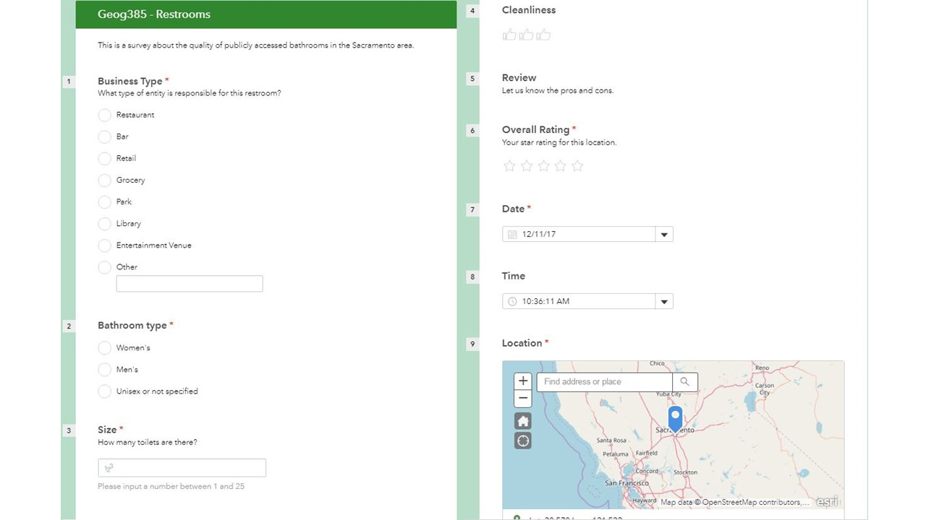
Figure 1: The survey requests descriptive information such as the business type the bathroom is located in, its cleanliness, and overall rating.
The completed surveys are immediately uploaded to the cloud. ArcGIS Online allows for location-based surveys to be tied to web maps and web map apps so that once that survey point is uploaded to the cloud it displays on the web map as well (though it does require the page to be refreshed). The map I created to display the survey points was intentionally basic, only juxtaposing the survey locations with lightrail stations, car parking locations, neighborhoods, and public facilities such as parks or community centers (Figure 2). I wanted to avoid making the web map too busy with unnecessary layers to streamline the symbology, making the primary layer the most prominent symbol with less potential of being clouded or confused by other symbols which, while potentially interesting, may not aid the user in the goal of finding a suitable restroom.
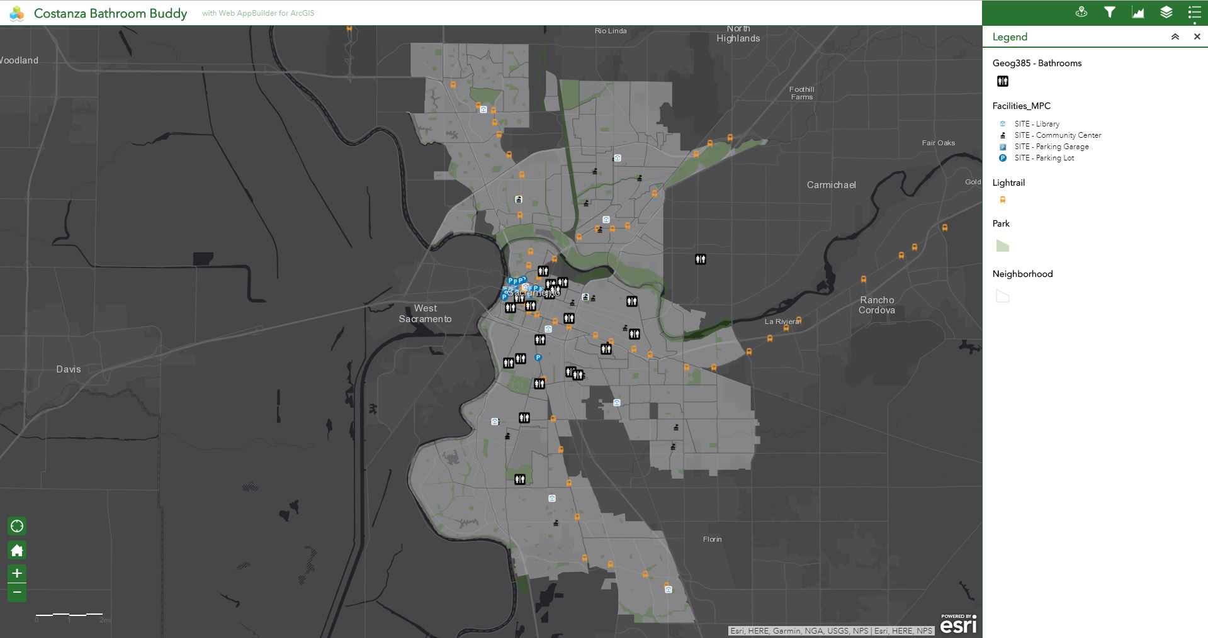
Figure 2: The area of interest is highlighted by the transparent white ‘neighborhood’ layer. The most prominent point symbol is the survey points representing restrooms, since that is the focus of the web map app. Completed surveys display on the map instantaneously.
The primary tool of this web map app is the ‘Near Me’ widget. This allows the user to enter an address, click a location on a map, or automatically input their location from the GPS on their phone and receive locations of restrooms within specific distances of said location (Figure 3). I set the maximum number of results to be 3, so that only the closest 3 surveys will be returned when using this tool.
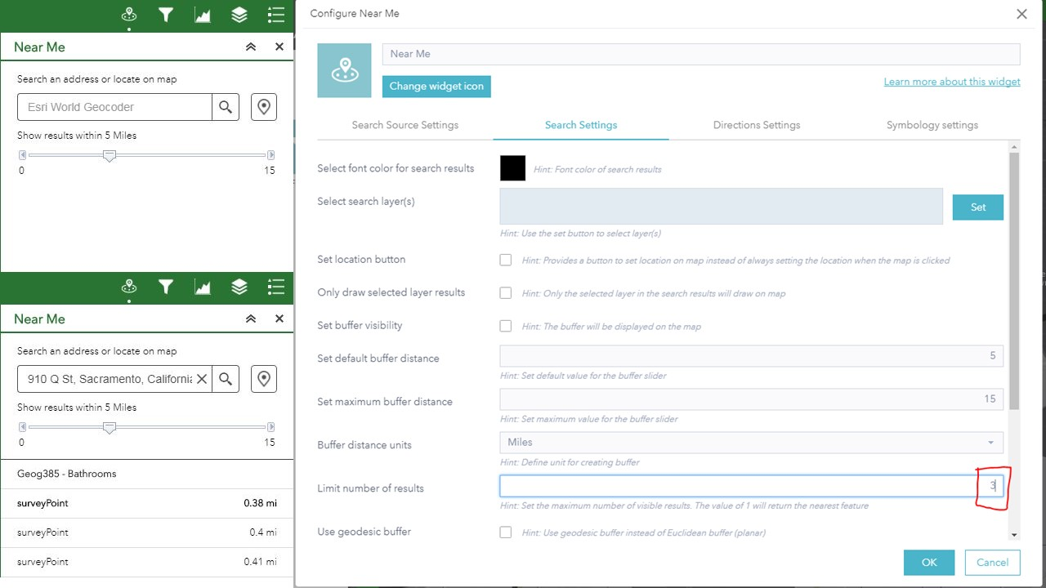
Figure 3: This shows the input window for the ‘Near Me’ widget that the user will see (upper left) as well as the results window after the location is determined (lower left). It also shows the settings for the widget where I limited the number of results (right).
The ‘Near Me’ widget then shows the selected bathroom on the map, highlighted with a cyan box, and displays its attribute information on the right hand side (Figure 4). By default, the attribute information tab on the right hand side is displayed, however the user may select the ‘Directions’ tab to receive step-by-step directions on how to get to the destination and the map zooms into the extent of the route, with a line snaking from the start location to the destination (Figure 5).
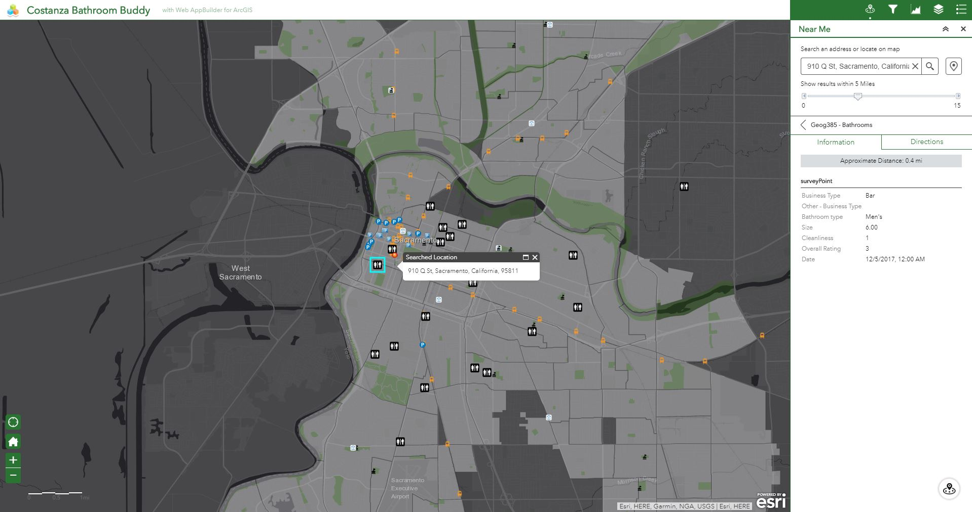
Figure 4: The selected survey point’s location highlighted (left) and the summary information (right).
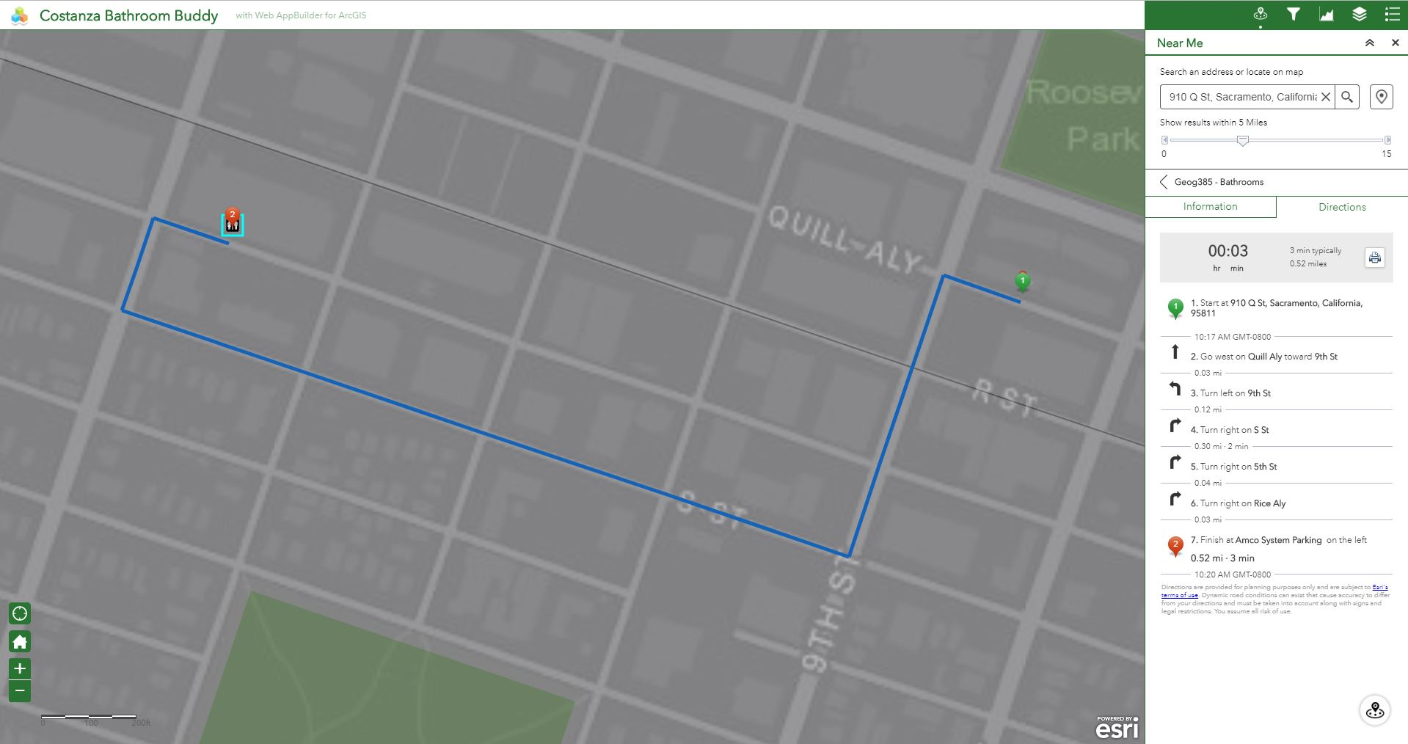
Figure 5: A line showing the route to get to the destination (left) and the step-by-step directions (right).
The second most important tool included in the web map app is the ‘Filter’ widget, which allows to the user to limit the number of survey points displayed on the map and parsed by the other widgets (Near Me and Chart). The ‘Filter’ widget on this app contains pre-programmed filters that I believed would be common choices for the end-user, prioritizing ‘Clenliness Rating,’ ‘Overall Rating,’ and ‘Business Type’ (Figure 6).
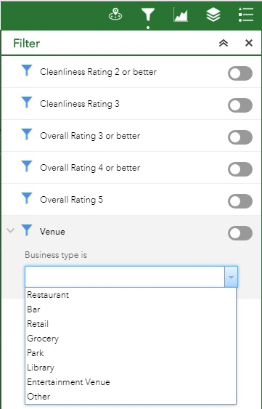
Figure 6: The pre-programmed filters on the ‘Filter’ widget are simple, self-explanatory, and easy to use.
The last tool added to the map was the ‘Chart’ widget. This allows the user to get a general summary of the survey points, providing counts for each attribute value for 4 of the most important attributes: cleanliness, overall rating, number of toilets (bathroom size), and venue (business) type (Figure 7). The input points can be limited by the filter, but additionally the tool provides an interface that lets the user restrict the input points based on their spatial distribution (Figure 8). The user has access to various drawing methods such as a rectangle, cirlce, or irregular polygon to create the bounding polygon. The utilized points are highlighted in a transparent dark blue on the map and the summary statistics are shown on the right hand side of the screen (Figure 9). For all charts in this app, ‘count’ is the value displayed, as the user may be interested in how many bathrooms in a target area have a high cleanliness or overall rating, or how many bars or restaurants have reviewed bathrooms in the area.
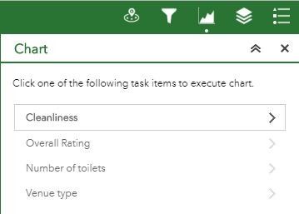
Figure 7: The 4 choices for attributes to be charted.
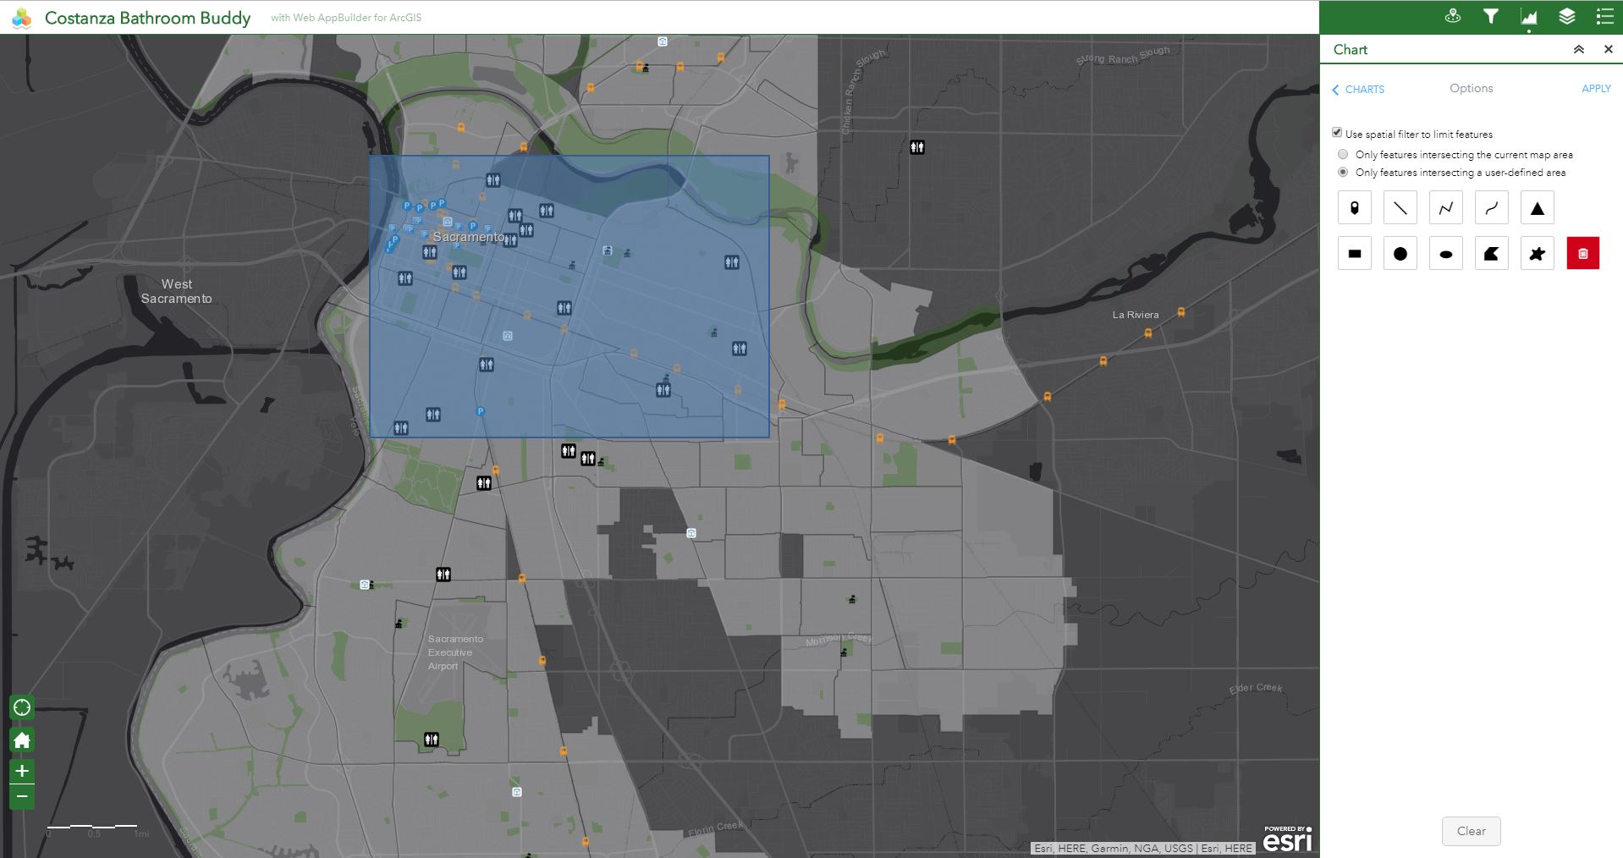
Figure 8: A bounding box drawn by the user, spatially selecting points of interest.
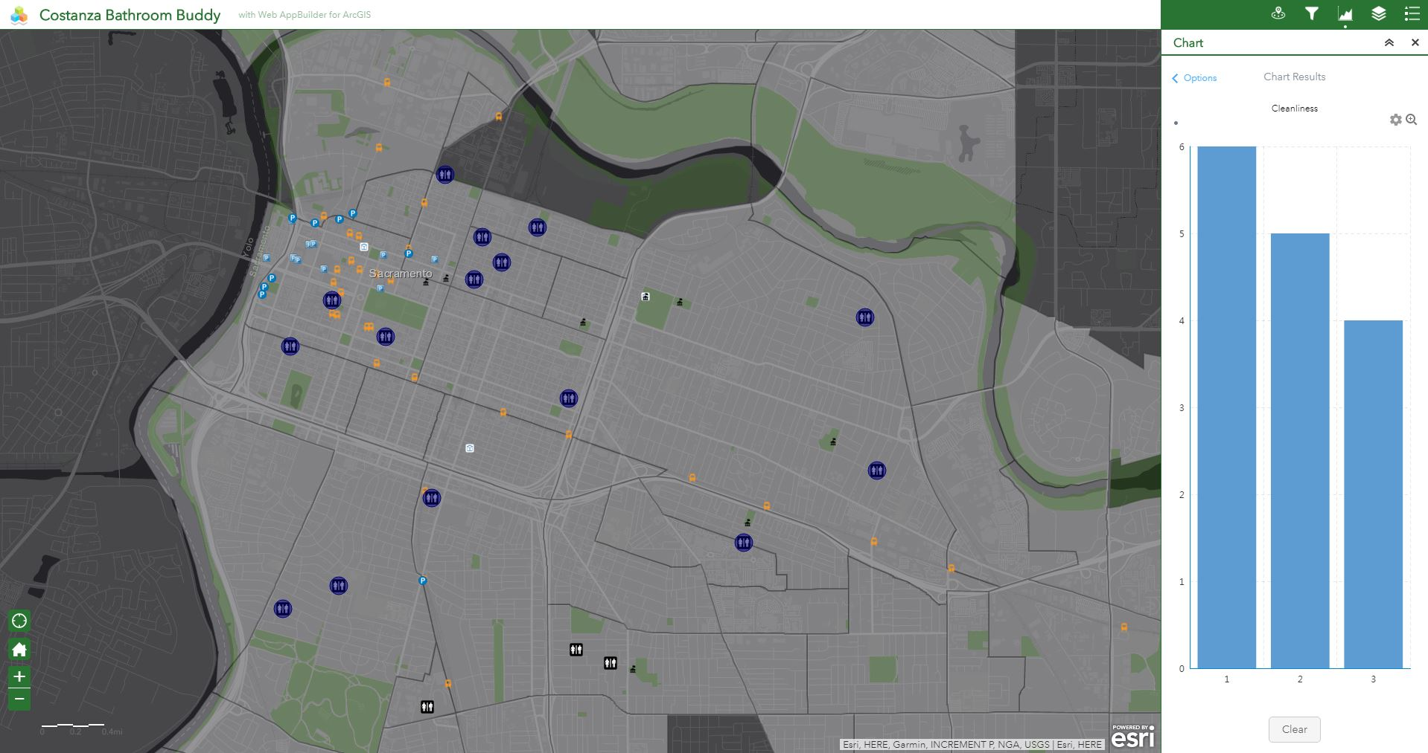
Figure 9: Survey points included in the chart summary are highlighted in a transparent dark blue, note the bathroom points located in the south of the map extent that are excluded from the summary statistics are outside the boundary box defined in Figure 8.
This web map app is, for lack of a better term, a sort of ‘Yelp’ for bathrooms instead of just simply businesses. It has the potential to be a useful tool for people with gastrointestinal conditions such as Crohn’s disease or irritable bowel syndrome, people who have phobias associated with public restrooms, or anyone who is at all concerned with the quality of restroom they use. It could also help the public in general by making managers aware of the issues in their bathrooms and (hopefully) seek to improve them.
The biggest limitation of this web map app is that there are 2 separate destinations for the map interface and for filling out the survey: ArcGIS Online and Survey123. It would be ideal to be able to submit a survey directly from the same page as the web map app. People don’t like to download extra apps they don’t use much onto their devices, so many potential surveyors may be discouraged from participating. Another draw back lies within the ‘Near Me’ widget in that the directions it provides are only car-based directions, I would like users to be able to choose directions for if they are in a car, walking, or taking public transportation. The ‘Routing’ widget allows for this function, but it cannot be directly tied to the ‘Near Me’ widget, and I don’t want to add another widget that provides directions because I want it to be as streamlined as possible.
If I were to make this app public I would want to address the issue of needing 2 separate apps to both input information and receive it. I also would like to add a few more optional attributes for surveyors to fill out including whether the bathroom has a baby changing table or if the restroom is ‘for customers only.’
*This was inspired by an episode of Seinfeld in which George Costanza knows the best, most proximal bathroom for every location in Manhattan.

