Jasmyn Bragg
GEOG385
12/12/17
Sacramento Food Truck Web Application
Summary:
For my final project, I created a web application of food truck locations in Sacramento. The food truck movement has gained a lot of momentum and popularity in the last decade around the country but the idea of selling food out of a nontraditional space or vehicle is not a new concept. What is so appealing about them is they’re generally affordable, convenient and the type of cuisine they offer can be unique and exciting. I particularly love the ones that focus on one item and do it well. The trouble with going to one of these trucks is finding their locations and the days and hours that they’re open. A lot of them do have social media accounts or websites that offer updates or information about upcoming events. This web application is a solution to the problem. It also has the flexibility for the data to be edited and updated by the user.

Purpose:
The purpose for this project is to offer a functional and easy to use web application where users can find these trucks in Sacramento. Because food trucks are mobile and are constantly changing locations, I want the users to be able to have the capability to edit or update those locations or to find the closet one near them. I would like to link the trucks to their respective Twitter, Facebook or Yelp account. Another goal of this application is to have the user be able to search for trucks based off price, food type, and availability depending upon the time of day.

Data Development:
After searching for related datasets, I knew I need to create my own data. One of the first steps towards this was compiling a list of food trucks in the area. I utilized the websites Sactomofo and Roaming Hunger. The latter website is targeted toward the Sacramento area as well as other parts of Northern California. Roaming Hunger has information for all over the U.S., Canada, Europe, and the UAE. The sites are helpful because they offer a directory of food trucks as well as schedules for any upcoming events. There are also links to their menus and social media accounts. One feature of the Roaming Hunger site that I wanted to incorporate into the web application was a time slider. There is an option to see a trucks location depending on the time of day. Once I had a list of more than 30 food trucks I began making an excel spreadsheet.
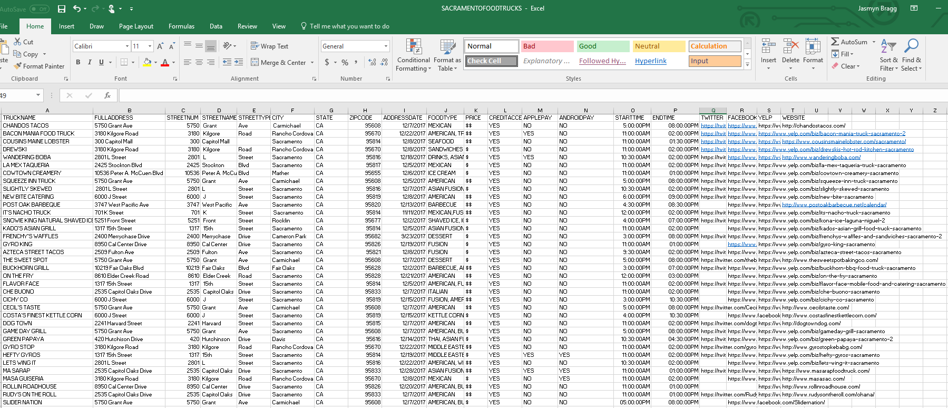
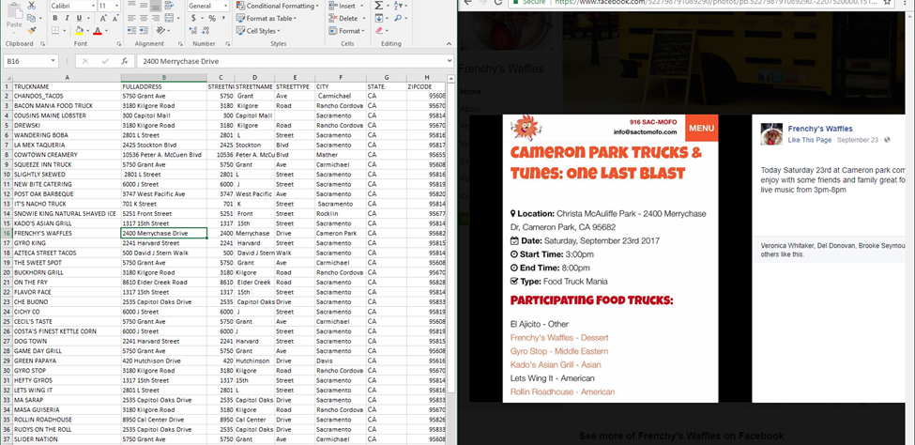
For the address field, I used a combination of Sactomofo, Twitter, Facebook and food truck websites to get that information. There is variation in the date of these addresses. I didn’t want all the trucks to have the same location. The current address also has a corresponding address date and time. Once the list was completed I used the Excel to Table tool to convert the spreadsheet into a table.
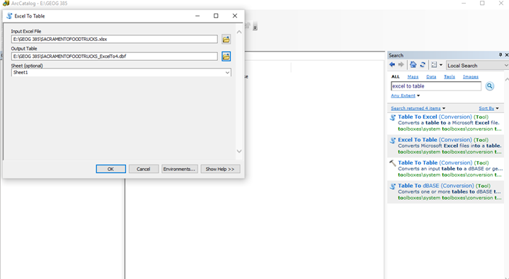
I already had an existing data set for Sacramento County, so I created an address locator, so I could geocode the food truck table.

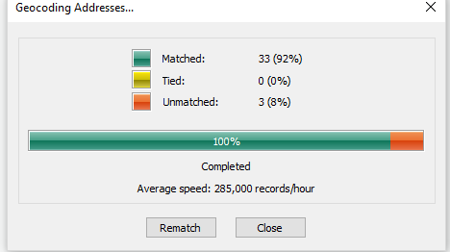
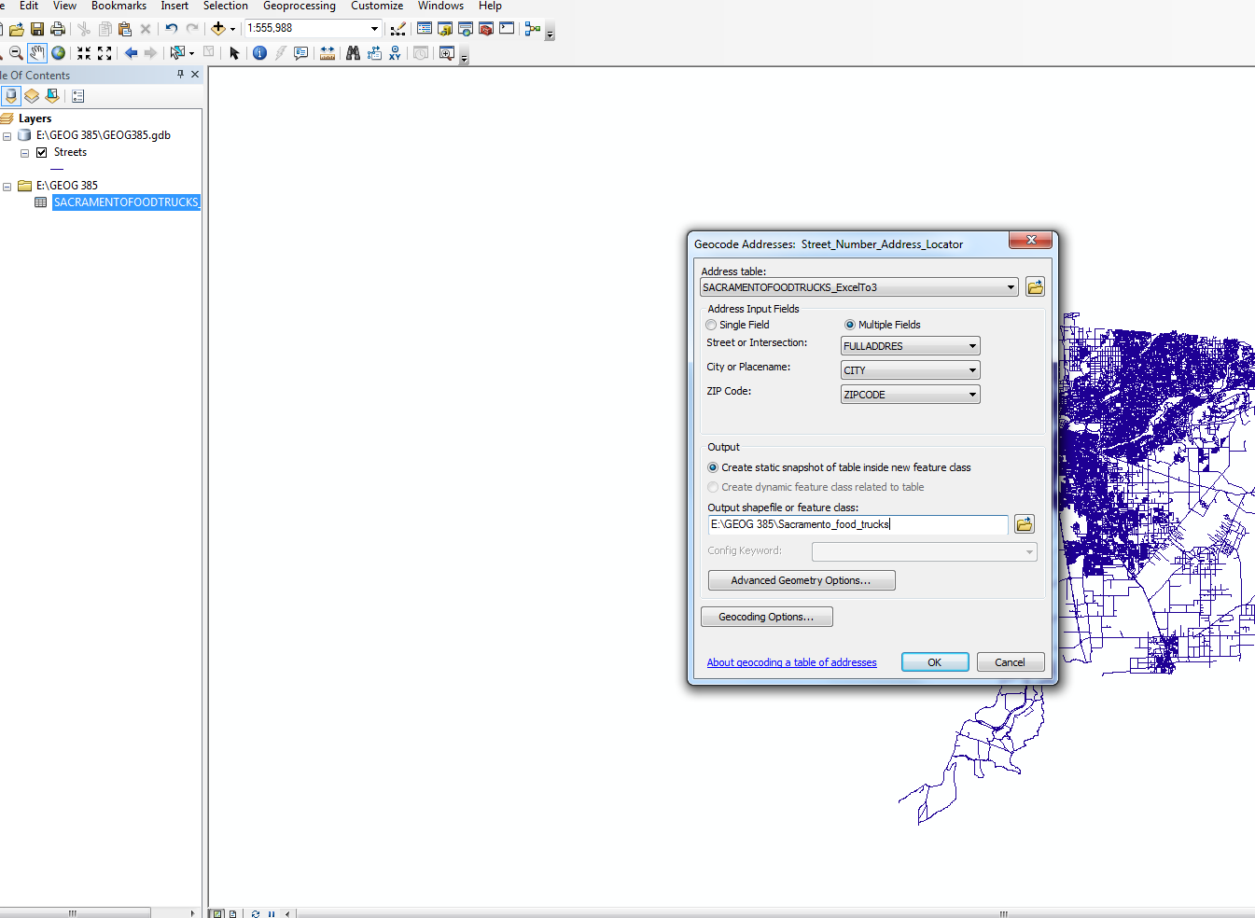

There were 3 address that I couldn’t geocode since they were outside the limits of Sacramento County. I wasn’t too worried about it since truck locations are constantly changing. I removed any layers that I didn’t want included in ArcMap as well as changing the name of the resulting layer. Once signed in to my ArcGIS account, I published the data as a feature service.
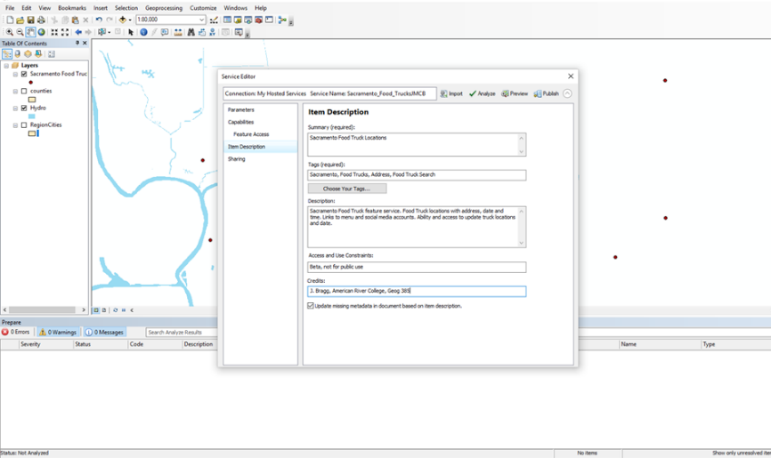
I only came across one error when I was attempting to publish it and I just removed my base map layer.

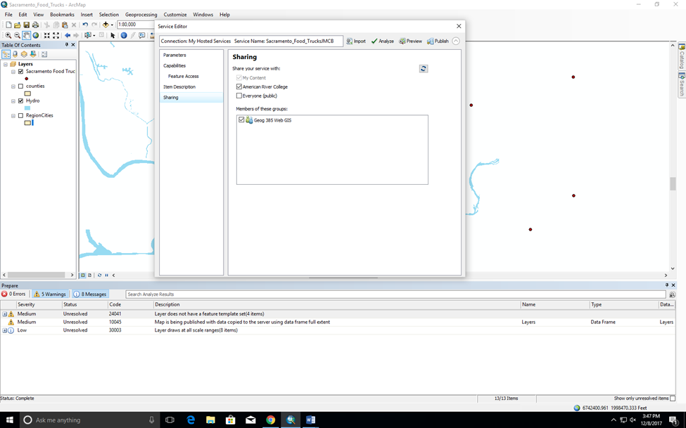

Web Application Development:
Once the map was published, I logged in to my ArcGIS online account. I kept the symbiology the same although I did test out different symbols to see what worked best. 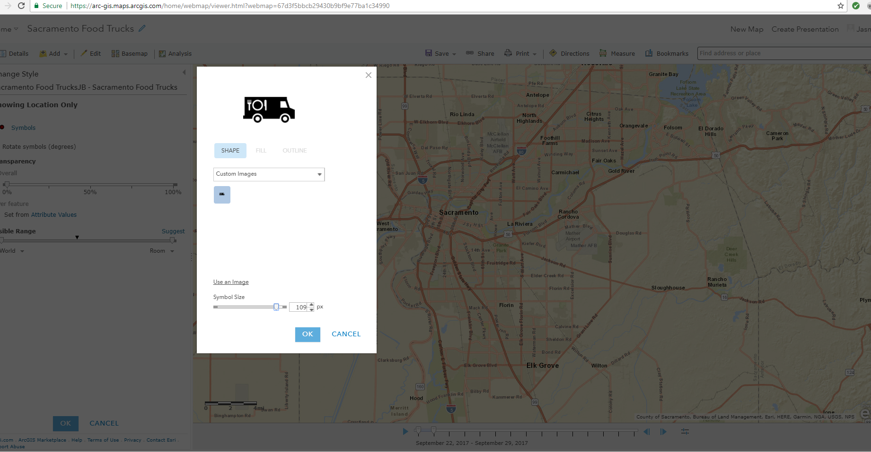

I then created a web app based off that web map using Web AppBuilder. I then changed the theme of the web app as well as added widgets that could be used in the app. I did add some filters based off the food type and price.
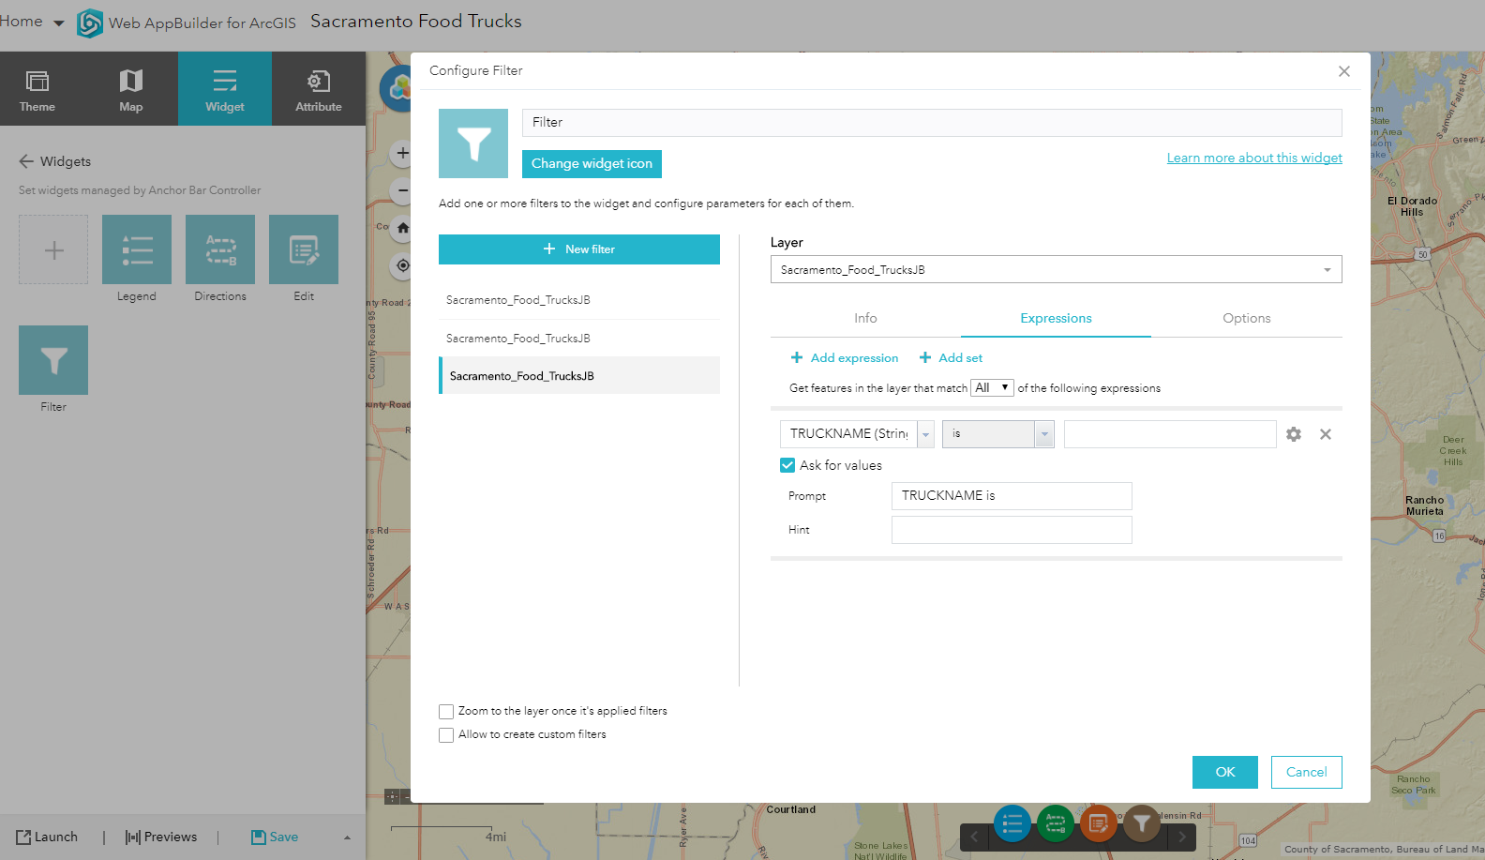
My last steps were previewing and launching the application.
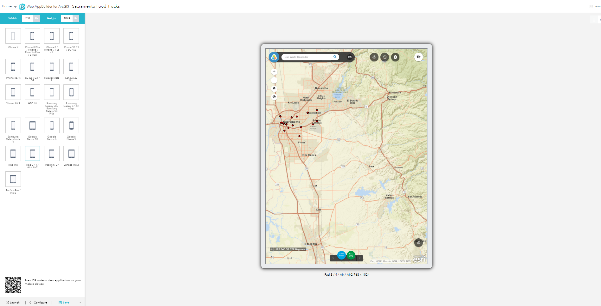
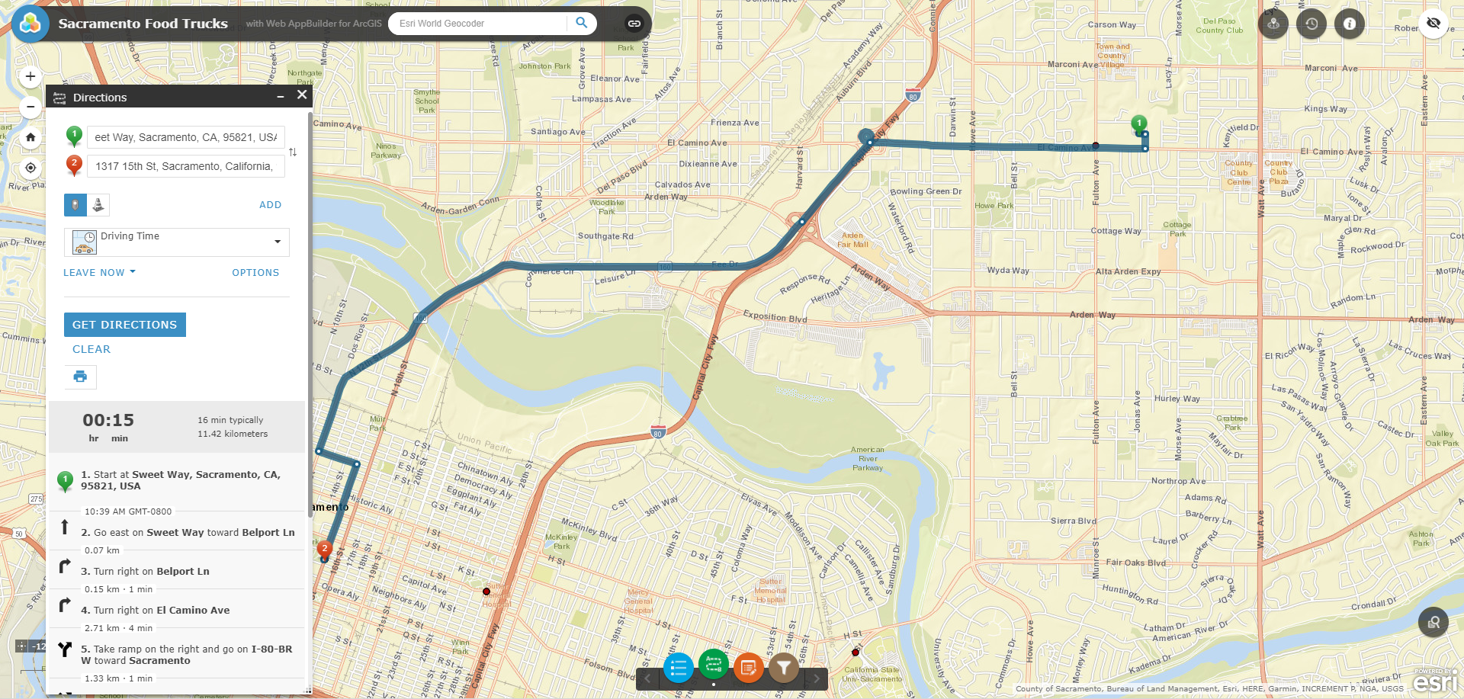
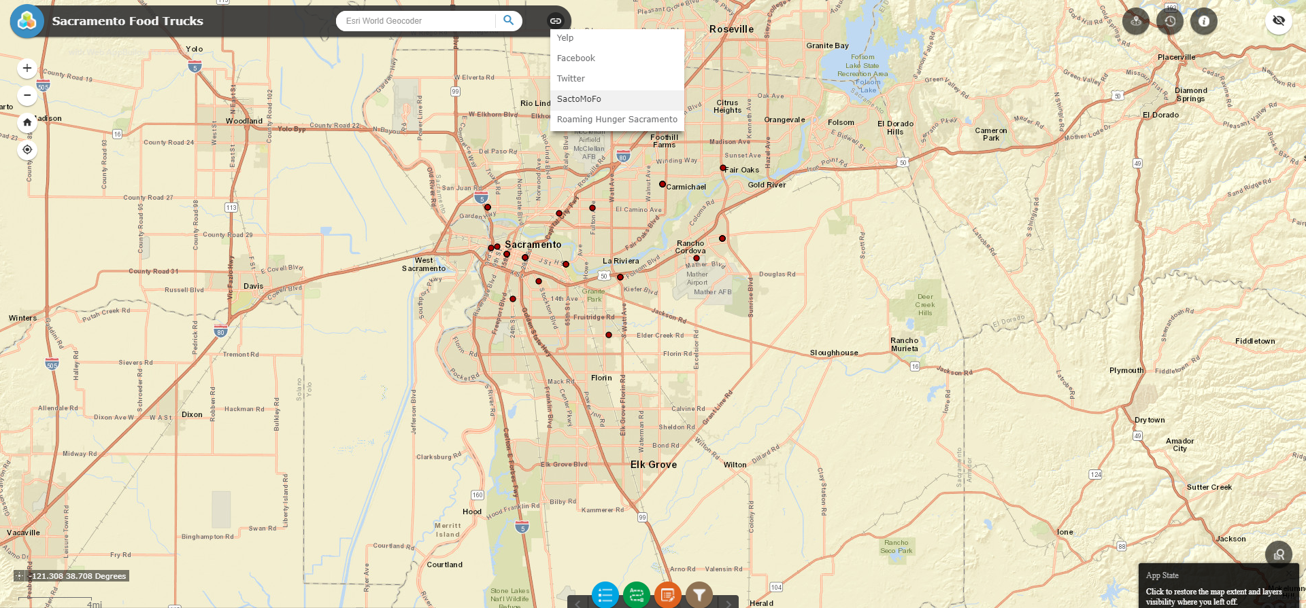

Difficulties:
I initially struggled with date time fields in the food truck location spreadsheet. Essentially it was just small errors in formatting and consistency. For the STARTTIME and ENDTIME fields, there were a few entries that had spacing between the numbers and AM/PM. When I was using Excel to Table tool in ArcCatalog or ArcMap, the resulting fields had decimals where there should have been an hour, minutes, seconds format. I was able to fix this by eliminating that space.
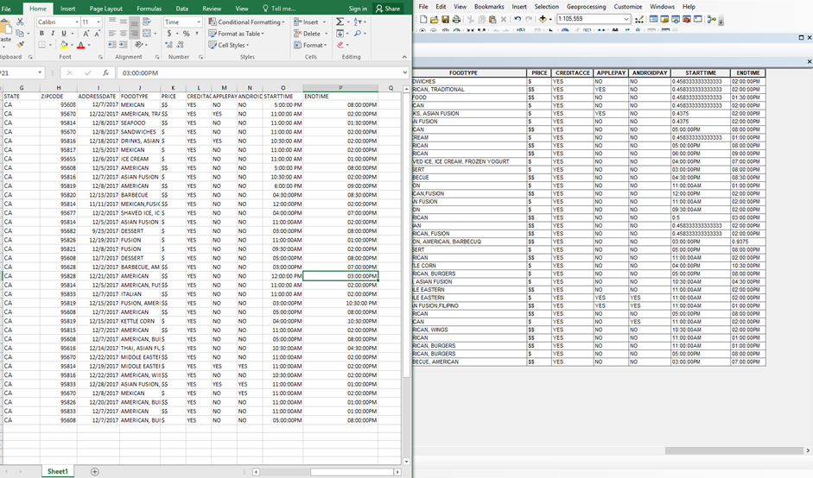
I encountered another date time formatting issue when I was enabling time. I could apply that for the current address date but not for any other fields like STARTTIME or ENDTIME.
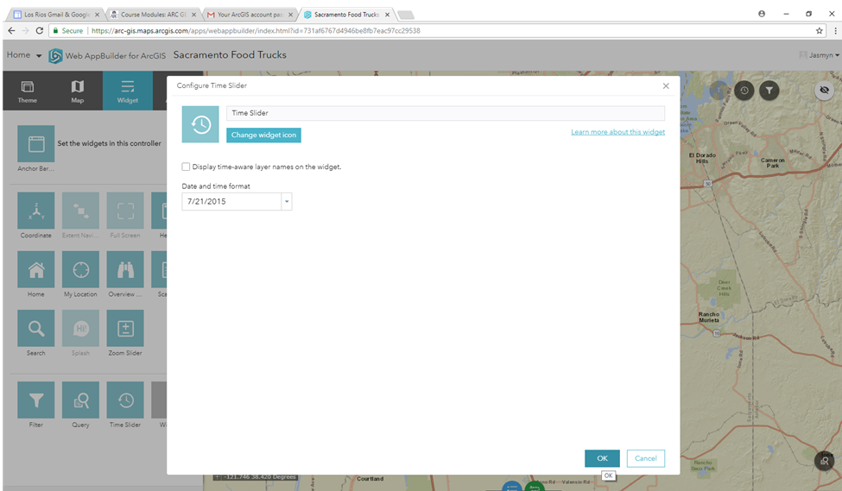
Another issue that I came across were my web hyperlinks. I really wanted that to somehow be a part of my data. It was one of the features that I wanted the user to have access to when utilizing the application. I initially wasn’t having any success converting that spreadsheet to a table, so I removed the fields for the Twitter, Facebook and Yelp and was able to finally have a successful conversion. I figured I could still add a media link when I was editing the web application later. Once everything had been published, I wasn’t sure how to add a media link for each food truck. So, I added the general links, so users could search for the truck they wanted.
I do have an updated spreadsheet with those links that I was able to convert to a table. So, in the future I’ll be updating the application to include that information and to make it more beneficial for the user. I also want to add photos that come up in the pops ups. Or an option to that allow users to attach photos themselves
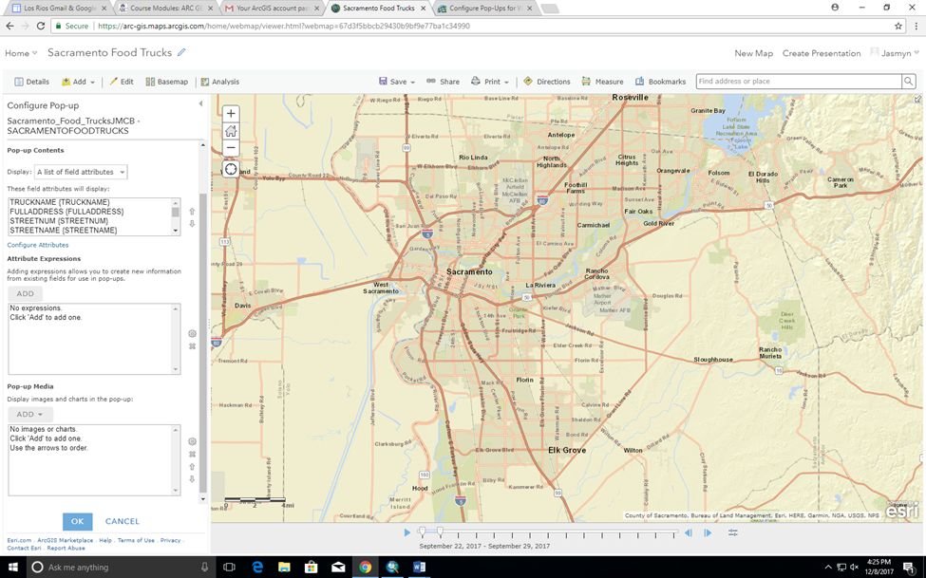
Final Thoughts:
There were a few things that I wanted to accomplish with this web application. The final application does allow the user to search and to filter out food trucks based of price level or food type. I think there is room for improvement. Updating and adding to the information in the existing table would be helpful especially when I am customizing those widgets in Web AppBuilder. In the future, I’ll be adding photos and links to the social media accounts.

