Shannon Bradley
Final Project Summary
12.07.2017
GEOG 90
My final project is a map of local Farmers’ Markets created with data gathered from multiple sources and compiled into a user friendly display. Information gathered includes Market location, operating season/day/hours, nearby landmark, cross streets, and multiple other market specific attributes. The visual representation of Farmers’ Market options available to consumers will help encourage shoppers to support local economy, promote sustainability, and reduce material waste.
Regarding technical accomplishments, through completion of this project, I would like to further my understating of and skill relating to data creation, data editing, and cartography utilizing ArcGIS Software. Beyond technical accomplishments, I hope to inspire an increase in the number of Farmers’ Market patrons in our local Sacramento, Placer, and El Dorado Counties.
To begin this project, I began researching local Farmers’ Market organizers and compiling information available on their websites in an Excel spreadsheet for easy data manipulation. The organizations included California-Grown Certified Farmers’ Market, Denio’s Farmers’ Market & Swap Meet, Placer Grown, Midtown Association, and Living Smart. I quickly learned the amount of information gathered was far too detailed to represent in a single map and narrowed the attributes from fourteen to four. Image below shows unrepresented attributes shaded in grey.
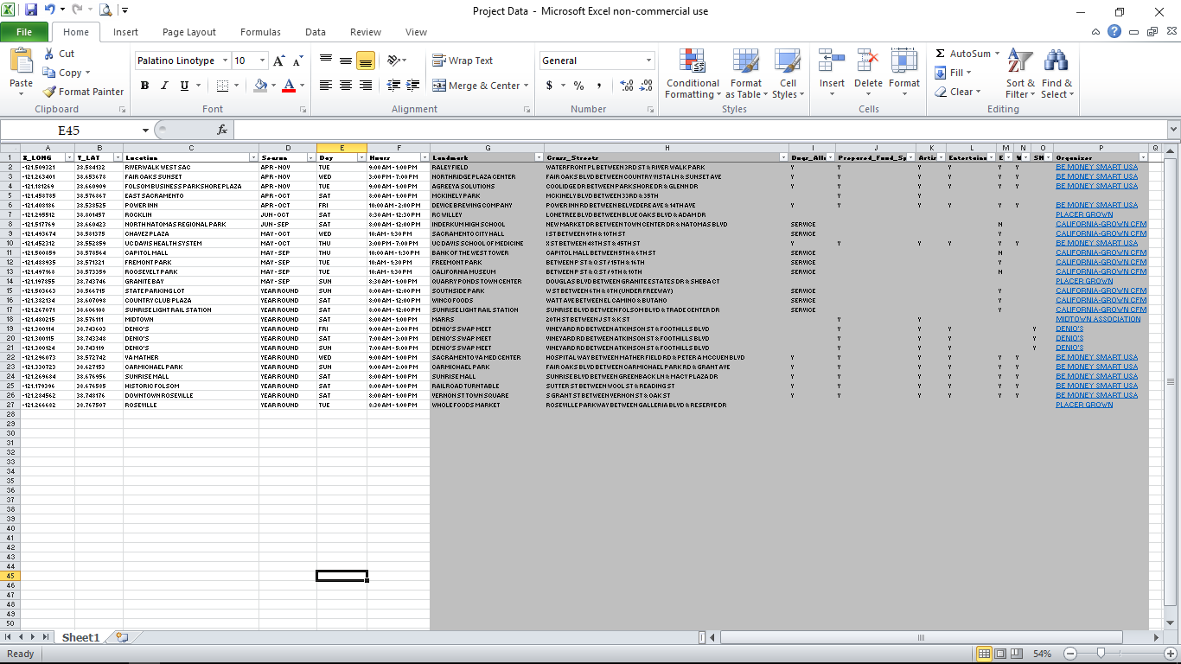
While I had originally planned to create the polygons to represent Market locations, I found points from XY Coordinates more effective for this particular map scale. It then became necessary to gather latitude and longitude points for each Market. Using Google Maps, I had little trouble inputting coordinates into the spreadsheet and the data set below became much more manageable.
In order to get a visual understanding of the data gathered and gain a better perspective of how to continue the project, I knew I needed to input all collected data to ArcGIS. This process required creating a New File Geodatabase and utilizing the Add Data/Excel to Table option. This step was repeated more than twice because of user error while gaining familiarity with the functions and trying to get things to be just as I wanted. Within the New GDB, I was finally satisfied with the “MARKET_LOCATIONS” Feature Class. I found creating a domain to be quite helpful when it came to selecting the season, day, and hours for Market attributes, rather than having to individually input data for each Market.
It was quite easy to add basic map features, i.e. title, legend, scale, and north arrow. With guided assistance I was able to begin exploring the options available within the Layer Properties and began adding label information. The following is a screen shot of one of my earliest iterations.
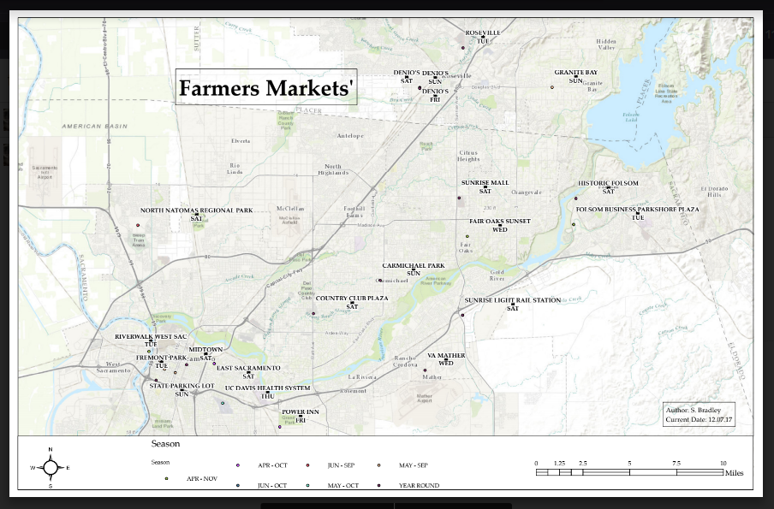
In not wanting the ESRI source data from the basemap to be visible, I was forced to style the legend across the bottom and I used that as a jumping off point regarding how to style the rest of the map. From this iteration I learned I was going to have to spend more time formatting Market labels for a variety of reasons. The marking that appears between the Market name and Market day was because of the style of label selected, designed for highway signage, but disappeared once the label style was changed. I found the all caps labels to be unappealing, so I had to individually edit each line of the Data Table to change to mixed case. To resolve the problem of Market labels overlapping within the Midtown grid, I created a “New Data Frame” and added the same layers of the original map, zooming into just the grid. To cover the ESRI source data on the inset, I placed the scale bar and author information over the shaded rectangle. Ultimately, I could write several pages on the edits made to reach my final map version. Here’s to hoping you like it!
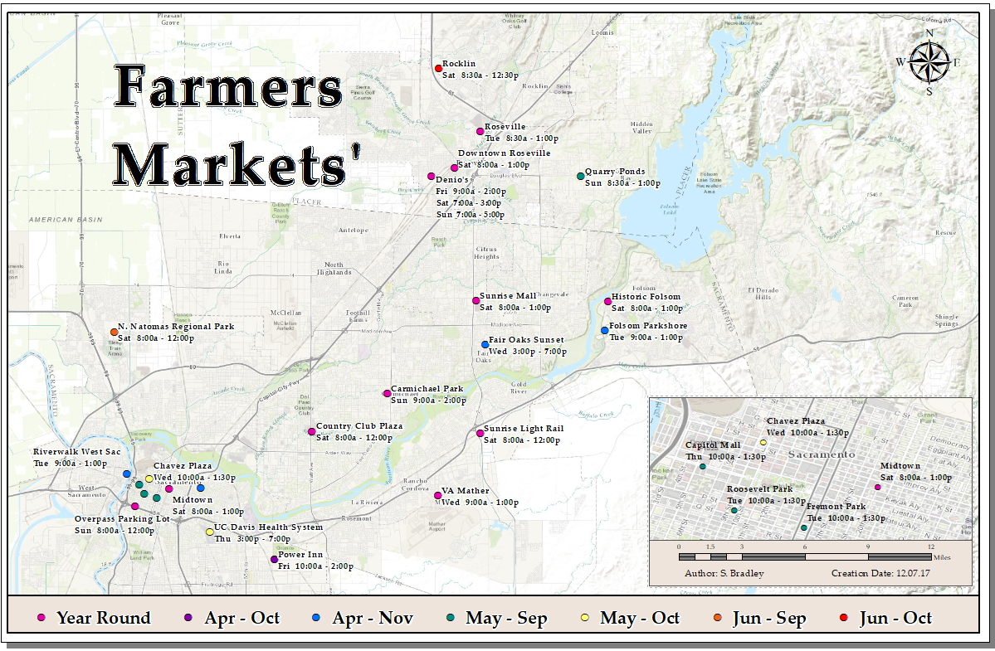
The most valuable lesson I learned from this project is to have a greater appreciation for the time and energy required to create the maps I love looking at and collecting. I am one of the few people I know who keeps a road atlas in my vehicle and I will never again look at it in the same way. Additionally, I am grateful for the introductory exposure to Arc GIS and look forward to utilizing the online version so as to continue editing this Farmers’ Market map and also creating new maps using the skills I’ve obtained as described above.

