Three Year Drought Analysis
A Tasseled Cap Transformation
Folsom Lake, California

Joseph Watkins
GEOG 342 Final Project

Summary
Initially, I chose to examine the ongoing drought impact to the Sacramento River and American River independently over a three year period. Utilizing the Tasseled Cap transformation process (TC), identifying wetness, greenness, and brightness associated with the individual rivers to determine if the drought had an equitable impact on each river. However, this venture was quickly foiled once I downloaded the Landsat 8 imagery and realized the footprint of the rivers was not large enough to convey in a power point presentation. After reviewing my options with the images, I set my sights on Folsom Lake. During the 2013, 2014, and 2015 calendar years we have seen a significant drop in the Folsom Lake water volume. I felt this would be a suitable landscape to perform the TC, and since the San Juan Water District (SJWD) uses water from the Folsom Lake to supply irrigation to the cities of Granite Bay, Orangevale, Citrus Heights, and Fair Oaks, I could examine the wetness, greenness, and brightness associated with these cities. I will perform the TC on Folsom Lake and the cities over a three year period to derive the association between decreasing Folsom Lake water volume and irrigation usage of the related cities.

Parameters
Determining image specs and acquisition was the first step. This analysis is best performed on a minimum pixel depth of 16 bit and a cell size of 30, 30. After searching a few online resources for imagery, the most comprehensive website was www.earthexplorer.usgs.gov. Once a login was created, imagery was freely downloaded. Image search criteria consisted of;
- Place: Sacramento, CA.
- Date: July 20th – July 31st 2013, 2014, and 2015.
- Data Set: Landsat-8 OLI (Operational Land Imager) and TIRS (Thermal Infrared Sensor).
- Additional Criteria: Cloud Cover less than 20%, and Day indicator.
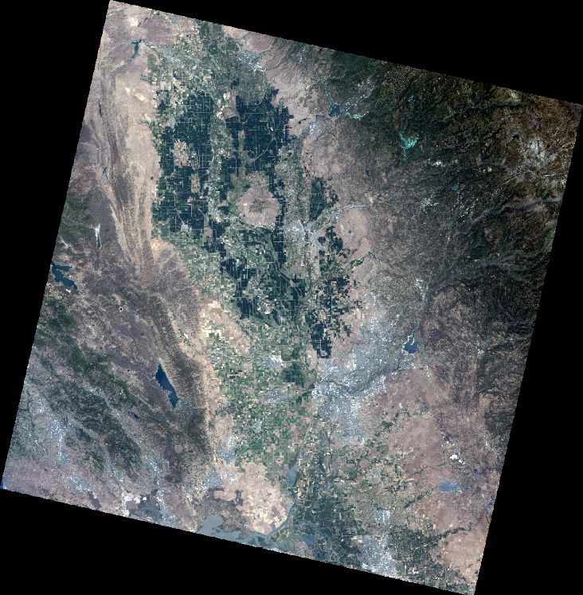
The open source file archiver, 7-Zip, was required to extract the compressed files. The files were extracted twice, once from .gz, then again from .tar, before the actual .TIF and .txt files could be accessed through ArcGIS.
Modification to the TC program was also required. This consisted of hands on manipulation to the Python script. The coefficients were updated to capture brightness, greenness, and wetness identified for Landsat-8 data as identified through the gis.stackexchange.com Tasseled Cap Transformation coefficient and Bias Value forum.
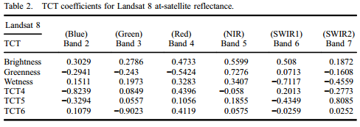
The Python script was also customized to reflect my personal workspace, reference the new imagery, re-naming of the saved tasseled cap, and updating the names of the bands identified in the multispectral images.
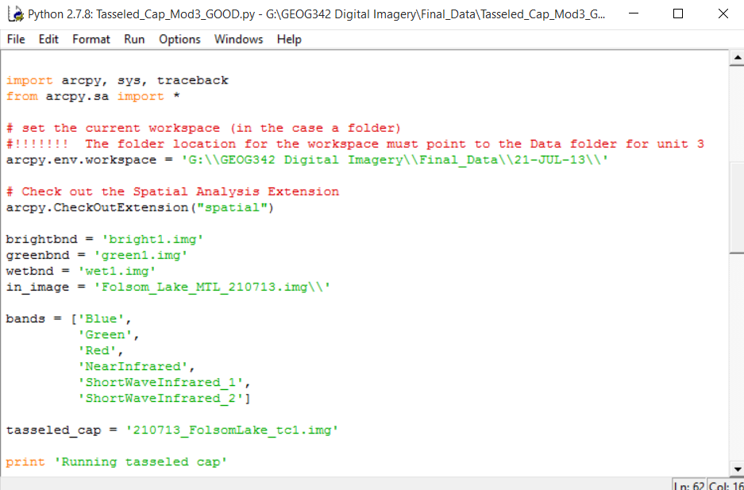
Methodology
Once the Landsat 8 images were downloaded, I performed a heads-up digitization of the 2013 Folsom Lake by zooming in on the feature and creating a polygon with the Draw tool. I used the Image Analysis, Crop tool to create a subset standalone image of Folsom Lake that would later be used for the TC. I loaded the additional two years of imagery and performed the same Folsom Lake subset using the original polygon. This ensured my footprint remained constant. Notice the continued decreasing water line and the anomaly of a darker subset, this occurred with all subset images but did not appear to have an impact on the findings.
2013 2014
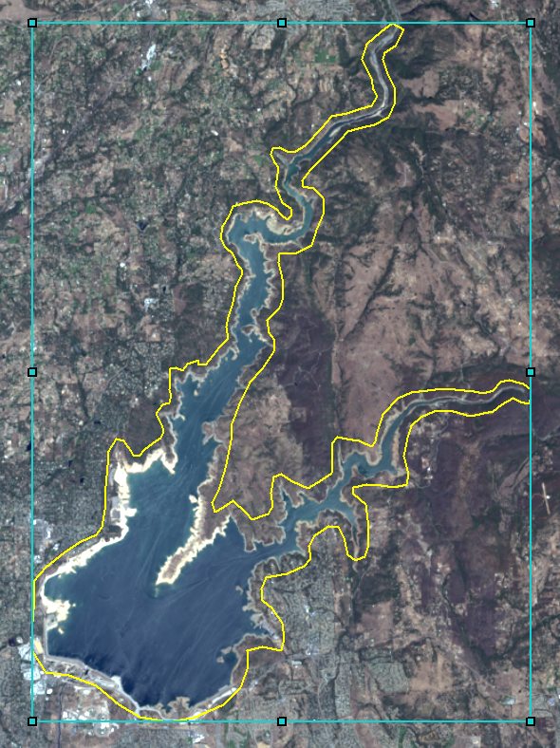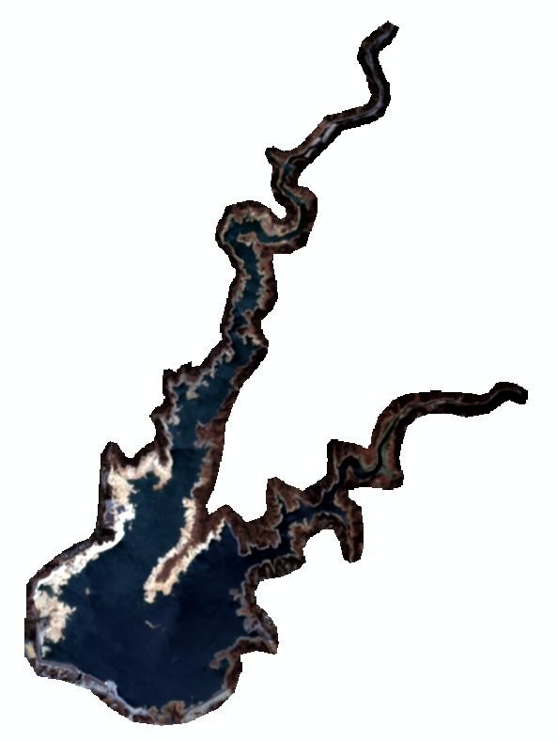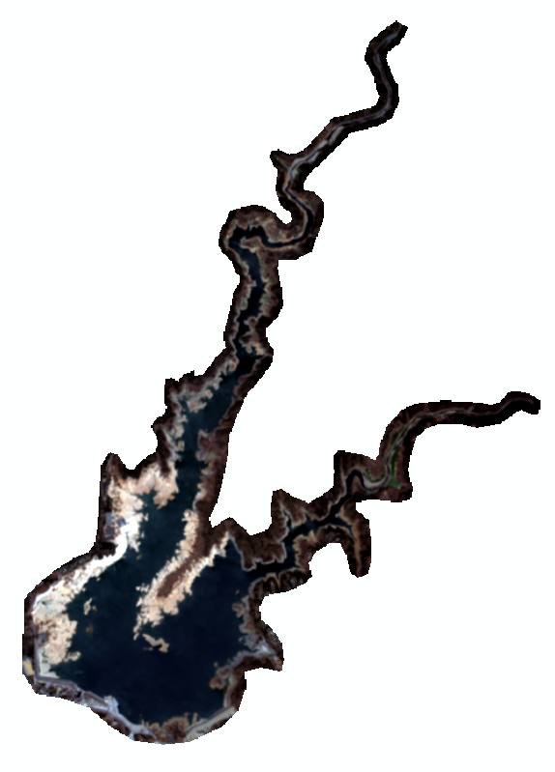
2015
Research was required to identify the boundaries of the SJWD. I found a PDF map of the coverage area on the SJWD website and contact the SJWD engineering department in an attempt to obtain boundary data in vector format that I could overlay with my image in ArcGIS. Unfortunately, SJWD uses CAD to create there data and did not know of a successful method to import into ArcGIS. Not wanting to waste limited time, I decided to again utilize the heads-up digitization process to create a polygon subset sampling of the SJWD boundaries based on visual cues from the PDF map. I used the same polygon to ensure my footprint remained constant with all three images.
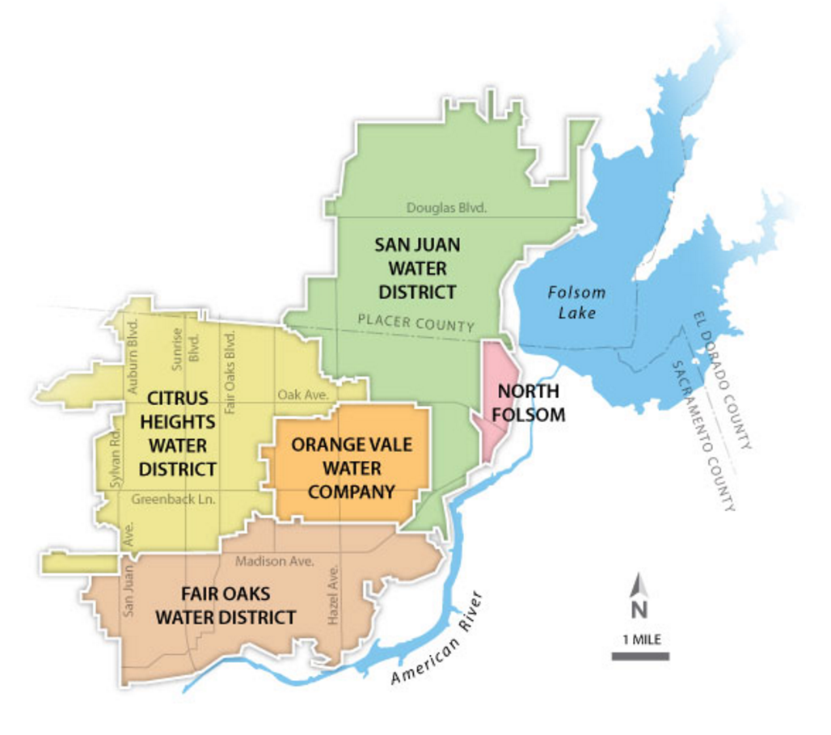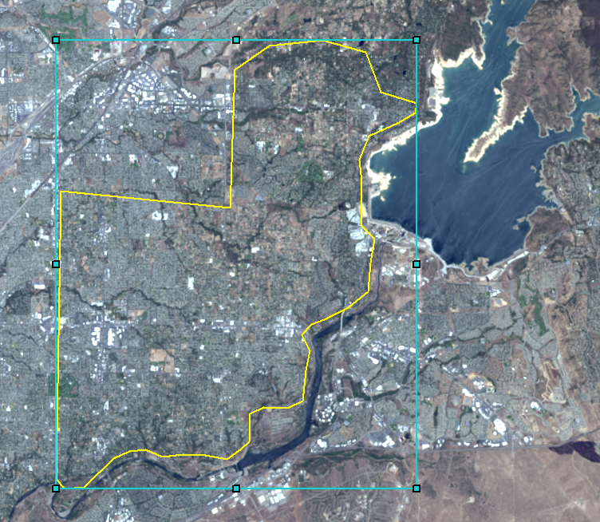
Transformation
I ran the customized TC on the three Folsom Lake images independently. Then referenced the Properties Histogram of each to derive the mean brightness, greenness, and wetness. Figures returned;
- Folsom Lake, 2013 – Red: 23618.62, Green: -2861.10, Blue: -1911.51
- Folsom Lake, 2014 – Red: 25972.53, Green: -2422.70, Blue: -2807.47
- Folsom Lake, 2015 – Red: 27492.27, Green: -2360.60, Blue: -3672.10
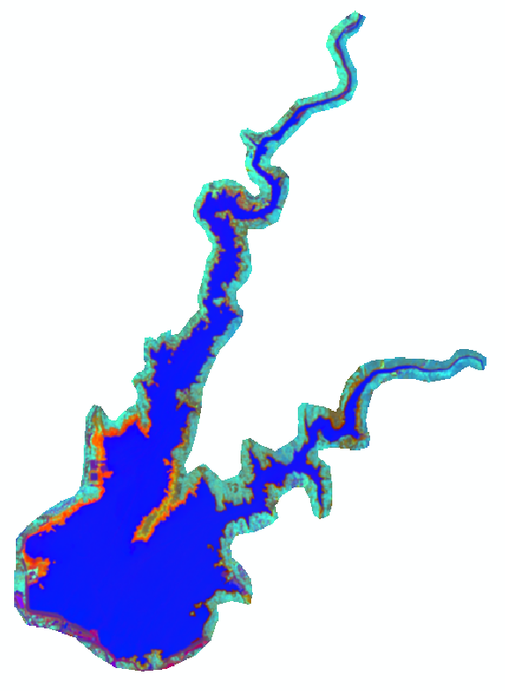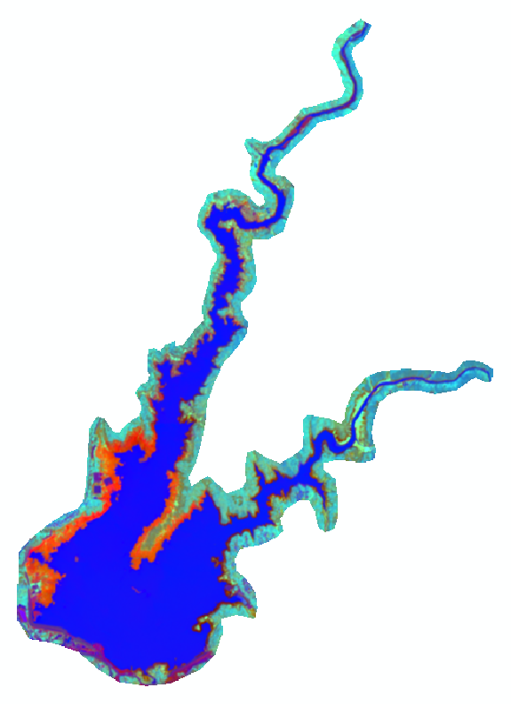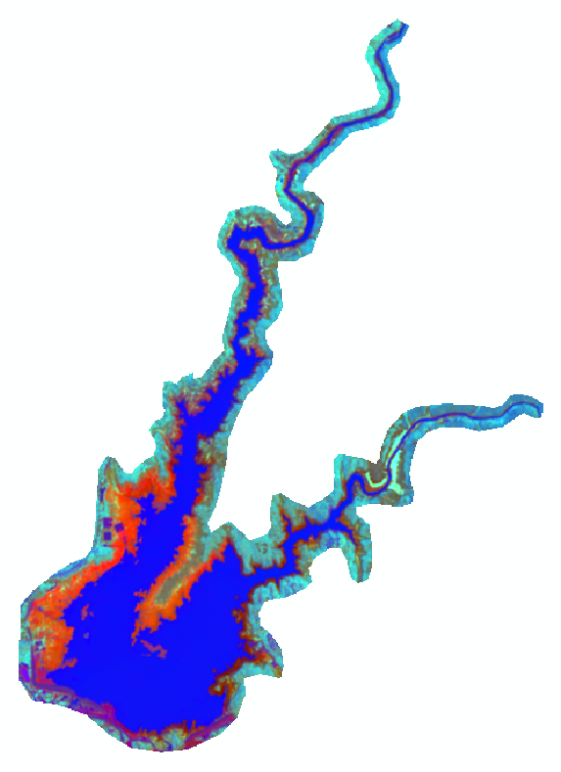
2013
2014
2015
I performed the same steps on the three Water Use images. Referencing the Properties Histograms for the mean image detail, figures below. Note the steady drop Water Use, Blue over the three years.
- Water Use, 2013 – Red: 28689.37, Green: 317.50, Blue: -2079.24
- Water Use, 2014 – Red: 28824.03, Green: 425.80, Blue: -2238.40
- Water Use, 2015 – Red: 28829.56, Green: 84.59, Blue: -2462.52
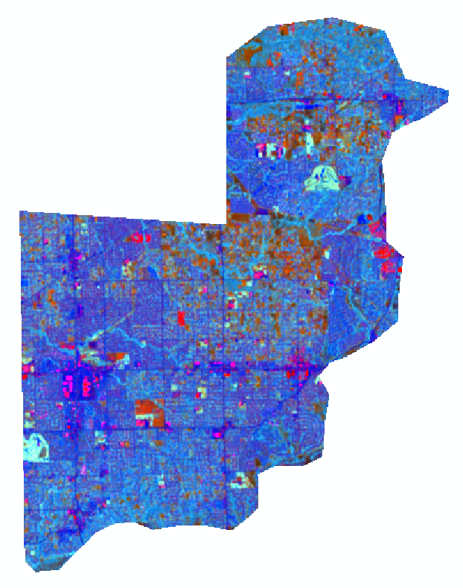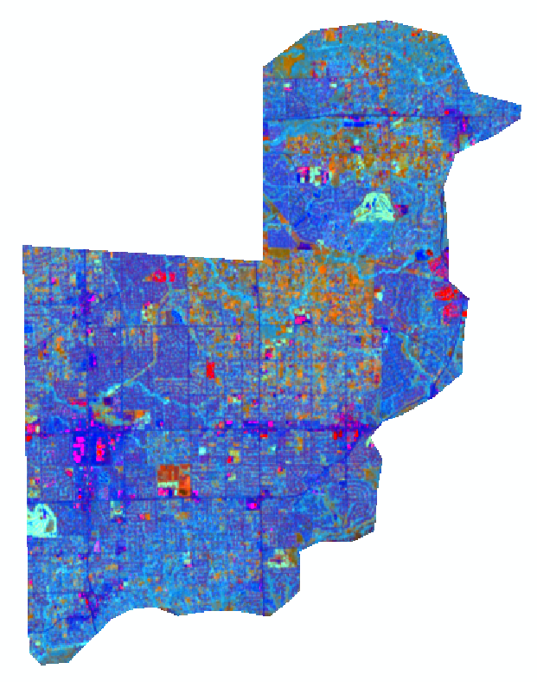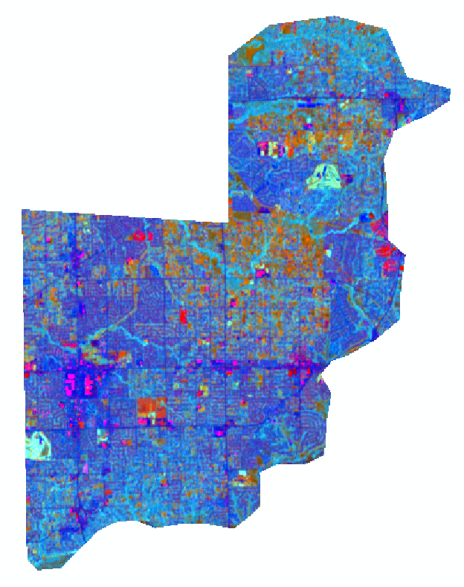
2013
2014
2015

Histogram results from Folsom Lake images.

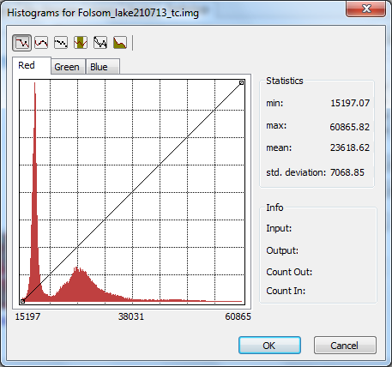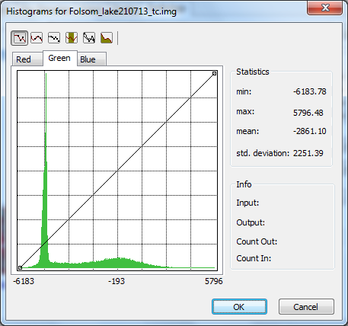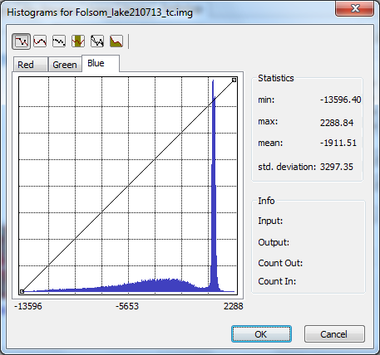

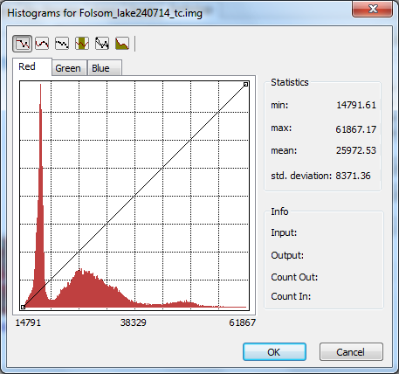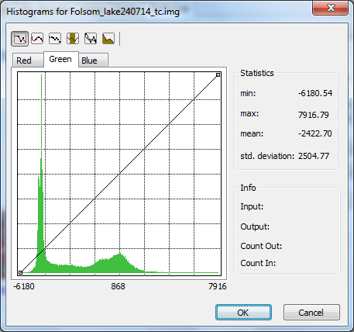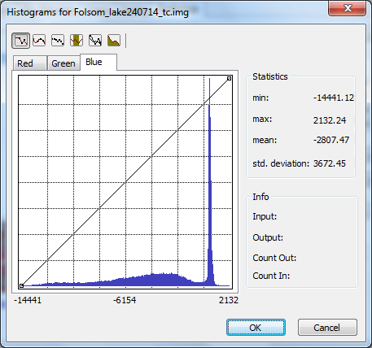

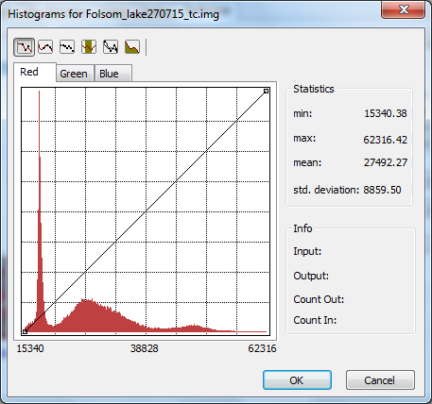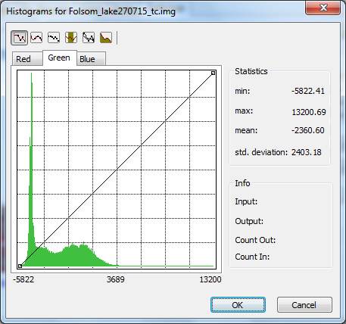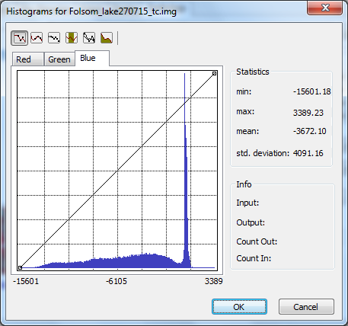

Histogram results from SJWD Water Use images.

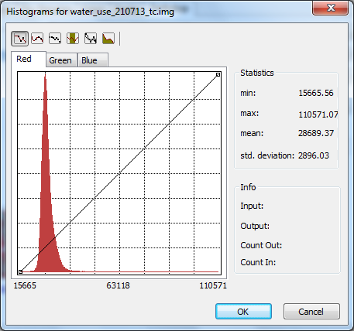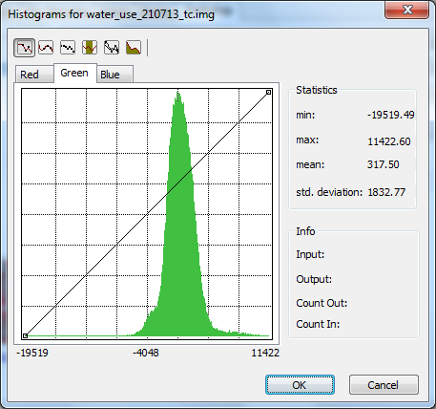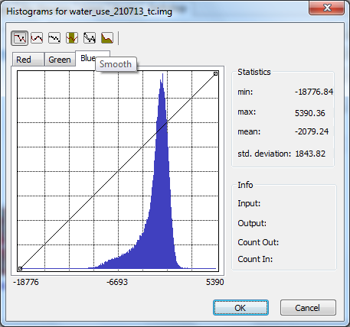

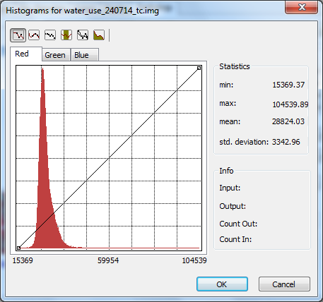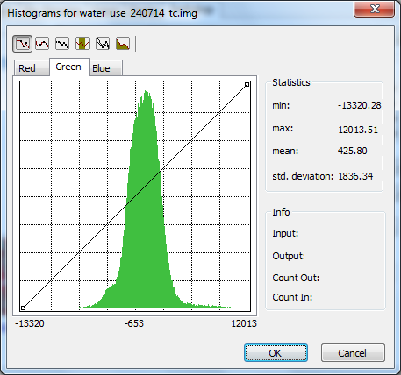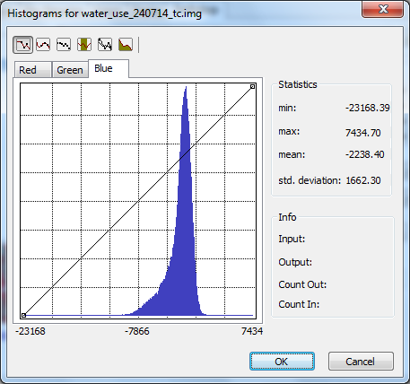

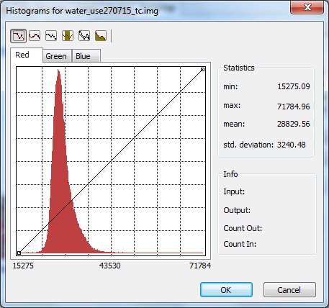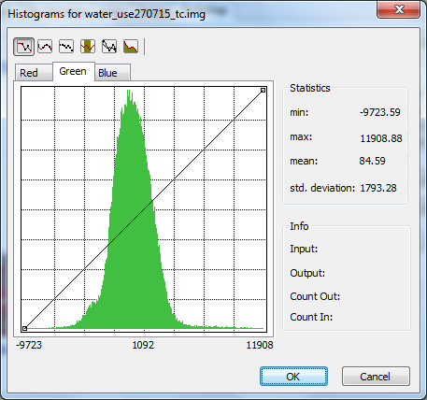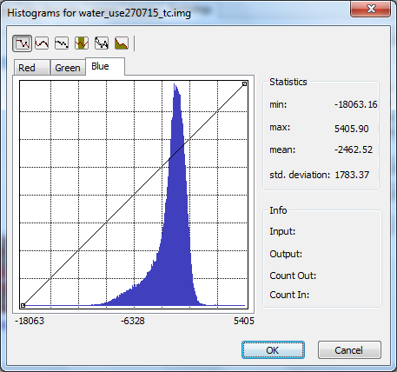

Analysis
I used the mean figures to create excel charts to compare water conservation efforts in the sampling section of the SJWD to that of the receding water of Folsom Lake. The Brightness represents bare earth /soil, the Greenness represents vegetation, and the Wetness represents water content.

As mentioned in the Methodology section of this report, the shrinking water line of Folsom Lake was clearly visible over time. This finding was reinforced by the notable increased Brightness on the Folsom Lake chart. However, the Brightness of the SJWD Water Use over time remained idle. In addition, you can see the aggressive drop in the Wetness component of Folsom Lake as it relates to the relatively subtle decrease in Wetness of the SJWD. Note the Greenness component of Folsom Lake increased as water content dropped. The parallax of Greenness vs. Wetness of each chart is more prominently defined when you remove the Brightness factor. This provides a closer look at the relationship between the two features as they relate to water content and conservation efforts. Analysis is seen on the following page.

With the Brightness component removed, the charts clearly reflect a conservation effort. In the SJWD Water Use, from 2013 to 2014, there was a 7 percent decrease in wetness. From 2014 to 2015, there was an additional 9 percent decrease. While Folsom Lake saw a 32 percent decrease and 24 percent decrease respectively. Even though Folsom Lake saw less water loss from 2014 to 2015 vs. 2013 to 2014, the conservation efforts of consumers in the SJWD continued to grow, increasing by 2 percent. If you look at the three years cumulatively, the SJWD reduced water consumption by 16 percent while the wetness of Folsom Lake footprint shrank by 48 percent. As the water receded in Folsom Lake this allowed more room for vegetation (Greenness) which saw a 21 percent increase over the study. I chose to explore the decrease in Greenness for the Water Use and visually compare 2013 to 2015. I used the “Yellow to Green to Dark Blue” inverted color ramp to emphasize highly dense greenness areas, images below. Even though the SJWD Water Use saw a Greenness shift from 317.50 to 84.59, it is not easily seen.
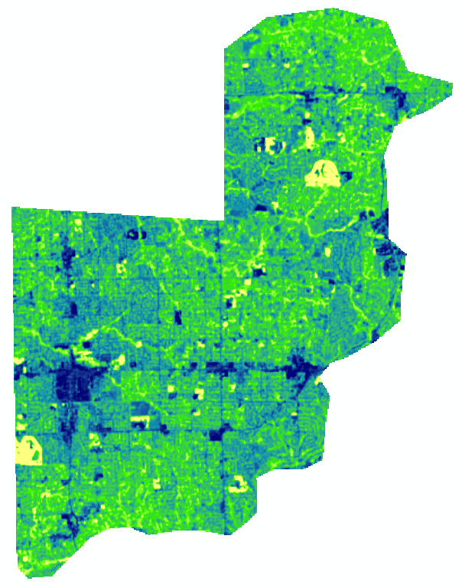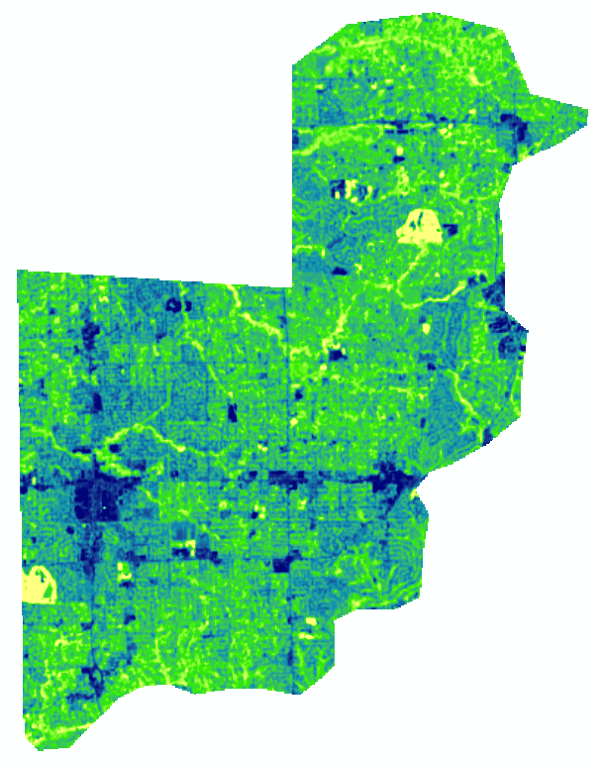
2013
2015
Conclusion
After completing this project, I feel the tasseled cap transformation process is a highly effective way of communicating large amounts of image data in a concise, comprehensive package. The Folsom Lake findings were in line with expectation. However, I did not know what to expect with the SJWD data. I was surprised to see the water conservation efforts increased in 2014 to 2015 over 2013 to 2014. I view this as a community wide understanding of the severity of our water situation and an effective water conservation education program. I also found the percentage of conservation interesting as it relates to Folsom Lake and would like to see how these figures compare to other professional analysis of the same time/area. The SJWD is only a fraction of the total Folsom Lake water use. Many more factors should be considered before presenting the findings as facts. For example, the SJWD supplies water to Granite Bay, however, they only supplement the surrounding cities. Also, for a true relationship, I would need to contact the Department of Fish and Game to factor in the yearly average water release from Folsom Damn for central valley farmers and salmon spawning requirements. Given more time, more accurate SJWD boundary digitization could have also been completed. The boundary could have been further broken down to reflect which city used the most/least, or which cities conservation efforts increased over time. From this analysis, you can conclude that SJWD users are aware of the droughts severity and are continuing to make concerted efforts to preserve the areas natural resource. Are these efforts enough? Only time will tell.

References
”Where does my water come from?” fowd.com. Fair Oaks Water District, 2015.
Web. 9 Nov. 2015. http://www.fowd.com/customer-service/frequently-asked-questions/.

“District_Map.” PDF. sjwd.org. San Juan Water District, 2015.
Web. 9 Nov. 2015. http://www.sjwd.org/pdfs/District_Map.pdf.

“Where does my water come from?” sjwd.org. San Juan Water District, 2015.
Web. 9 Nov. 2015. http://www.sjwd.org/customer-service/faqs.shtml#water1.

“2013_0725-water-agencies-area-map_LIVE.” JPG. sjwd.org. San Juan Water Distict, 2015.
Web. 9 Nov. 2015. http://www.sjwd.org/images/2013_0725-water-agencies-area-map_LIVE.jpg.

Rasmussen, Mikkel. “Landsat 8 TC coefficients:.” gis.stackexchange.com. Stack Exchange Inc., 2015.
Web. 11 Nov. 2015. http://gis.stackexchange.com/questions/156161/tasseled-cap-transformation-coefficient-and-bias-value.

