Laurel Warddrip
W1213599
5/14/2015
Geog 375 Individual Final Programming Project
Lwarddrip@gmail.com

- Document on this project.
  - Executive Summary
Goal: Use Python to pull out impaired water bodies within a selected regional water board boundary and quickly get information back in a table format that answered the question.

Often at work I am asked to look up water body information within a geographic area. Using ArcMap to run the queries takes a lot longer. Using python allows me to quickly provide the information to the question at hand.

I used the knowledge I gained in GEOG 375 to run a python script using my data of interest. I queried the Regional Water Board of interest (by attribute), selected impaired water bodies by location. Copied the rows to a new .DBF table.

The tasks performed were:
Set up workspace
Set up variables
Creating Feature Layers
Set up proper queries and selections
Create print statements to help check work/count records
Export the product (.dpf file of water bodies)

Complete: The script ran and returned the proper records into a .DBF file

Data:
- Impaired Water Bodies: A waterbody (i.e., stream reaches, lakes, waterbody segments) with chronic or recurring monitored violations of the applicable numeric and/or narrative water quality criteria. (US EPA definition). This is a line feature class I converted to a shapefile.

File Source (Public): http://www.waterboards.ca.gov/water_issues/programs/tmdl/integrated2010.shtml

Projection: NAD_1983_California_Teale_Albers

- Regional Water Boards: The State Water Resources Control Board has jurisdiction throughout California. Created by the State Legislature in 1967, the Board protects water quality by setting statewide policy, coordinating and supporting the Regional Water Board efforts, and reviewing petitions that contest Regional Board actions. There are nine regional water quality control boards that exercise rulemaking and regulatory activities by basins. This organization is a result of the landmark Porter-Cologne Act. This is a polygon feature class I converted to a shapefile.

File Source (Public): http://gispublic.waterboards.ca.gov/ArcGIS/rest/services/Administrative

Projection: NAD_1983_California_Teale_Albers

Definition Source: State Water Resources Control Board Fact Sheet

Impaired water bodies are a very crucial component to complying with some of our storm water permits. Many of the individuals that get our permits do not use GIS, but need site specific information/regional board specific information to comply with their permits. From the 100s of emails I get, many want to know geospatial information about what water bodies are in their area, this tool allows me to quickly answer their questions without even opening ArcMap.

  - Purpose. Include what you hope to accomplish with this project
I hope to be able to write a script that runs independent of provided data to provide a solution to a data need and to stream line several processes. This project allowed me to use data I would use at work, and run a complete script using the data. This script could be modified to automate other queries I would use on the data, and readily provide an output table I can reference for discussion purposes or if certain members of the public or the Water Board wanted the information.

  - Description of the geoprocessing tasks
Set up workspace – the workspace I used was a file containing the shapefiles for this project.

Set up variables – I understood how to set up variables to link back to the shapefiles and also to create new layers that I would be using in the python script.

Creating Feature Layers – to run the selections, I had to create feature layers and use them for the attribute and location selections. Also used in exporting the final product to a .DBF

Set up proper queries and selections- I had to understand the various selection syntax and the order of operations to process the data and get the records I wanted back from the dataset.

Create print statements to help check work/count records – this was invaluable on checking which parts of the code were working properly and to make sure that the correct information was being returned from the code.

Export the product (.dpf file of water bodies) – I chose to export to a .DBF since not all people have ArcMap, it is very useful to have summarized data specific to a question either the public had or the Water Board. I can easily share the table with them specific to a Regional Water Board.

Exported DBF file:
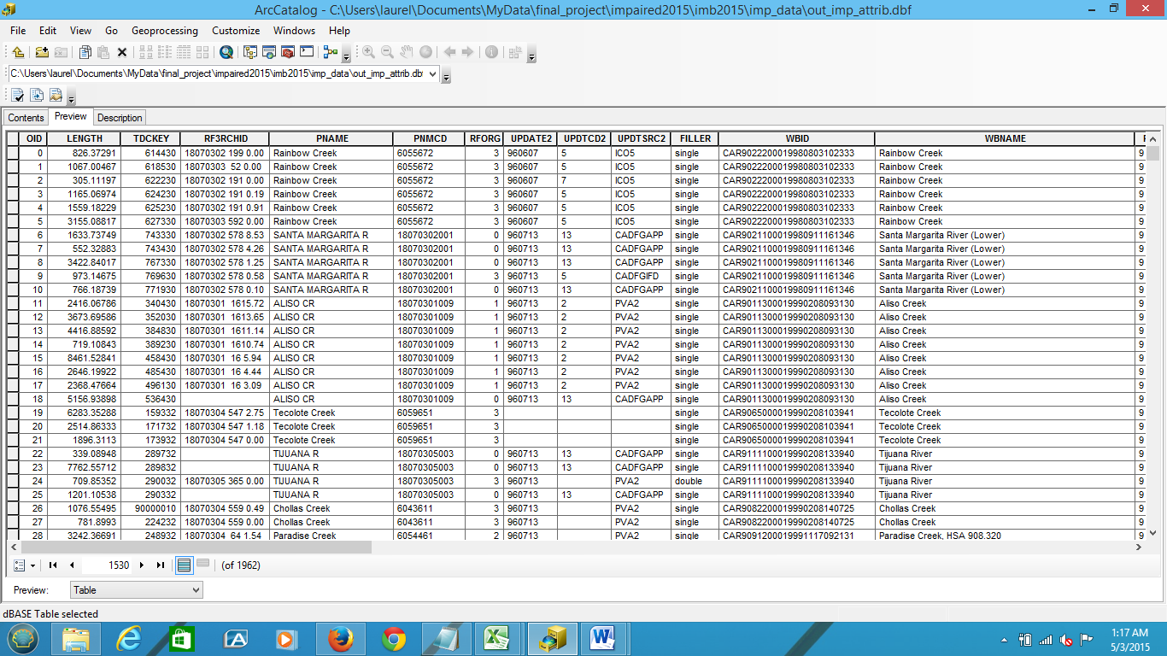

  - Summary of any difficulties/issues and how you resolved them
- Creating shapefiles, cannot use GDB feature classes. Ensuring naming matches the features names.
- Forgot to create shapefiles, figured this out and ran smooth. Print statements really helpful and ensured that the correct programming was taking place.
- Ensured that query made sense using ArcMap, then created the query in python. Also tested the selection logic using ArcMap, helped a lot when completing the correct query to get desired results (took a couple tries).
- Ensuring that you use a layer for this part of the code and setting up/using the proper variables.

Overall I overcame challenges by trial and error, using the internet, and looking at past products from the class. I hope to expand this code to also be able to automate the impaired waterbodies within a hydrologic unit (e.g. 12, 10, 9) and to add other automations as they are needed.

NOTE: the file I used summarizes multiple regions codes (HRC column) into different “regions”. The exported DBF table is correct based upon this feature class I used, but each polygon displays multiple regions in the “Region_NM” column, but this is not an error of my coding, it is the way that the feature class was set up when I checked this in ArcMap.

