Customer Locations Map for Delivery Truck Drivers
- Summary
The postal address data used to be most common way and the most of location data in the organization are still mostly postal address string format such as address, city, state and zip code, since it is the common way to exchange for people. However, for spatial data processing, it is not most efficient way to process and handle. For logistic point if view, understanding the set of locations at one look is very importance and essential for the worker recognizing the delivery route and delivering the customer packages efficiently. In this project, the postal addresses are geocoded and put on the base map and automatically printed out. In addition, the optimal route is automatically generated on the map.

- Purpose
In this scenario, each truck driver are assigned several packages to deliver to many customer locations. Each day, each driver is assigned set of customers and packaged to deliver. The customer location is stored as postal address such as Address, State, City and Zip Code. In order to add map, those postal addresses should be transformed to the spatial information and display on map, so in this project, those are automatically geocoded by arcgis geocoding service and put on the map. In addition, the optimal route is also determined using arcgis online route service.

- Description of Tasks
The postal address are stored in the relational database and the data are updated continuously. The tables inside the database, new fields lat and long is added to store the geocoded results. Then the all assigned data are loaded to the map.
The detail step are as follow.
- From Python, all postal data without Lat or Long or Change Flag is true are retrieved and saved as CSV file

- The retrieved postal address are geocoded and create the feature, then new feature X(Long) and Y(Lat) data are written back to the database. The ArcGISOnline gecodoing service is used for this. (The alternative free geocoding is to use census street data as Address locator, however it this is far from the practical level of the accuracy.)

The following is the geocoded points feature.

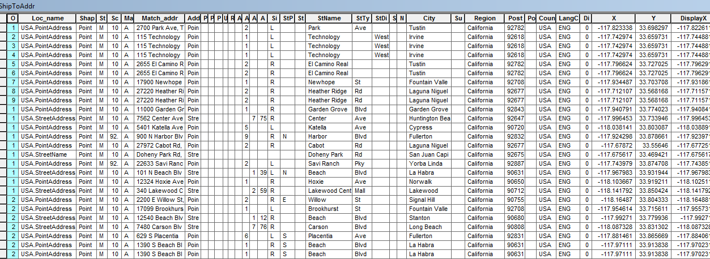

- Again, this time all data are loaded and converted to CSV. One reason for doing this partial geocoding that good Geocoding is generally not free, and can be very expensive. Another reason is that the address data in general is not so frequently change so once you geocoded once, you can keep using that information.

- From the CSV file generated, make a XY Event Layer and load it the mxd which the base map is already loaded.

- The optimal route is also determined using arcgis online route service. In the python code, JSON request and response are used. Also the program prompts the Client ID and Secret Key as needed to generate token for the service. Then from the points feature from JSON, the line feature representing the optimal route using Point to Line Conversion tool.

- Print out the map for the driver with the base street map

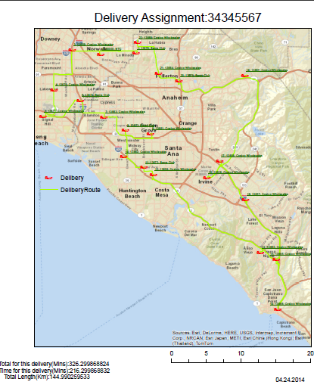
- Challenge/ Difficulties

a). Initially , I attempted to use Address Locator and Network Dataset the free census street data. However, it is far from the practical level of accuracy. The census street data itself is not so updated and accurate. So I decided to use the arcgis online service (Using free trial account). Though it costs some credit, it is worth using it for the accuracy.
b). Though I can use arcpy to directly generate points feature for geocoded locations, for the optimal route, I cannot find the direct way, so I manually generate the url request with JSON and decode the JSON message and captures the points forming the route to generate the optimal route. From ArcGIS Desktop 12.1 or later, JSON conversion is supported so in future, I do not have to manually decode the JSON.
c.) PostGIS and other relational database such as MSSQL 2008 or later now supports Geometry and Geographic data type. I initially attempts to directly connect the database from arcpy and save the feature class to the database directly without using the file geodatabase. However, some driver is not automatically installed into ArcGIS Desktop. Though I did not resolve this, I decided to generate CSV and Feature classes each time. In future, we can use the features from the spatial relational database directly without using CSV or running command such as Shp2PGSQL or so.

Possible Improvement as Next Step.
PostGIS connection may be created by ArcCatalog and it may be accessible from arcpy, in this way, we possibly save the features into the PostGIS directly.

Depending on the number of the records, ArcGIS online could be very expensive. For the geocoding part, we can utilize Google API and decode XML and get XY info as the program did to get JSON route information.
(In this program, trial account is used)

