Lance Duncan
Geog 375, Spring 2014
Prof. Nathan Jennings
Creation of a Map through Python

Executive Summary
This Project resulted in a script which allowed a user to input a county in order to generate a map with all the hospitals in that county selected and labeled. In working though this project there were some difficulties which caused me to try a different method in completing the script. In my first attempt at generating the script, I ran into issues with select by location, which later resolved themselves. What ultimately led to my reevaluation of my methods was editing a map document. Because I could not create a script which successfully modified the map in a desired way, I took a step back and decided to try a different approach to the whole project. In my second script I performed a join, so there was only on selection set. Also in this approach I found what I had done wrong in my first attempt at modifiying the map and was able to complete the edits to the map layout and dataframe. This project was a major learnig experience for me, teaching me to think about the best method to complete a task and I gained critical experience with the mapping module.

Purpose
The goal of this project was first of all to fulfill the requirements for a final proect and demonstrate my knowledge and proficiency with python for ArcGIS. With that in mind I decided to write a script that would involve most of what I learned this semester. Looking at what data I had easily available I chose to work with Hospitals from the Esri Data and Maps package. The final objective I decided on was to write a script which would allow the user to input a county and a map showing all the hospitals in that county would be generated. I also contemplated developing a GUI, but procrastinated the construction of that and did not complete it.

Tasks
On writing this script I ran into many roadblocks and ended up creating two different scripts because my first approach was not successful. I will examine my first approach and its failures, and then detail what I did differently the second time around.

ATTEMPT 1:
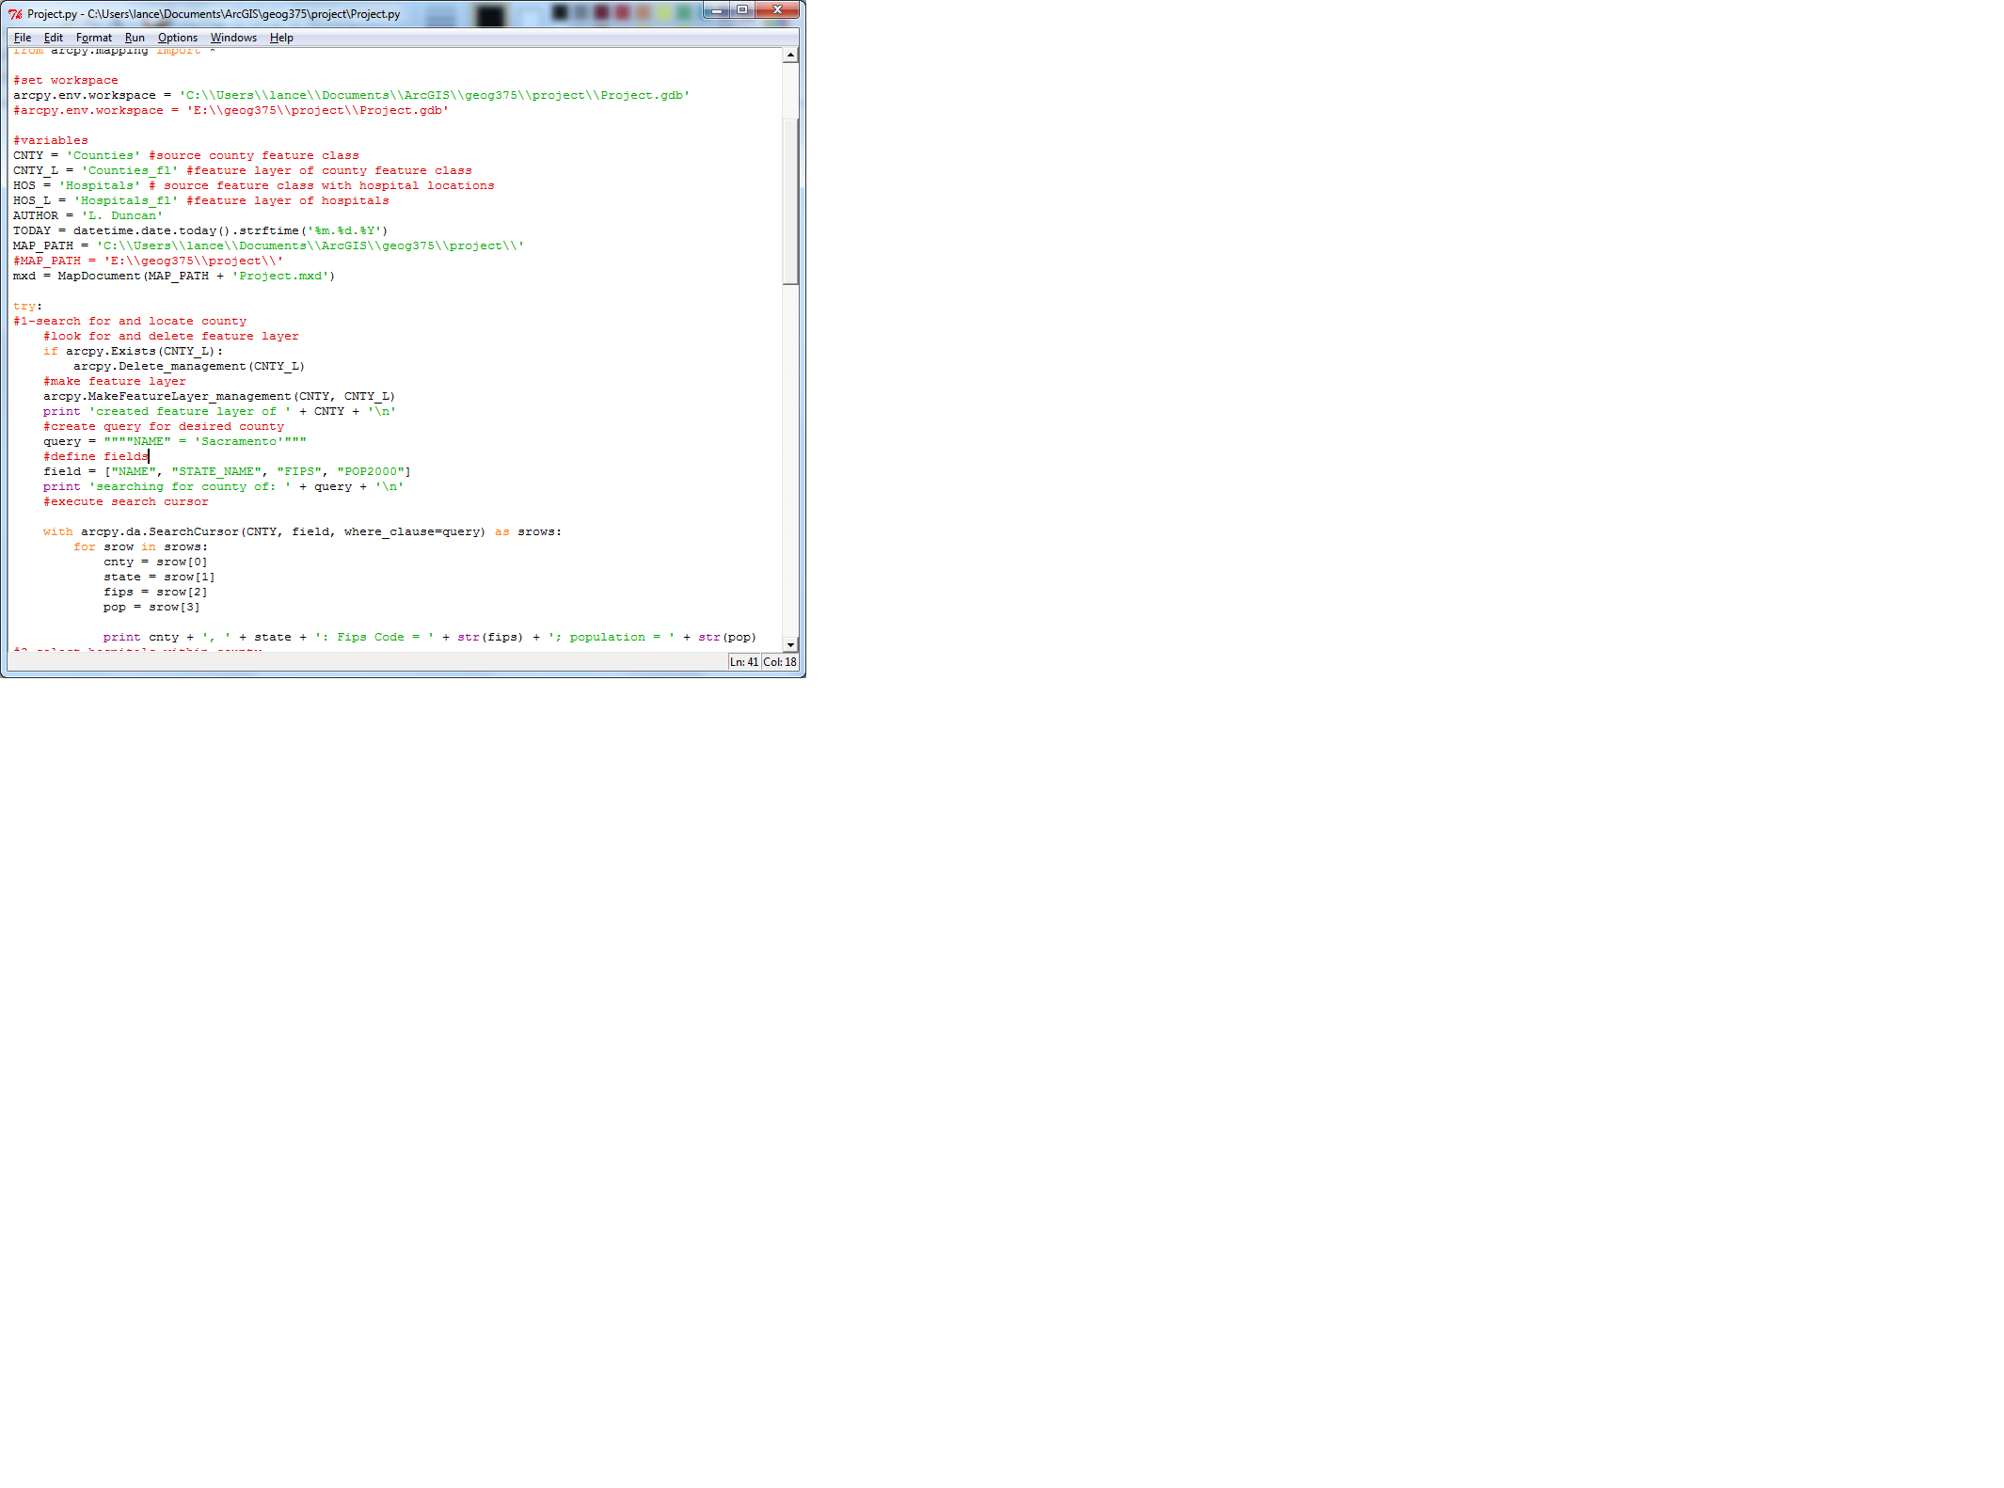
My first objective was to search for a specific county, so to do this I created a search query on a feature class containing counties.

Next, I had to select the hospitals within a certain county. So I used select by attribute followed by a select by location. At first this wasn't working, the select by location would return all the hospitals in the feature class and not just the ones in the county. So as a work around I used select by attribute to select the hospital based on the fips code returned from the search cursor. When I came back to the code a few days later and tried the select by location a second tiem, it worked perfectly, so I scrapped the workaround. Following the selection I performed another search cursor meant to return the names of the selected hospitals. This was based on the fips code, as a result the user would either have to know the fips code of the desired county or run the script up to a point to find the fips code. This complication is not something I desired in the script, and which I was able to work past in myy second attempt.
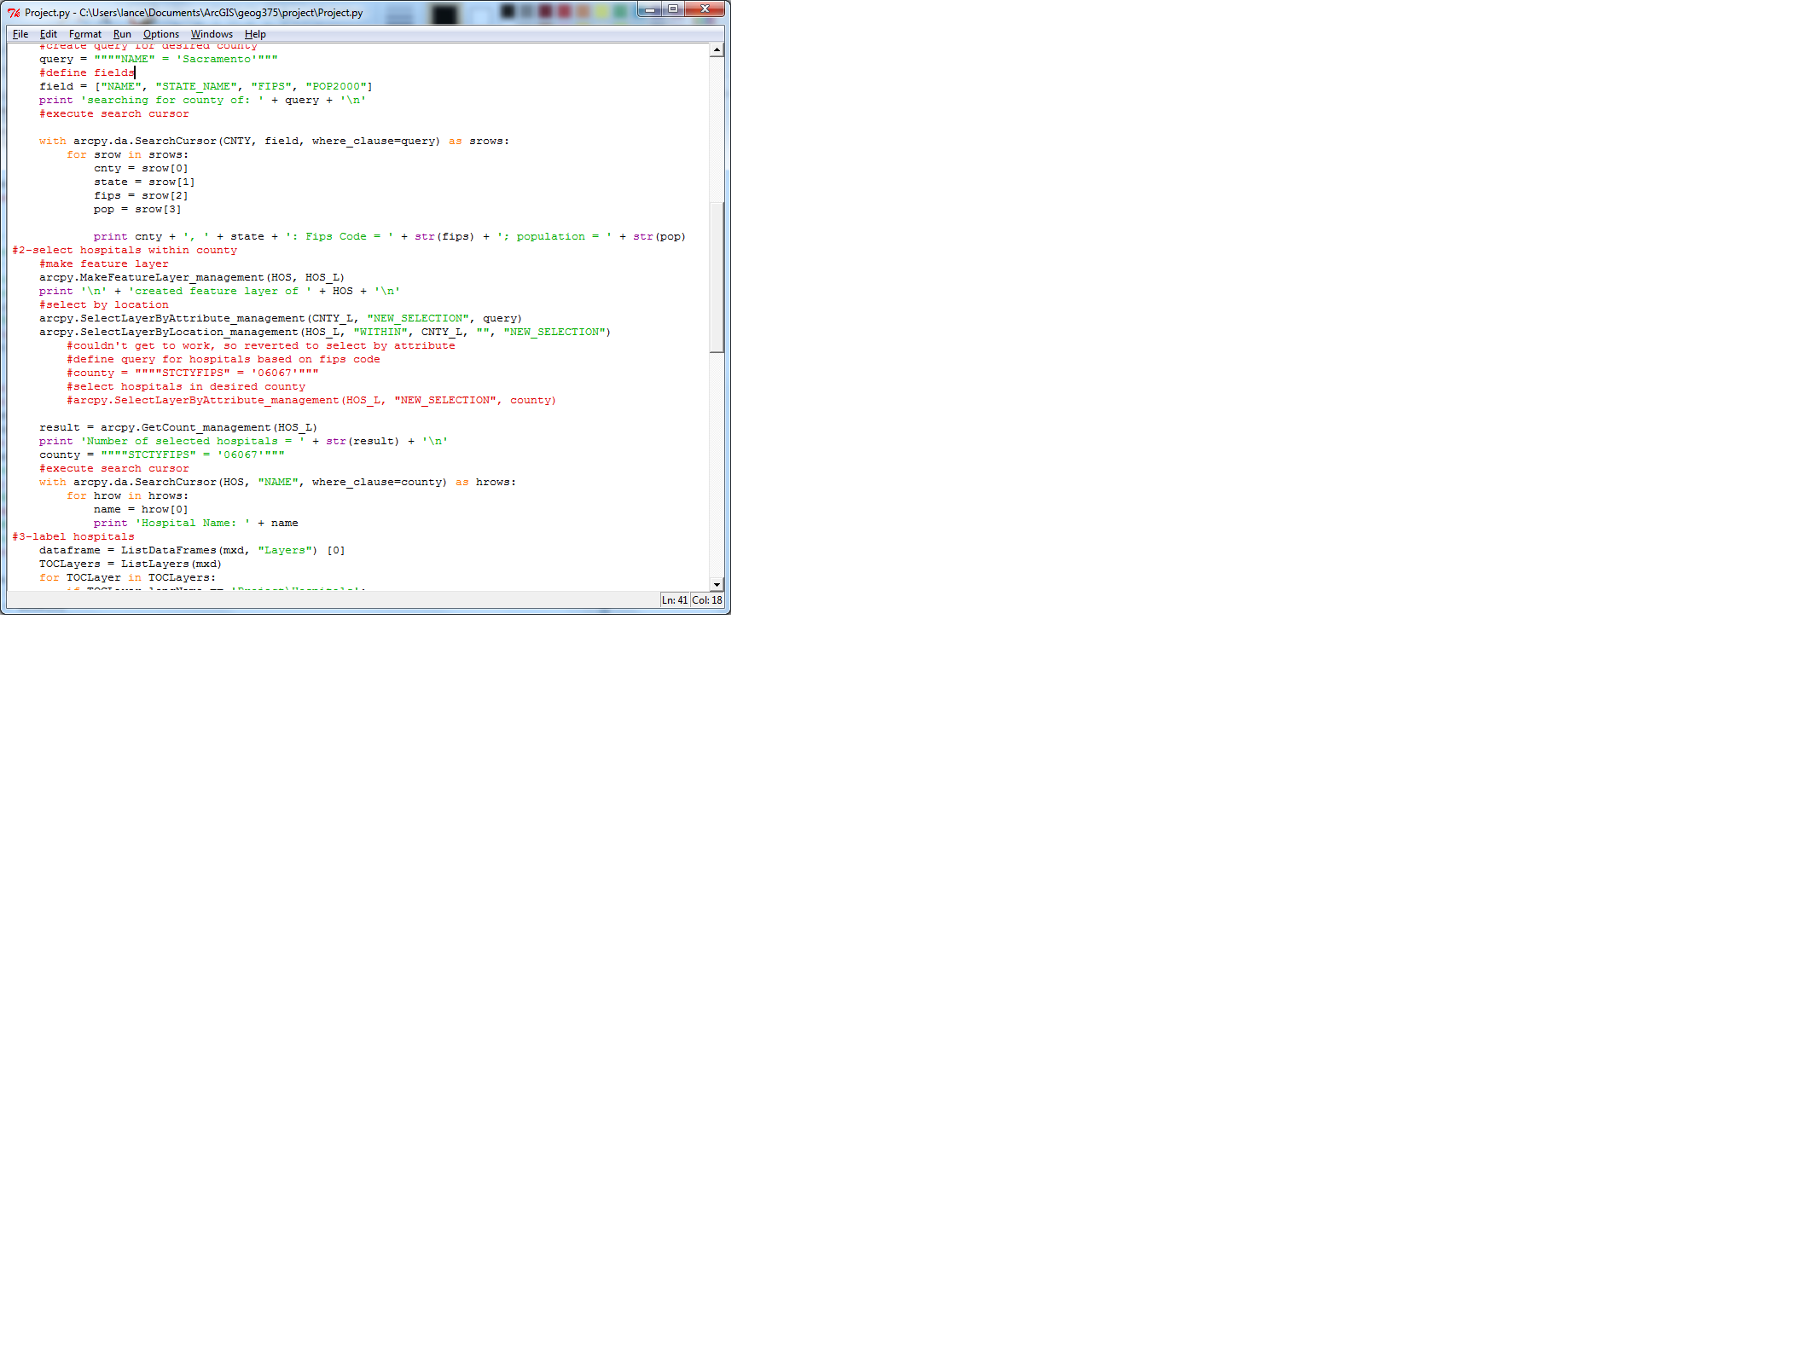

This next step is where I ran into serious problems and decided to try a different approach. I wanted to label the hospitals which were selected, zoom to the selected county, and change some layout elements. I could not get any of these processes to work. Looking at a comparison of my final script and my first attempt, I suspect I could fix it now. It seems that the issues may have arisen form improper indentation and other syntax. What is shown below is the jumbeled mess of the different methods I tried to implement to make the script produce a result. In running it, I would use the # to block certain sections so only the desired element ran, but despite my best efforts I couldn't accomplish any of the tasks.
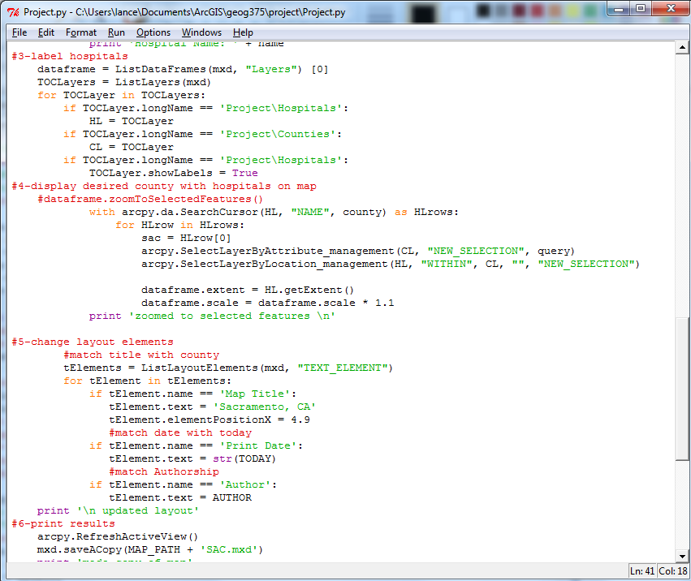

ATTEMPT 2:
After giving up on my original script, I determined that it might be easier to accomplish my goal by using a single feature class to select from. So I decided to perform a join of the counties feature calss and the hospitals feature class. Before I performed the join I thought it might be a good idea to index the feature classes, and this immensely improved the processing time of the join.
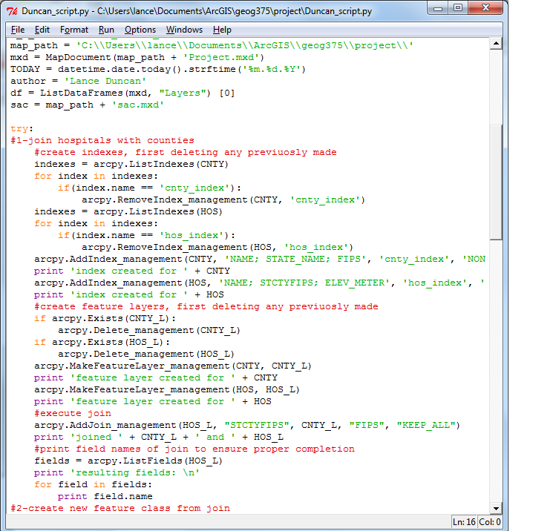
Once the join was complete, I exported the joined features to a new feature class.
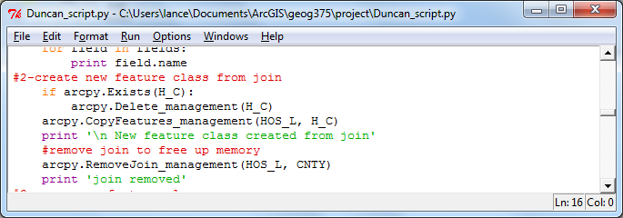
Once the new feature class was created, I made a feature layer for it and used select by attribute to select all the hospitals within a specific county.
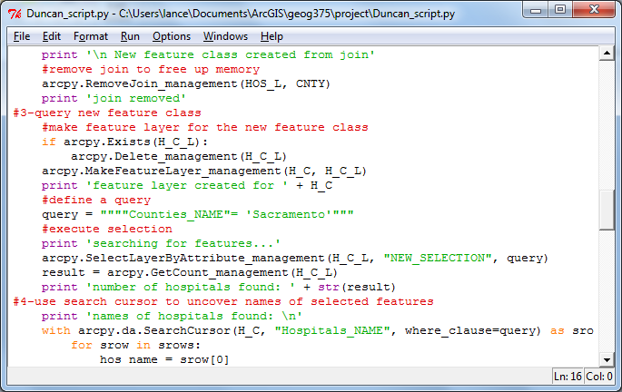
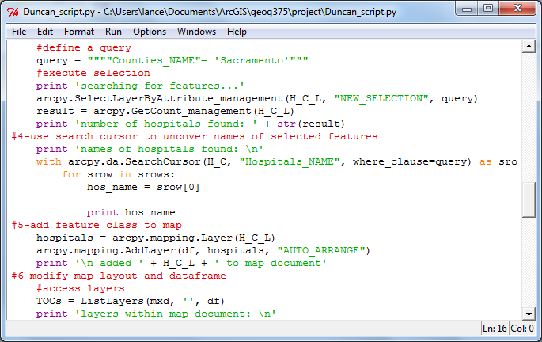
Once the selectin was complete I used a search cursor to list the names of all the selected hospitals. Having a joined feature overcame the previuos problem of needing to know the fips code, the query used for the selection set could also be used in this search cursor.
After a lot of trial and error I discovered I needed to add the joined feature class to the map document because in the process of creating the feature class, any previously constructed feature classes were destroyed and thus removed from the map, so I had to add it back to the map in order to change the map document properties.
Also through research I discovered I had to name the layout elements I wanted to change in the map. Once I had done that; I labeled the hospitals using proper indentation, and zoomed to the selected features, and changed the desired Layout Elements.
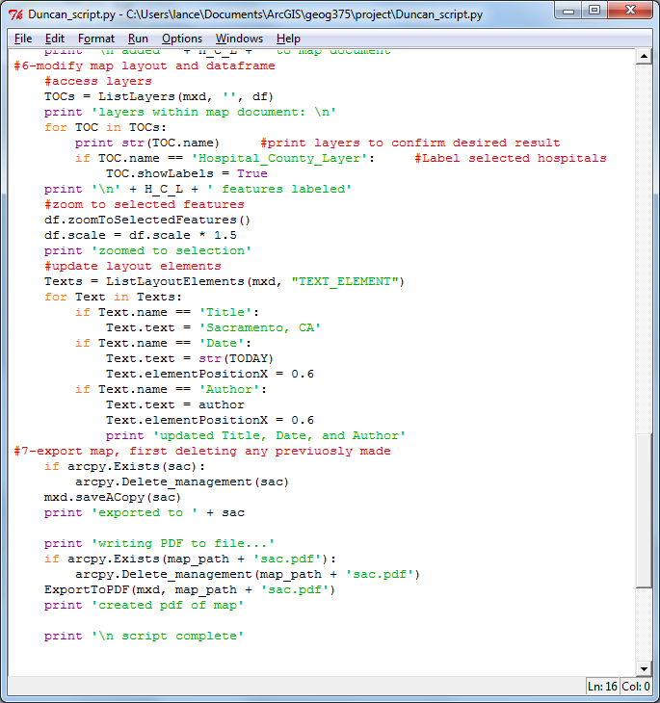
Once all this was completed I saved the changes to a new map document and exported that to a PDF so the resulting map could be viewed by non ArcMap users as well as edited by someone who could use ArcMap.
Conclusions
Working through this project I learned and discovered many things about using python with ArcGIS. An important lesson that can be taken away from this project is that the first or most obvious approach might not be the best approach. My second script shows this, it is much simpler in copncept and more elegant in implementation. I definitely had more direction when developing the second script as one task naturally led to another. There was not nearly as much guesswork involved.
Another lesson can be seen in my dificulties with editing a map document. Despite the fact that I had completed the exercise and written my own version of the demos for chapter nine, I was still not proficient at using the mapping module. There were many simple things that I did not realize the importance of until I grew extremely frustrated. I had to take a step back and give myself time to think about the methods I was using. I also had to reread the entire chapter on the mapping module to really understand what I was doing wrong.
In the end the script works perfectly and writing it was a great learning experience. As I mentioned in the beginning, I had planned on developing a GUI to accompany the script, but ran out of time due to my own procrastination. After reading the chapter on developing the interface with ArcMap, I can clearly envision how I would go about converting the script, I would just need some time to complete it, and now I also question the usefulness of even making a GUI for this script, as it is very specific in what it does. In order to make a useful toolbox script I might have to modify the script to be more general purpose.
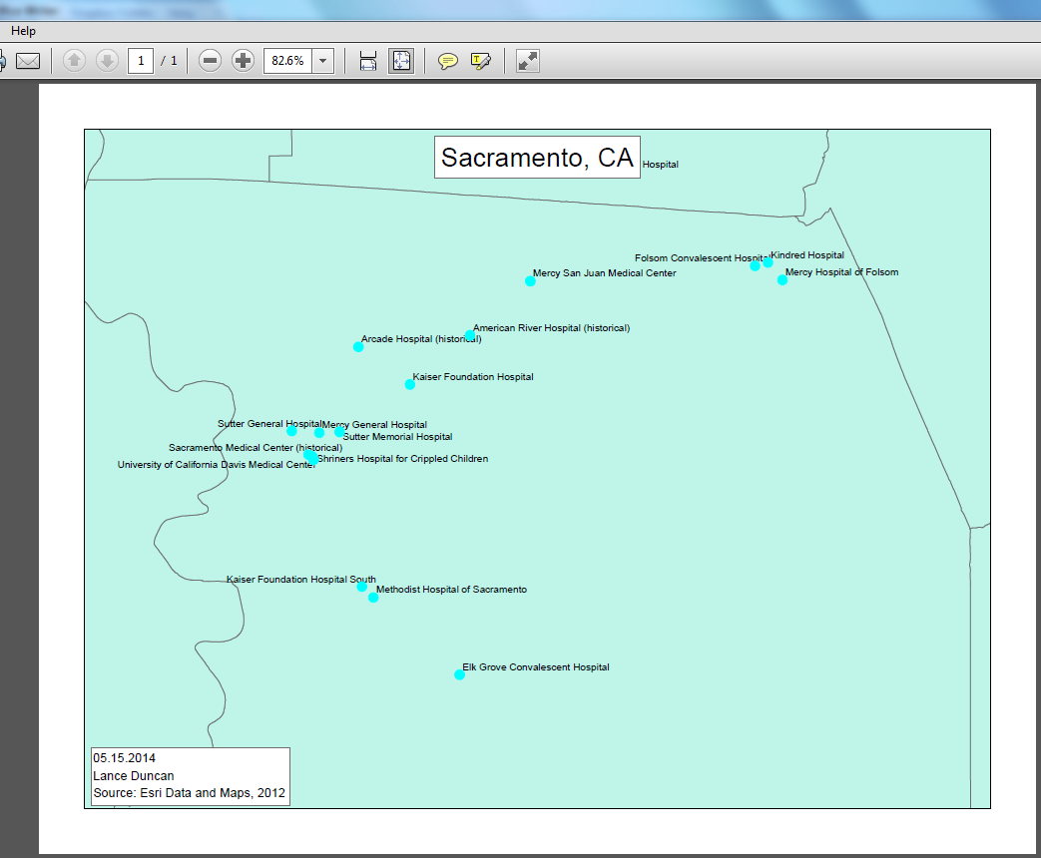
The end results of the script turned out as I desired, not the best cartographic work, but certainly useful. Including a streets feature class may be useful for real world appilcation.

