Andrew Cole
Final Project Report

Project Summary:
My project was to take the geodatabase I created of the ARC campus and create a functional webmap with a room finder search function. The end result is a webmap with the buildings and rooms of the campus with a vector basemap, and a functional room finder that allows the user to enter a room number or name and it will zoom in to the room and put a label with the room ID and room description. The map is presented using Flexbuilder, which extremely limits its functionality; however, it works as a great test and demonstration platform.
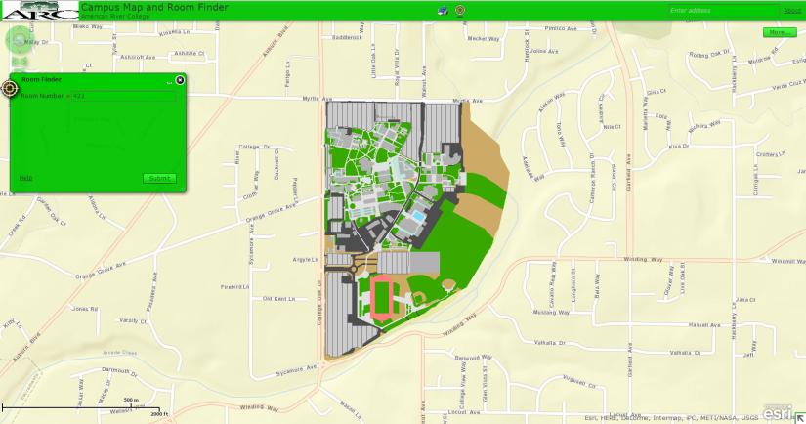

Purpose:
The purpose of the project was to create a functional webmap that would allow students to find classrooms and other student related rooms on campus. I did get the map up on Flexbuilder and included the Room Finder search feature to locate rooms on campus. I wanted to make navigation that would give turn by turn directions to from any two points on campus; however, I never got the Network Analyst work complete, to be able to include that functionality.

Development and Difficulties:
I already had the data; however, I did have to limit the number of layers to those needed for this project. Flexbuilder did not work with the entire campus geodatabase, so I removed as many layers as I could, without impacting the functionality of the map. I also simplified the symbology of the layers, so they would be compatible with Flexviewer. In development of the webpage, I was limited to the functions of Flexbuilder. I did not like the look and function of the Flexbuilder pop-ups for the search function, so I opted to use the ARCmap label function instead. This took some working and multiple attempts, but in the end I liked the finished product much better.
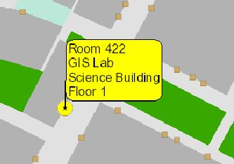
In order to create the Room Finder function, I had to create a model to make it work.
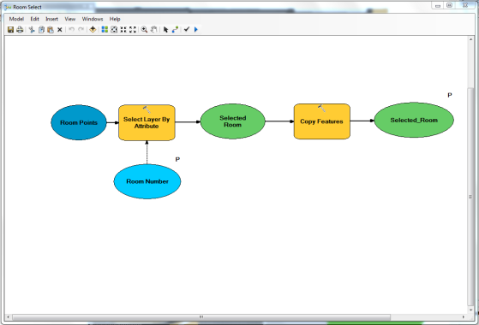
The model is similar to that used in the school search class demonstration. However, I had to “play” with it and its service, to get the styled labels to come through Flexbuilder and be displayed on the web browser. Flexbuilder limits how far the map can be zoomed in on the web, to about 1:2,000 scale, this was a horrible limitation for my map, as the farthest out view is only the ARC campus and it should be able to zoom in all the way to a single room, or about 1:500. This further limited my ability to show restrooms and emergency phones, as at 1:2000, they were either too small of symbols, or they covered more important features, like rooms. I also could not label all rooms, because at the furthest zoom the room labels were over lapping many were unreadable. The furthest out room labels worked was at about 1:600 scale.

Final Product:
In the end, the map does show the campus and its rooms and allows a user to search for the location of a desired room. Additional functionality that could be added would be a building finder, a food service finder, proximity searches for features like restrooms, vending machines, and drinking fountains. The biggest enhancement that could be made would be to increase the maximum zoom the map could be viewed at, which would allow show more feature classes and individual room labels. The biggest thing I learned with this project was the value of Java programming which would have allowed me unlimited customization and viewing options; however, I do not currently have, or plan on ever gaining, the ability to write Java. I am really looking forward to seeing what the new ARCgis web portal suite are going to be able to do; however, they have not even announced a release date, so I won’t hold my breath on that one!

