Juanita Cano
GEOG 375
Spring 2014 – Final Project
jycano@msn.com

Python Script Tool for Revocable Encroachment Permits

PROJECT SUMMARY

The City of Sacramento has a GIS Archiving Interface that is maintained by the Department of Public Works, Engineering Services. This database currently contains only improvement plans but we are working towards including other plans such as Certificates of Compliance, Abandonments, Revocables, as well as other documents and plans useful for staff and the public.

The purpose of this GIS Archiving Interface is for accessibility and convenience. Currently there are thousands of plans and permits from recent years to the 1910’s that have been scanned. The next step is to enter them into GIS so that we have the convenience of searching for them with the click of a button. Permits can be accessed by entering cross streets, addresses, or via an advance search based on the attribute fields. You get a list of projects you can go through or you zoom into an area where the project is located. By clicking on the polygons you can access the information that is attached to that polygon which represents the area where the improvements were done.

Previously we were using a VBA script to update the features created with attributes. This was working fine up until all the computers were updated with ArcGIS 10.1. The tool that had been previously created no longer worked and all newly created features attributes had to be entered manually into the table in order to update.

In order to work more efficiently new Python Script Tools were created. Currently three scripts were developed to replace our previous VBA script used to update the features created with attributes. These scripts are passed values from the Arc Toolbox GUI that takes what is input from the user and then performs an update cursor to update the attribute values on the feature class with pertinent information for that specific feature which is then linked to the original scanned plans.

PURPOSE

The purpose of this project was to create my own Python Scripting tool to update attribute values for our revocable permits. I was assigned to update the feature template for our Revocables in order to start entering them into GIS, but there was no GUI or tool to enter the attribute values unless it was done manually in the table. Revocable Encroachments Permits grant you permission to install an object above, on, or under the right-of-way. Examples include canopies or signs that extend over the sidewalk, privately owned bicycle racks and works of art, bollards, and other objects. The tool used to update the attributes for these features is a VBA script that no longer works with the ArcGIS software 10.1 or beyond and therefore needs to be replaced.

Currently the Python Scripting tools created were only used on polygon feature. The tool I created updates a feature class represented with points, lines, and polygons. The points, lines, and polygons can represent anything from wells to trenches and even buildings. The tool will be used to update and enter information such as keywords, plan number, plan title, and more importantly the image location or image path which will connect to the scanned plans.

The script created can then be used in the future to continue updating any Revocable Permits entered into GIS. Only points are currently used for the Revocable Permits entered by the city but I took on the challenge of adding the option of updating other features such as a line or a polygon if all three were used in future applications as well as a personal learning experience.

PROJECT SETUP, GEOPROCESSING TASKS

Step 1. The first step to updating the Revocable Permits GIS process was to create a new feature dataset that contained a point, line, and polygon feature class. Those feature classes were created with a field for a permit number, approval date, keywords, plan title, image location, and a comment field. In order to symbolize these I added the keywords depending on what it was to represent (Fig. 1); such as a polygon feature representing a bus shelter. 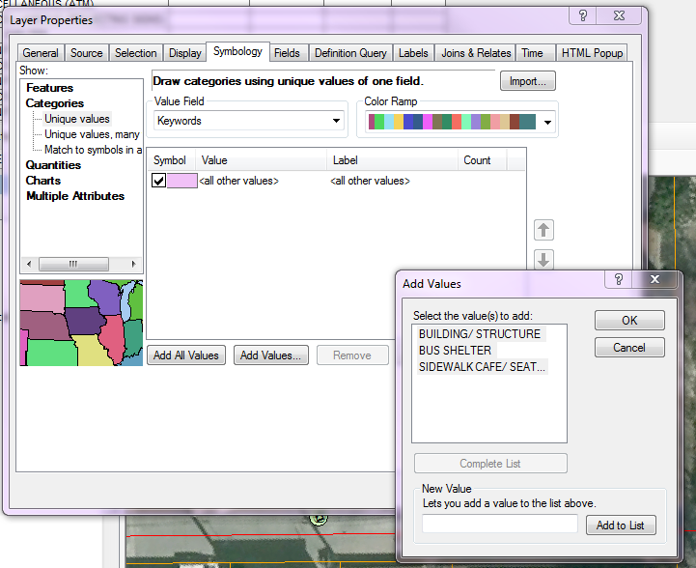
Fig. 1

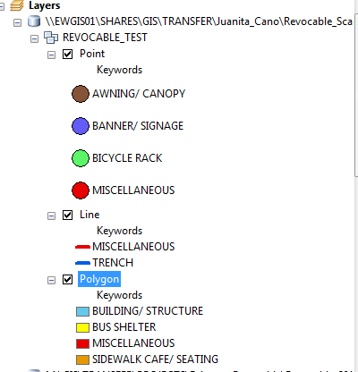
Each of the feature classes was given values based on what was to be represented when adding and updating features which would represent the project or purpose of the permit (Fig. 2).

Step 2. Create a table and save it into a file geodatabse with the keywords to be used to update the feature attributes via the Python Script tool as the features are created.

Step 3. Create the Python Script
for the GUI tool. The original Python Scripts created for other
Fig. 2
permits were used as a reference and modified in order to make the script applicable to the revocable feature class and its attribute fields. The script created begins by listing some except: blocks that contain some print statements that involve the use of some variables needed to update the features as well as some rules in order for the tool to function correctly.
Following this entry the script contains parameter arguments. The script parameter arguments are used so that the parameters can be typed or passed from an application to the script.

Python Script
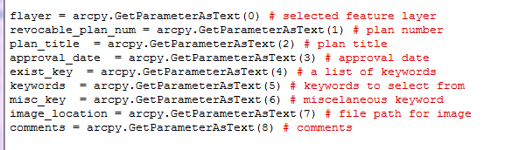

Script Tool Interface
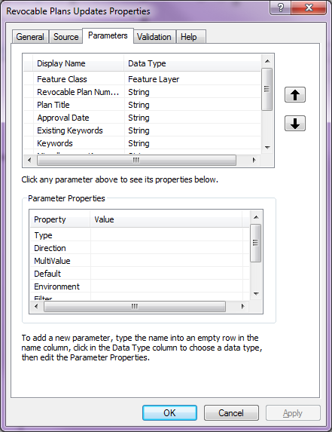
When the tool is executed, the parameter values are sent to the script. The script reads these values and proceeds with its work. The list will update the Revocable features created with the appropriate information.
Several messages are added to the script in order to verify that the Revocable features are being updated as well as verify that fields were not left empty or keywords were left unselected.
Error handling is also an important component of this script. The script is written to expect certain errors and return an error message. The tool then writes an error message or an exception with the use of “classes” exception as detailed at the beginning of the script. The first statement as written below is written so that following code, a raise statement is used when an input feature class has been identified as having no features. This is not strictly an error but a condition that the code can be used to guard against.

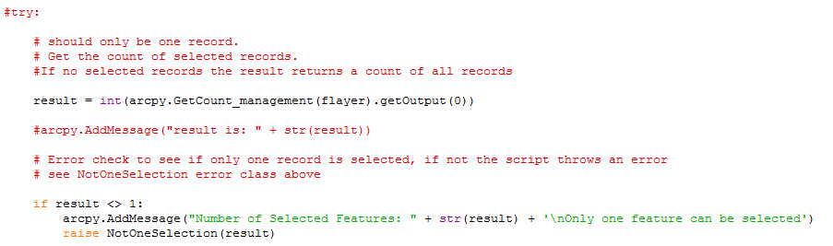

In the following code the except statement is used to trap the error, then fetch a print the error message generated by the script.

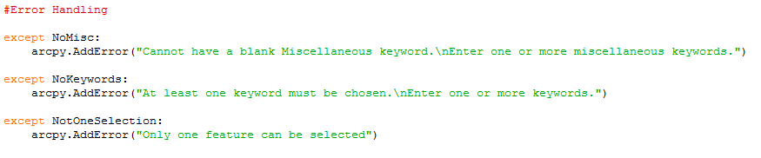

Finally an important component of the script is the updating of the records which occurs every time a new feature is created or edited.

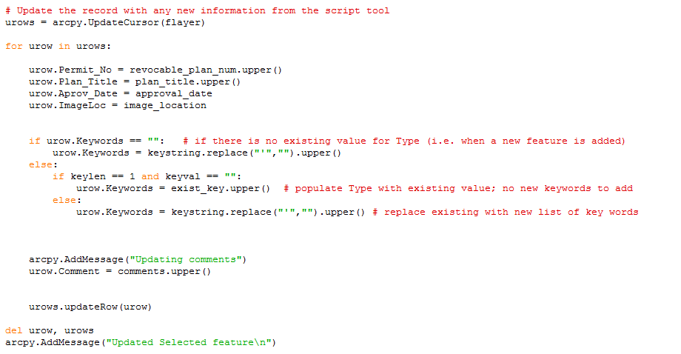

Step. 4 Once the Python Script has been completed a tool can be generated by creating a tool box and then adding the script which brings up a dialog box for the tool properties. Here I assigned the script to the tool. In order to create the script tool interface, I had to enter the Display Names for the field and Data Type and choose the Feature Class from the list. Here is where I allowed the feature class to have a point, line, or polygon.
As previously noted this is where the parameters are listed to match those of the script and in the same order. The keywords parameter is also populated with a list of values that correspond to the keywords in the table. Once all parameters have been entered and parameter properties assigned, the tool interface was saved.
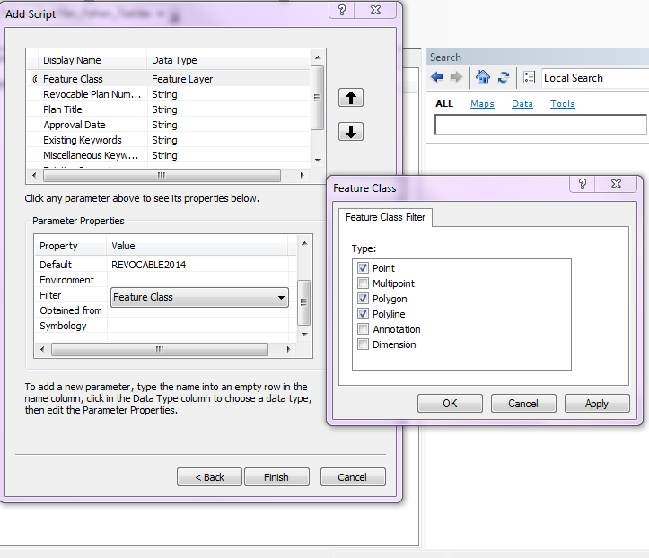
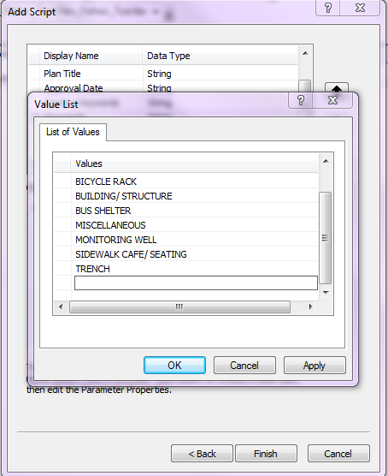

Step 5. Once the Script Tool Interface has been saved it’s opened in Catalog while creating and editing features in ArcMap. One feature is selected and the Script Tool is opened and the attributes entered along with the image file path. This is then saved and a new feature is created and the steps are repeated again and again.

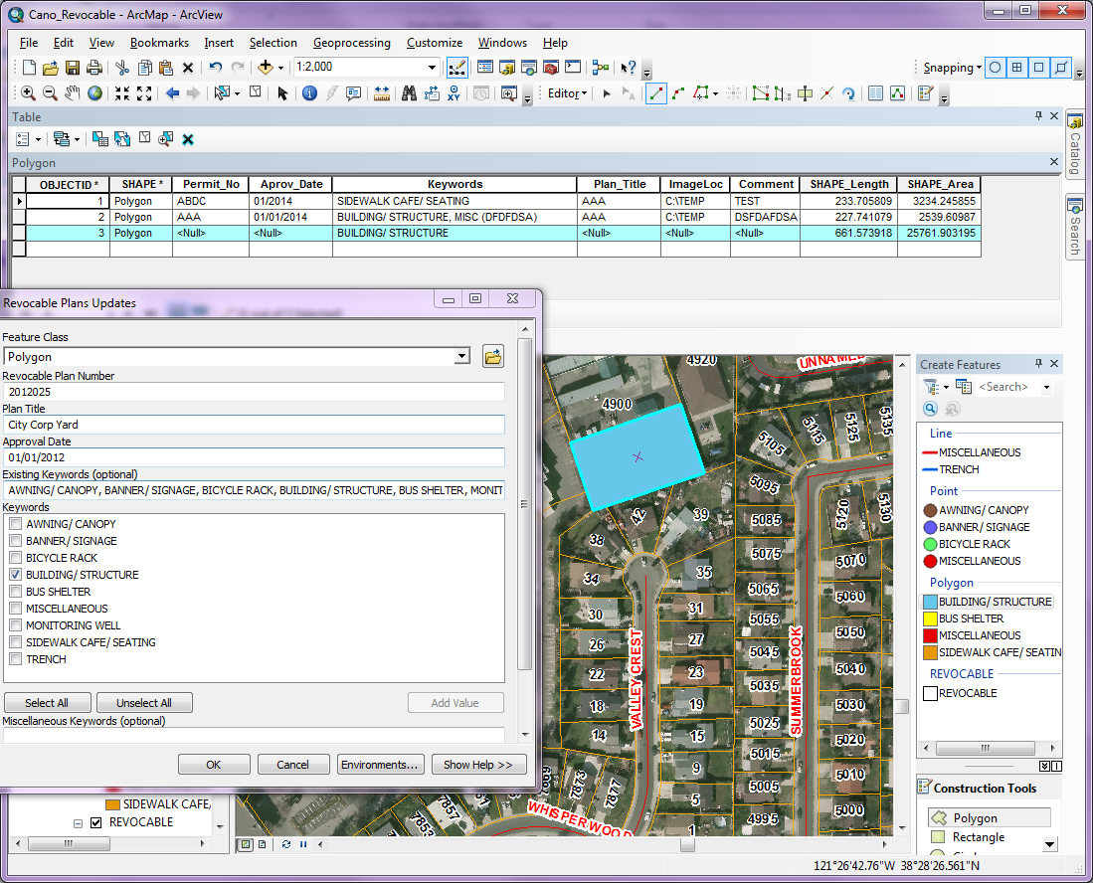

DIFFICULTIES/ISSUES

Some of the difficulties that I encountered were with the modification and editing of the script that had previously been used to update other types of permits. I had to modify and only use components that applied to the Revocable Permits. Most important of all I had to use portions of the script that I clearly understood what the function of that script was for and what it was supposed to do. Other portions were not used because I did not feel it was something that I could explain and were beyond my skill level. The parameters of the script caused issues for me because they have to match the script and the tool exactly. Not realizing that even just an additional letter in a field can cause it not to update that specific field in the table because all three do not match; feature table, script, and script interface parameters. It was a lot of trial and error until I got the script and tool to work together. It was also a lot of research to know what and how the script functioned with the tool because I had a perfectly good template but it was not about coping and pasting it was about knowing what I really needed and how I was going to make it work for my own project.

OUTCOME

I can say that the outcome of my project was successful and that I now feel confident that I can create a basic GUI for other types of functions other than updating a feature with attributes. This was a wonderful learning experience for me because I had been using this type of tool for almost a year and basically had zero knowledge of how this tool ran other than entering the information and pushing a button and vua-lah it magically updated my features. I now have the knowhow and can edit or fix problems that the tool may have in the future. If needs change, keywords are added, or possibly having to add another field. I can now do it myself without having to turn to others to do the work for me. I feel accomplished and confident that this experience has given me skills that I can carry with me.

Juanita Cano
GEOG 375
Spring 2014 – Final Project
jycano@msn.com

Python Script Tool for Revocable Encroachment Permits

EXECUTIVE PROJECT SUMMARY

The City of Sacramento has a GIS Archiving Interface that is maintained by the Department of Public Works, Engineering Services. This database currently contains only improvement plans but we are working towards including other plans such as Certificates of Compliance, Abandonments, Revocables, as well as other documents and plans useful for staff and the public.

Currently three scripts were developed to replace our previous VBA script used to update the features created with attributes. The tool used to update the attributes for these features is a VBA script that no longer worked with the ArcGIS software 10.1 or beyond and therefore needed to be replaced. The Python script tools are used on the feature class to update with pertinent information for that specific feature which is then linked to the original scanned plans.

My project focused on the creation of a Python Script Tool for Revocable Permits which was not updated. The tool updates a feature class represented with points, lines, and polygons. Currently our other scripts only update polygons. The points, lines, and polygons can represent anything from wells to trenches and even buildings. The tools are used to update and enter information such as keywords, plan number, plan title, and more importantly the image location or image path which will connect to the scanned plans.

Revocable Encroachments Permits grant you permission to install an object above, on, or under the right-of-way. Examples include canopies or signs that extend over the sidewalk, privately owned bicycle racks and works of art, bollards, and other objects.

The Script Tool created will then be used in the future to continue updating any Revocable Permits entered into GIS.

