Walker Wieland
GEOG 385
GIS Web Applications: Environmental Justice goes Online, Power to the People
Environmental justice is the concept that there are disadvantaged populations that bear a disproportionate load of environmental pollution. There are many reasons for this, among them being that businesses that pollute are located on cheaper land, and some poorer communities also happen to be located in these areas. Often times, poor people have nowhere else to go, and they are forced to take in the environmental pollution that is created by businesses. Environmental Justice is and will continue to be a hotly contested topic that will involve science, policy, lawsuits, and much more.
With this concept in mind, I wanted to create a web map could theoretically serve as a beta viewer for someone who was interested in this type of data. My goal is for a user to be able to view continuous data across the state as it relates to Environmental Justice, and for this information to be useful. I wanted to be able to include socioeconomic data that has been historically established as information relevant to Environmental Justice concepts. I downloaded socioeconomic data from the US 2010 Census for census tracts across California (about 8000 total). I used the following datasets from the census:
- Percent HS grads
  - The percentage of people reporting from a tract that they graduated high school. This correlates with education and income.
- Percent speaking Spanish
  - The percentage of people speaking Spanish in the household. This data is useful, but it might be more representative of Environmental Justice to show the data on those household who didn’t speak English.
- Percent under 5
  - This represents populations with children under the age of 5, who are more sensitive to certain kinds of environmental pollution, like respiratory diseases.
- Percent vacant houses
  - Houses may be vacant because they have been abandoned or foreclosed. There are correlations between areas with many vacant houses and lower income.
For the above datasets, I joined the data with the geographic boundary of my choice, census tracts. I then symbolized the data into three classes, using quantiles as my classification method. For the census tracts, I set a scale reference so that the tract name (or ID number) would be visible after a certain zoom extent. The data I used to represent environmental pollution was Superfund sites, or the EnviroStor database from The Department of Toxic Substances Control (DTSC). This data represents 5500 locations across the state that document where hazardous materials have been handled, or are currently handled.
In addition, I added a Bing Maps – Road layer so that the user can have some frame of reference to where they are. From here, I wanted to create a geoprocessing tool that would give the user some useful information while they browse the site. So, I created a model that had two steps. The first step was “select by attrtibutes”—this was designed to allow the user to select the census tract they were interested in viewing. An alternative could have been me using a ZIP code as a geographic unit, this might be more useful to a person because most people know what their ZIP code is, and few know their census tract. However, ZIP codes are larger units and would generalize the analysis more. Nate had actually talked about a script that could be written that would provide different “selections” based on the exent and location of the viewer, so that a user could view many different tracts and could select from a dropdown based on their area.
The second step was a “intersect” that followed the Select by Attributes. I intersected the selected census tract with all of the Superfund sites to return the sites that fell within the census tract. This answers the question “what sites are in my census tract?” When this tool runs in ArcMap, the output is a point layer that gives the names of the sites, lat/long, as well as potential contaminants of concern. In addition to these inputs and geoprocessing tasks, I had to create a parameter within the model that was a string datatype with a value list. This value list was pulling from a SQL expression I created in the select by attributes tool. What this does is create a dropdown menu on the website that appears when I click on the geoprocessing task. The fields available on the dropdown menu are tracts that I keyed in. I made this string datatype and the output intersected file both modeled parameters, and added the intersected output to display. From here, I made the tool a layer in my MXD and saved it. In ArcCatalog, I made sure my local server was pointing to my project folder, and that my Schema and Scratch folders were created and data was pointing to the right geodatabases. The tool was ready to be implemented in ArcServer.
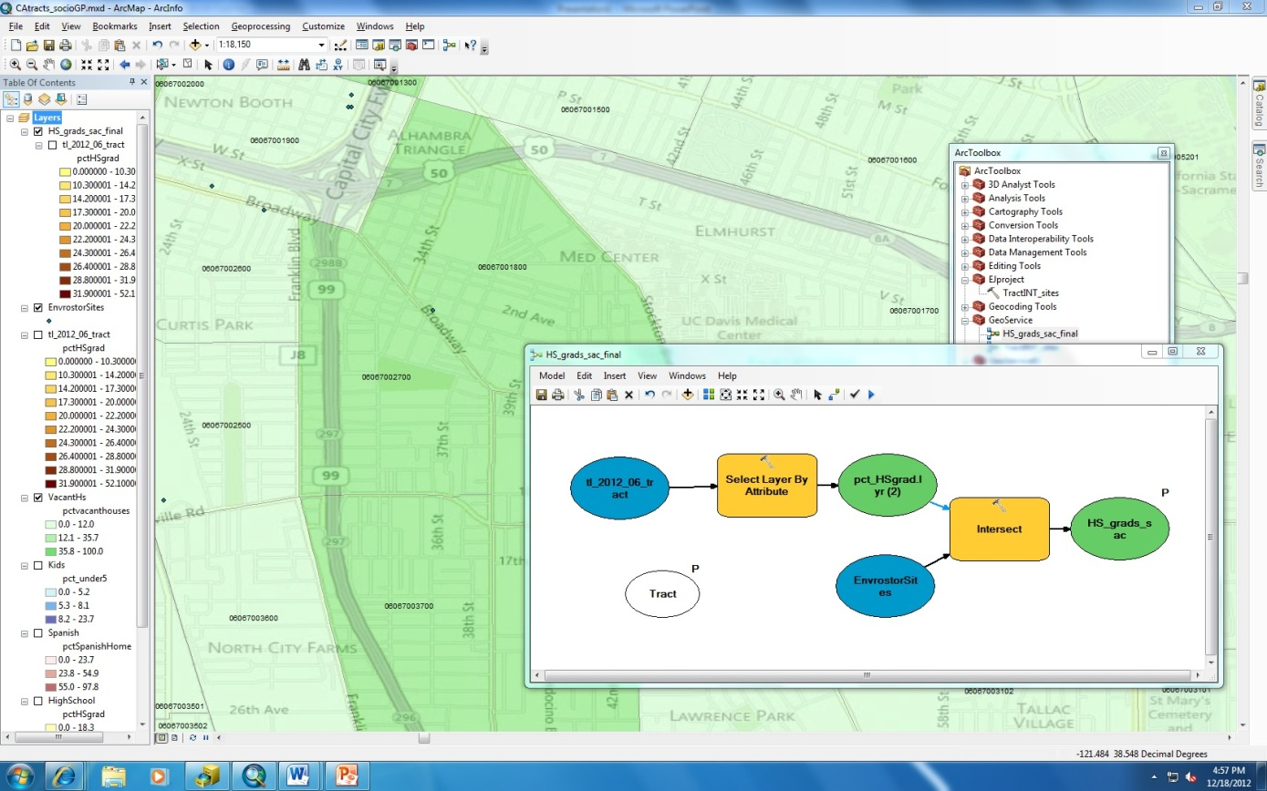
My MXD, Model, and tool in the toolbox and as a tool layer in the table of contents.
In ArcServer, I had to publish my map document as a mapping service, which included my census data, point data, and my basemap. I saved my MXD with a different name and published that as a geoprocessing service. After that, I created a web application to put my map in motion. I added both the mapping services and geoprocessing services to the application, and eventually deployed it, after some minor cosmetic editing to the application, such as title, banner, north arrow, etc.
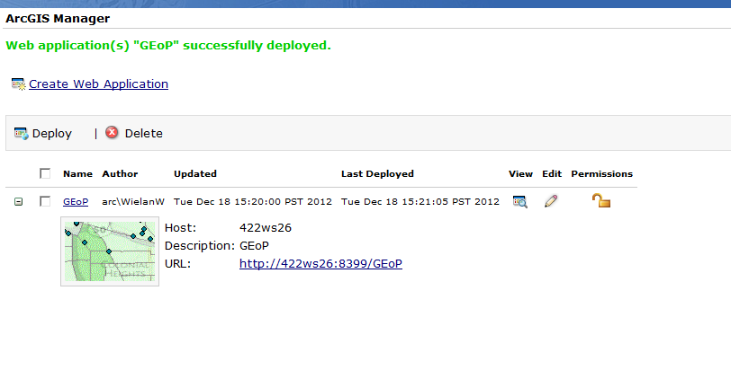
A view of my successful web application deployment.

When the web application is opened, a census data layer shows up with the superfund sites, and when the user zooms in, the tracts are labeled. The tool is called “find your tract”, and a drop-down menu appears where potentially multiple tracts could be selected, but I only had one tract available for selection in my revised model (my original model had more tracts available, but it broke and I re-created the model). When the tract is selected, a button is hit and a tract in Sacramento is first selected, then it is intersected with superfund sites in the area. In this example, it selected one superfund site, located at Cal Expo. A potential advantage of this service is for a user to see sites that are not only close to their tract/house, but also to get additional information from those tracts. An even better use is one that only appears when the service runs in arcmap: a point layer is returned that shows the sites within the tract, giving information on site name, site type, and potential contaminants of concern.
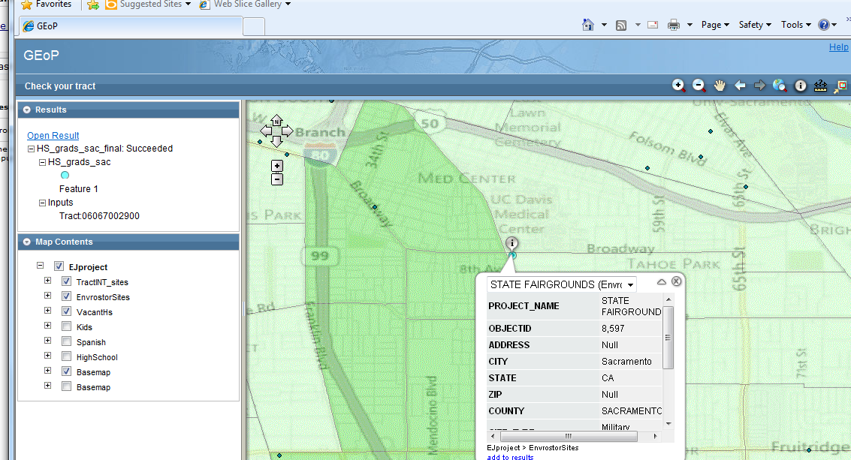
A view of my web application, with the geoprocessing tool run.

Challenges

I encountered many challenges while attempting to build this web application. Some of the challenges occurred because of my lack of familiarity with the software, while some occurred because I did not document every initial setting as well as every subsequent change I made while trying to get the web application to work. In addition, I encountered more challenges because of unforeseen problems with the computer/server, which were quite frustrating! I will highlight some of the main challenges I encountered:

- Geoprocessing tool worked in the web app (said it succeeded), but no output showed up on the display. Not sure why this problem came up.
- Geodatabase became locked for a long period of time, tried many techniques to unlock it. I think I ended up creating a new folder and copying all the data into there.
- Tool was not working when I published it from ArcCatalog, tool did end up working when I created a tool layer in the MXD and then saved a copy, then created a map service and geoprocessing service from the two different MXDs.
- Accidentally crashed the SOC, not sure how this happened.
- Ended up going to a different computer and re-building the tool, but since all settings were the same, I think the server on my PC may have been getting too jumbled.
- Was incorrectly referencing my initial data input as a layer file, when in fact my shapefile was the one in the MXD. It was difficult to tell the difference between the two because I had originally made additional layer files from the original shapefile, and they appeared as duplicates.
- Constantly scoured through the GIS server log error file to try to determine what the geoprocessing error was.
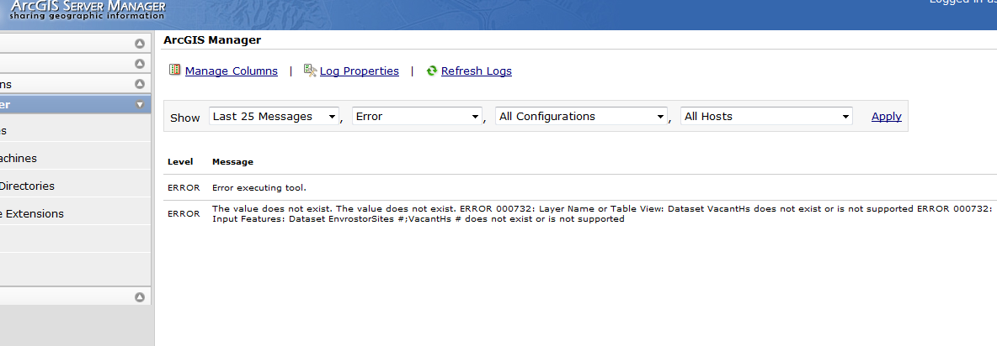
An example of my error log file (there were many errors…this is just one error from the new computer I was on)

In conclusion, this proved to be a very challenging, yet satisfying project. For the future, I would like this map to have a drop-down menu that changed census tract based on zoom level and area of map viewer. Also, perhaps an interactive selection method may be good for this so that the user can just click on their census tract instead of having to memorize the tract number. I would also like to include solid and hazardous waste sites on this map, that would provide more good information to people.

In terms of what I’m taking away from the class, it is overwhelmingly that ArcServer is not a complement to the other ArcDesktop products and it is a standalone product that requires quite a bit of attention and training. I found that I should have done a better job at documenting every single change I make when doing something like this, because, unlike arcmap, I don’t have most concepts memorized in arcserver. I think that this will help me more efficiently produce a better map next time I create one.

