Citrus Heights Street Hazard Online Data Collector:
An ArcGIS Online Application
TedSmith
December 17, 2013
A Project for
American River College GEOG 385
Nate Jennings, Instructor

ABSTRACT
The Citrus Heights Street Hazard Data Collector is intended to demonstrate competencies in developing an online map service that collects information about street and sidewalk-related hazards. Initial efforts focused on developing the application for ArcGIS Flex Viewer. However, time limitations (needing to be on campus to gain server access) coupled with technical issues necessitated a shift to using ArcGIS Online. The latter approach eliminated the need to develop a suitable base map but encountered ArcGIS Online limitations and did not entirely succeed. While it appears that the map application can be edited online, for some reason, it is not displaying in Collector for ArcGIS. As of the afternoon of the final day of class, that issue still needs to be resolved.
The Objective
The project was to create an online service that would allow residents of Citrus Heights to report potholes, broken sidewalks, and property complaints to the city. Data to be collected include the type of hazard (i.e., pothole, sidewalk tripping hazard, missing manhole cover), size, and location of the hazard. Ideally, I wanted to allow users to submit a cell phone photo and extract GIS data (if contained in the file) but recognized these tasks might be too complex for this exercise. Most options (i.e., dimensions) would use pull-down lists (i.e., less than 6 inches, 6 inches to 2 feet, more than 2 feet).
Focusing on using ArcGIS for Flex required developing a suitable base map. I downloaded the following shape files from Sacramento County GIS Data Library (http://www.sacgis.org/GISDataPub/Pages/default.aspx ):
- Cities (city boundaries)
- Parcels Without Owners
- Sacramento County boundary
- Streams and Rivers
- Street Centerlines
I also downloaded one shape file from Cal-Atlas (https://projects.atlas.ca.gov/frs/?group_id=41&release_id=404 )
- County Boundaries 2009
Next, in ArcGIS. I loaded city and county boundaries, added street centerlines, streams, and parcels without owners. Because the area of interest is Citrus Heights, I considered clipping the street centerline file to 1000 feet around the city, but decided to skip that step at first because I did not want to cause problems with the geocoding service. As a later step, I planned to try clipping the data to see whether response times improved.
I created an Address Locator from the CENTERLINES layer using the style US Address – Dual Ranges. I set the From and To Left and Right entries to their corresponding “EXHAUST” values.
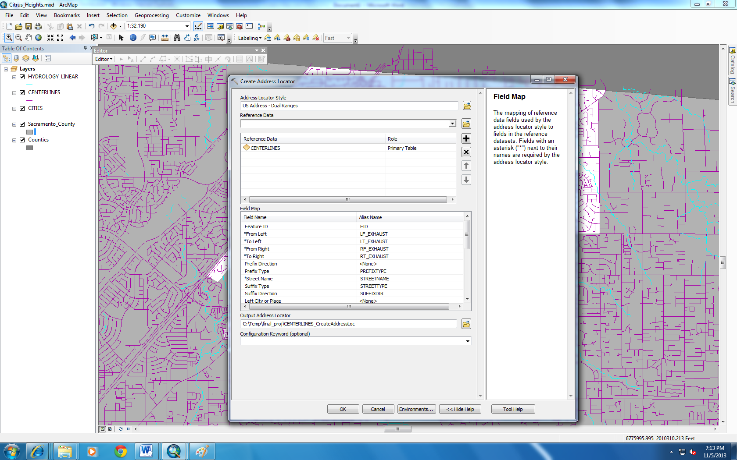
Using ArcCatalog, I next published the shared address locator as a geocoding service in the root folder of the server, naming it Find_Address. ArcGIS Server Manager indicated that the address of the service is http://422ws11:6080/arcgis/rest/services/find_address/GeocodeServer , so I pasted that into the configuration of the locator widget.
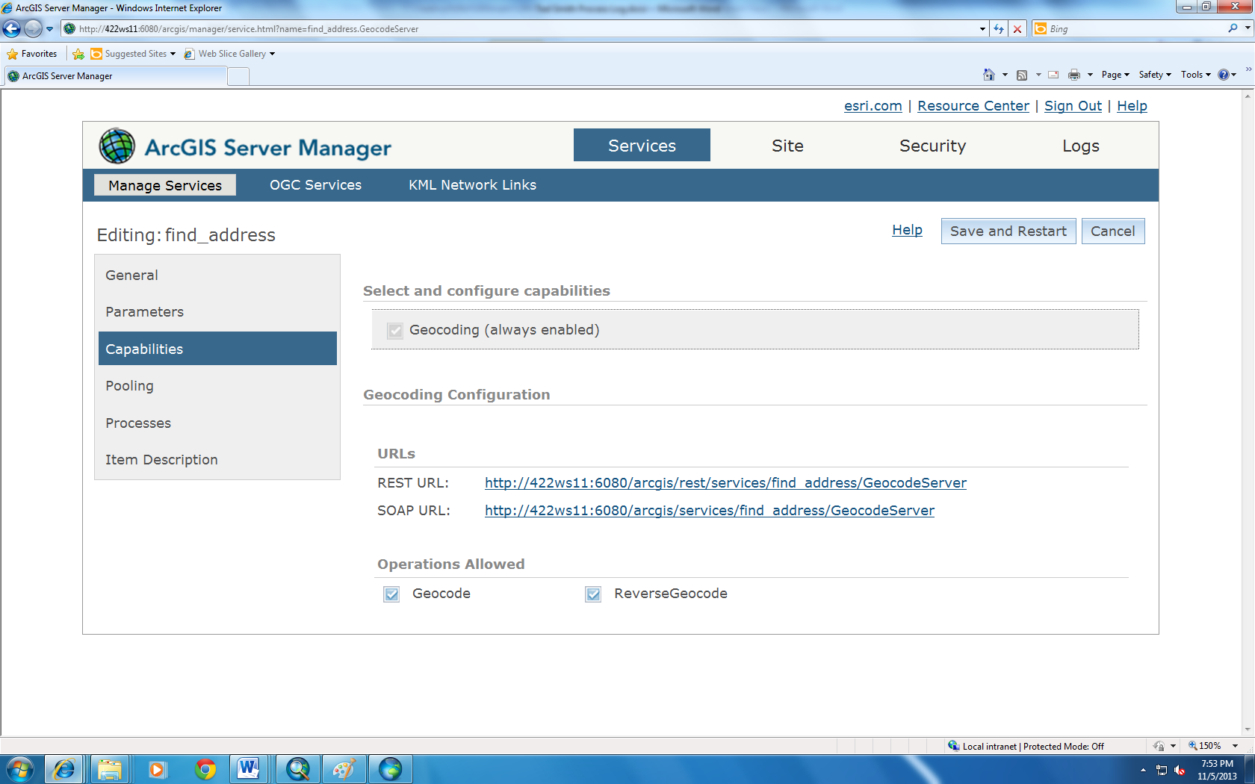
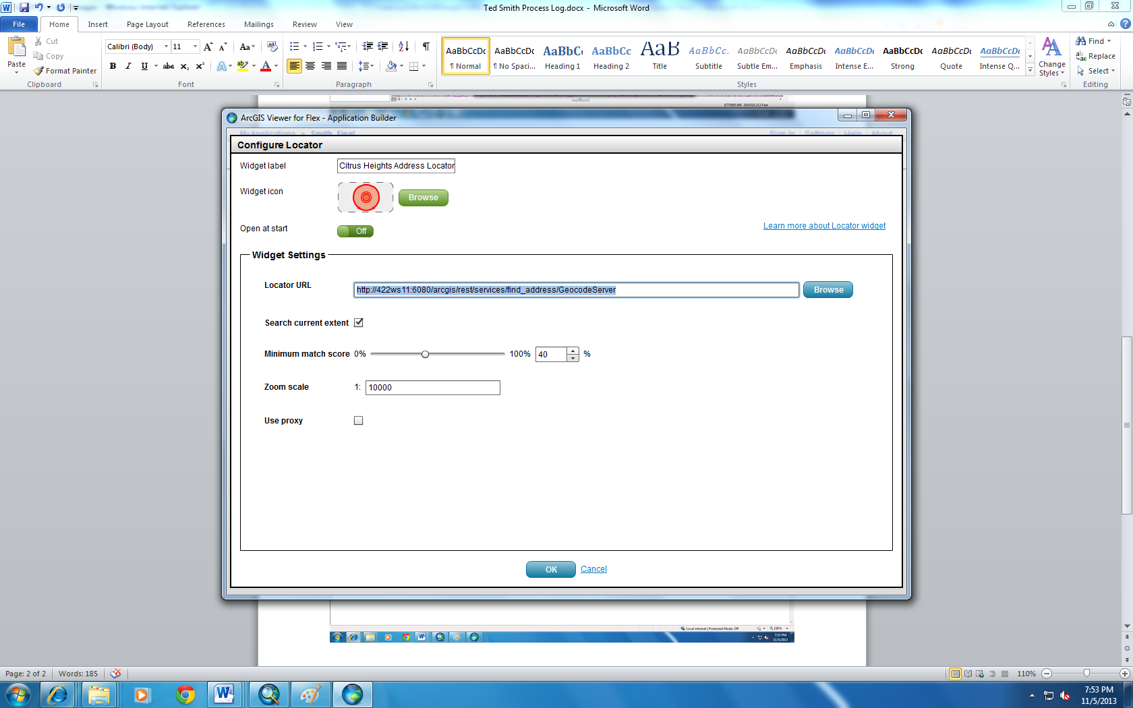
I next edited the base map, setting zoom levels for the various layers and labels. One trick I used was to use the Centerline file twice in the base map, setting centerlines to display when zoomed out beyond 1:12,001 and disappear when zoomed closer when parcels display. The second copy is set to display only street names (including prefixes and suffixes) when zoomed closer than 1:12,000 (the centerlines use no color). This approach allowed the street names to display when parcels were displayed.
View at 1:1,000,000 scale:
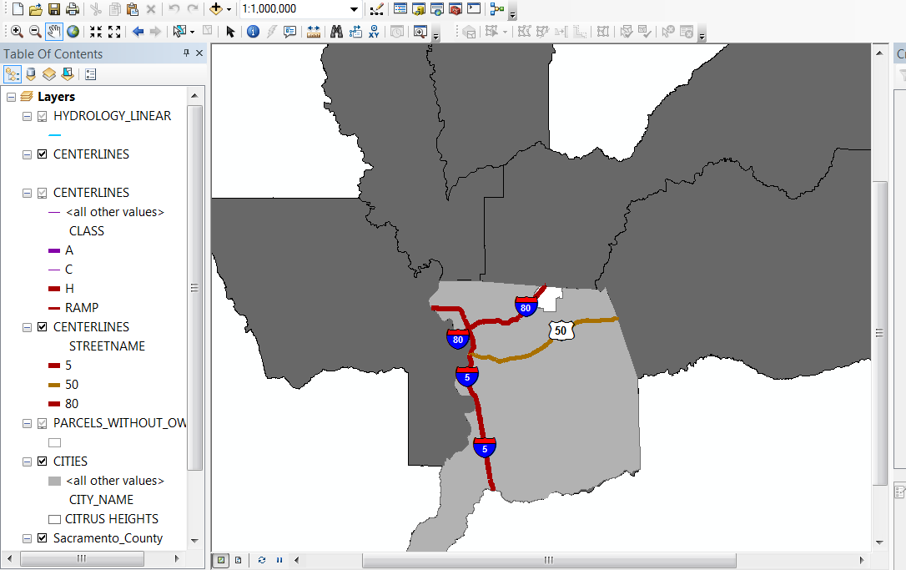
View at 1:100,000 scale:
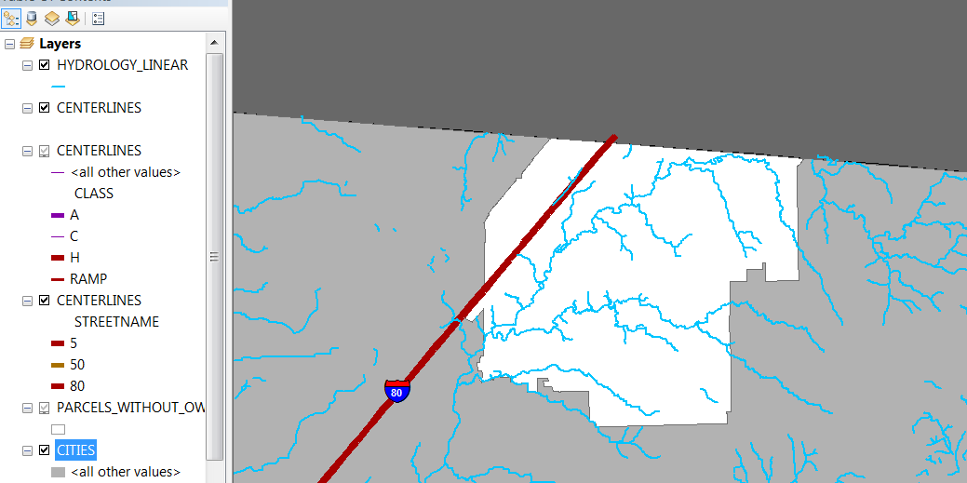
View at 1:24,000 scale:
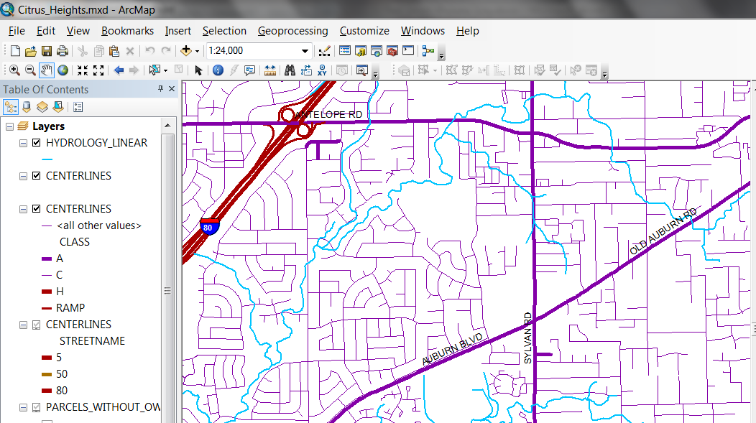
View at 1:10,000 scale:
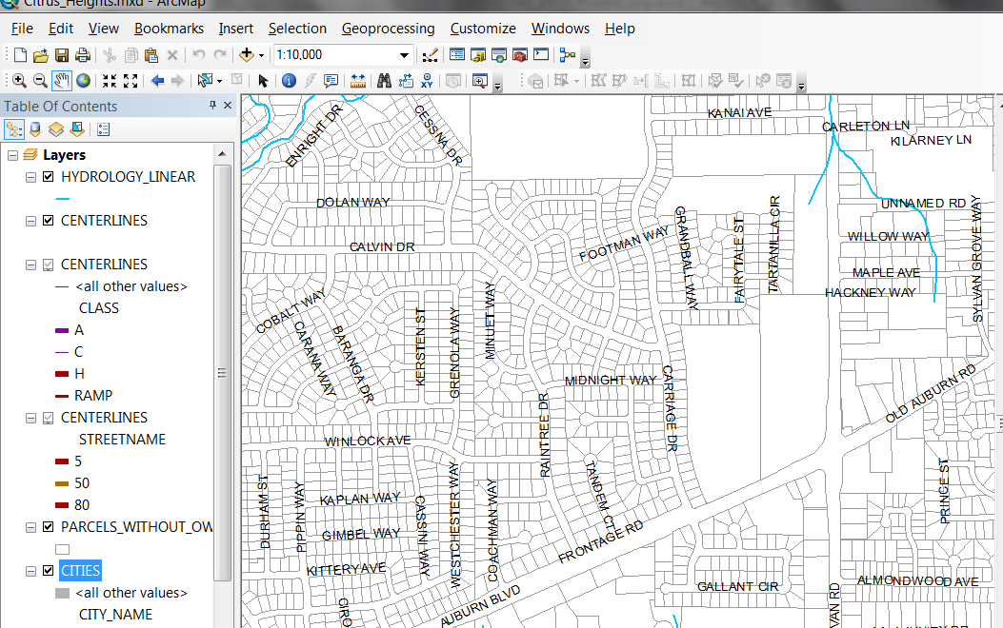
I shared the base map as a map service ( CH_Pothole_Reporter ). Next, I started ArcGIS Viewer for Flex, selected my map service (Smith_Final) and edited the application. I clicked on Basemaps, the ArcGIS Server tab, and browsed to my CH_Pothole_Reporter base map, and clicked Include. I clicked on Preview and was able to view the base map and test the locator widget. I also checked this in the web browser (accessed through Flex).
I needed to create a database to store the data that will be collected. At first, I tried creating linked tables in Access. However. I was unable to export them to DBF. After reviewing the lecture notes, I decided that the correct approach was to create a new geodatabase (California State Plane zone 2, NAD 83, feet) and layer.
However, at this point my frustrations really began. First, the content failed to publish to the Flex server. Working with Geoff, we finally got it to publish, but then I discovered that there was no way to transfer the locator service coordinates to the feature editing widget. Thus, it appears that someone could use the locator but then would manually have to add the point to the map along with all other needed data. I also discovered that my data collection layer was the wrong approach, that I needed to create the collector links and populate the pull-down lists after publishing the service and map layers. At this point, I ran out of time in class.
With about two weeks left in the course, I decided to try developing the application in ArcGIS Online. I found Mann (2013) to be a valuable resource that describes the steps needed to create the application. First, I created a new folder (CollectorProjects) and, using ArcCatalog, a new geodatabase. Because I would be using an ArcGIS Online base map, I used WGS 1984 Web Mercator (auxiliary sphere) as the coordinate system. In that geodatabase, I created a point feature class (StreetHazards) with five fields:
Field Name | Data Type | Coded Value Domain | Allow Null Values
OBJECTID | Object ID |  | No
SHAPE | Geometry |  | Yes
HazardType | Long |  | Yes
HazardSize | Long | HazDimension | Yes
Surface | Long | SurfaceType | Yes
.
I next created domains and subtypes in ArcCatalog, setting the default values:
HazardType
- Broken pavement
  - HazDimension (default value 4)
  - SurfaceType (1)
- Broken sidewalk
  - HazDimension (3)
  - SurfaceType (2)
- Missing manhole cover
  - HazDimension (3)
  - SurfaceType (4)
- Missing storm drain cover
  - HazDimension (2)
  - SurfaceType (4)
- Pothole
  - HazDimension (3)
  - SurfaceType (1)
- Sidewalk tripping hazard
  - HazDimension (2)
  - SurfaceType (2)
Hazard Dimension
Coded Value | Description
1 | 0 to 6 inches
2 | 6 inches to 2 feet
3 | 2 to 4 feet
4 | More than 4 feet

Surface Type
Coded Value | Description
1 | Asphalt
2 | Concrete
3 | Packed earth
4 | Other (metal, etc.)

Next I attached the StreetHazards feature class to a blank map in ArcMap, logged into ArcGIS Online, and published the service. I opened My Content tab in ArcGIS Online and verified that the service was published. I clicked on the Map tab and added a new map, then added the service to that map.
The first thing that I noticed was that I only saw the worldwide base map. Although I searched for help in setting the extent of the initial display, the process described in the help file at http://www.esri.com/esri-news/arcuser/fall-2013/control-the-map-extent-in-arcgis-online pointed to buttons that I could not locate. The other issue was that I had no base information of my own on the map (the assignment required at least three layers).
I decided to add a city boundary to the application. I extracted the Citrus Heights boundary from the cities layer that Nate Jennings had provided to the class. I transformed the layer to the required Web Mercator projection and attempted to add it to the map. I quickly discovered that I needed to zip the layer files to add them to the map. Next, I attempted to add a layer that contains parcel information. After transforming coordinated and trimming the map to Citrus Heights, I zipped the files and attempted to add them to the map. The process failed because the file contained more than 1,000 features, an ArcGIS Online limit.
Although I now had the map and service sitting in ArcGIS Online, I wanted to use Collector for ArcGIS to collect data using my cell phone. I attempted to download the app from Google Play and discovered it required the Ice Cream Sandwich 4.0 operating system. After locating and updating the operating system (available as of October 2013), I downloaded Collector, logged in, and only saw 23 available maps; I other words, the map I added was not displayed in collector. I made the map available to the GEO 385 Group, but it still would not display. I tried removing Collector form my phone and reinstalling it, but I still could not see the map. I could see the other maps and edit features on them, though.
At this point, I decided to try adding data manually to the file. Using Chrome, I added some points. The default legend contained small color-coded circle symbols that I attempted to change. However, when I attempted to save the changes, the operation failed. I noticed that if I tried to share or unshare the map with the group, those operations tended to fail, too. So, I tried MS Explorer, which told me that I had to download Silverlight. When trying to download Silverlight, the OS said it already was installed. So, I next tried Firefox. That seemed to work, and everything seemed to save. However, I still could not see the map in Collector for ArcGIS.
I was able to add features through the web browser. I also added a dashboard gadget that summed the number of selected features. Ideally I wanted it to give counts of each type of feature but could not discover how to make it do that.
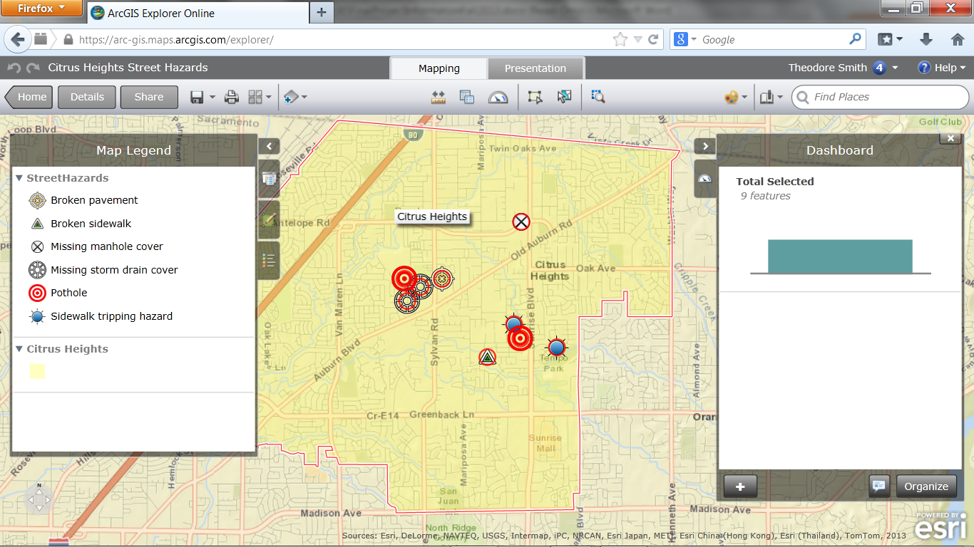
I noticed that it was easy to add the features, but the attribute pop-up lists never appeared. I discovered that I could change the attributes by editing each feature after it was created. The attributes for each feature are visible in pop-up boxes when editing one feature or in the Service Details (an XML file that lacks X,Y data). I have not yet discovered how to export the data.
Sample XML Data for One Feature:
ID: 1
Name: Broken pavement
Domains:
Field Name: HazardSize
Coded Values:[1: Less than six inches], [2: Six inches to two feet], [3: Two to six feet], More
Field Name: Surface
Coded Values:[1: Asphalt], [2: Concrete], [3: Packed Earth], More
Templates:
Name: Broken pavement
Description:
Drawing Tool: esriFeatureEditToolPoint
Prototype:
Attributes:
Surface: 1
HazardType: 1
HazardSize: 4

In conclusion, were I to approach this project again, I would skip trying to use Flex and head directly for ArcGIS Online. However, I still have some questions that require additional research:
- Can users might select a different base map rather than the one the author selects?
- Can users edit the symbology?
- How can one export the collected data?

Web Link to Map: https://arc-gis.maps.arcgis.com/explorer/?open=e38271c25891422a9efe048adddd0ed0

https://arc-gis.maps.arcgis.com/explorer/?open=e38271c25891422a9efe048adddd0ed0

Reference
Mann, K. (2013, Summer). Create your own collector map. ArcUser, 16(3), 48-50.

