GEOG 342 Remote Sensing
Final Project – Kim Mauch

Use of Satellite Imagery Data to Identify Isolated Depressional Wetlands

GOAL OR PURPOSE OF PROJECT
The goal of this project is to replicate and apply the processes used in a remote sensing academic paper in order to identify isolated depressional wetlands (IDW) within the Nevada Greater Sage-Grouse Project area. Depressional wetlands are critical to female and brood survival, and are also critical for other desert species.
A scientific paper entitled Satellite Remote Sensing of Isolated Wetlands Using Object-Oriented Classification of Landsat-7 Data,written by Frohn et. al¹ was reviewed for its potential application to identify isolated wetlands in the arid environment of the Great Basin region of Nevada. A habitat suitability model is being constructed and the availability and use of small depressional wetlands has been identified by project scientists as an important element in determining habitat suitability across the sagebrush habitat of Nevada.

DETERMINING PROJECT PARAMETERS
In order to replicate the procedures described in the paper, multispectral satellite imagery with a 15-meter panchromatic band was required. Landsat-7 imagery was not available for the season required (spring, early summer), so Landsat-8 imagery data was acquired. Earlier versions of satellite data (Landsat 4 or 5) do not have the 15 meter panchromatic band, and so cannot be used .
A known spring that Greater Sage-Grouse utilize was located and used as the area for study. The spring is known as Oreana Springs in Douglas County, east of Gardnerville, Nevada.
The other project parameter is the use of Feature Analyst (FA) instead of eCognition, due to the fact that the USGS Dixon Field Station had already acquired 5 licenses of FA for the Greater Sage-Grouse project. It was decided that FA would first be utilized, and if deemed not sufficient, eCognition could be used instead.
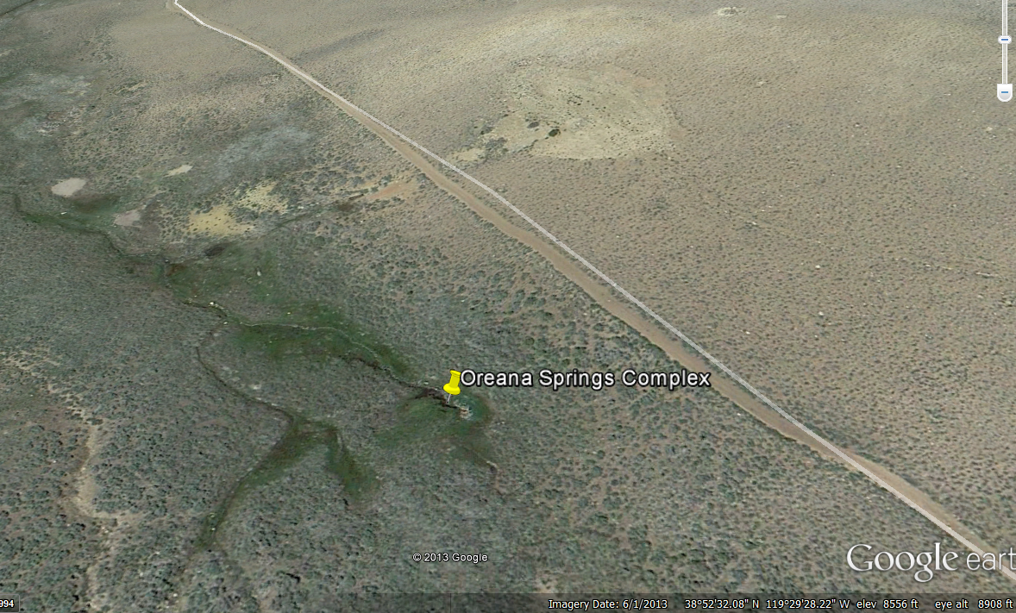
The project study area, Oreana Springs Nevada.

METHODOLOGY
The Frohn and the other authors of the paper define a geographically isolated depressional wetland (IDW) as “wetlands that are completely surrounded by uplands, with no apparent connections to perennial surface waters” (Frohn, et al). This description perfectly describes the characteristic of the Great Basin region’s depressional wetlands, as there are few streams in this arid environment. The range in size of IDW in Nevada is unknown, and it is another goal of this endeavor to be able to gather area data.
Another key characteristic of IDW is that the boundary between wetland and the surrounding upland area is distinct, thus making it an ideal candidate for indentifying via remote sensing data and interpretation techniques.
Bands 2 though 8 of the Landsat-8 imagery were used for this project. Band 1 is for coastal margins, band 9 is for clouds, and bands 11 and 12 are thermal infrared , none of which are applicable to this project.
In the paper, the imagery data was processed via three independent data transformations using ENVI software, followed by image segmentation and object-oriented classification using eCognition software. For reasons already described, Feature Analyst was used for classification.

DATA TRANSFORMATIONS
Three transformations of the Landsat-8 imagery bands 2 through 7 were performed to enhance the potential classification of isolated wetlands in the project area.
A Minimum Noise Fraction (MNF) transformation was applied to bands 2 through 7 to segregate noise in the data, reduce the complexity of the data, and to determine the dimensionality of the data. Noise in spectral data degrades the interpretation ability of the data and is produced by factors such as thermal effects, sensor saturation, transmission errors, etc. In the paper, the obtained images and eigenvalues, were analyzed for noise, but not having any experience with these values, I did not attempt this analysis.
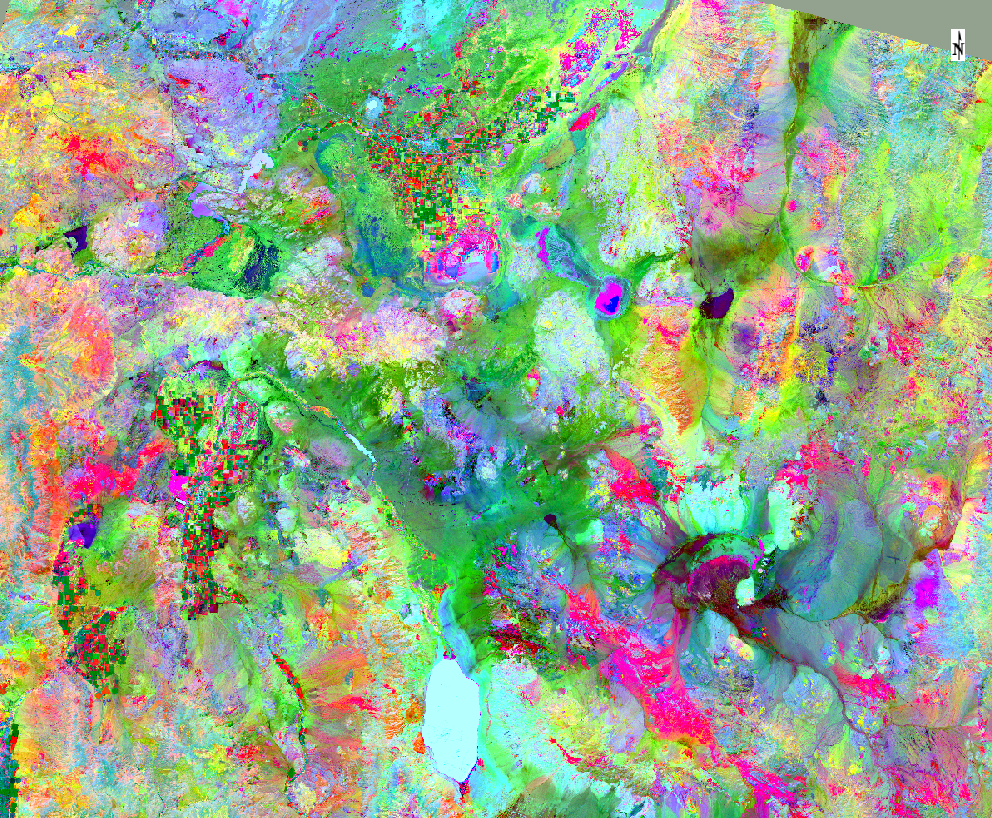
MNF Transformation results, bands 2 through 7

A Texture transformation based on a co-occurrence matrix was then performed. Texture in remote sensing data is the spatial variation of image tone as a function of scale. To be classified as a distinct textural area, the gray levels within these areas must be more homogeneous than areas having a different texture. There are two texture filters that can be applied – co-occurrence and occurrence. The paper applies a co-occurrence matrix, meaning that the filter applied is a function of both the angular relationship and distance between two neighboring pixels. It shows the number of occurrences of the relationship between a pixel and its specified neighbor. In the paper and in this project, Band 5 (NIR) was used and 4 brightness value matrices were derived for each pixel based on neighboring pixel values. The average of the four values was output as the texture value. The paper states that this transformation greatly improved the ability to discriminate wetlands (see the following image).
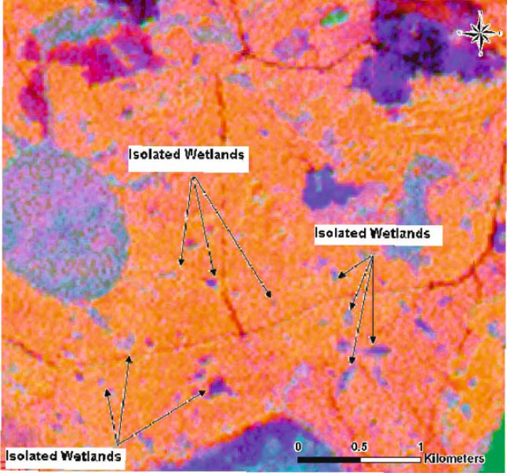
MNF Transformation from Frohn et. al paper

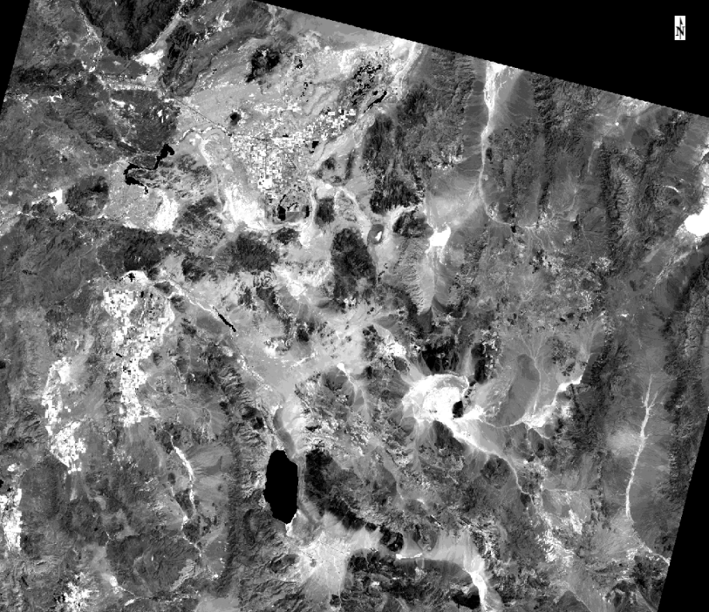

Texture Transformation output, Band 5 only

The third transformation involved merging the 15-meter panchromatic band with the 30-meter spectral bands using a Gram-Schmidt Sharpening algorithm on bands 2 through 7. The end result is a 15 meter spectrally merged dataset.

IMAGE SEGMENTATION AND OBJECT-ORIENTED CLASSIFICATION
The final phase of the image analysis is wetland classification, and the investigators used an object-oriented classification approach. This is because wetland boundaries are highly contrasted to the surrounding uplands. This approach involves two steps. Step 1 is image segmentation, roughly defined as ‘segmenting’ the spectral characteristics of the imagery into discrete objects. Step 2 consists of classification of those objects with the appropriate software.
As explained in the paper, the image segmentation process uses ‘low-level’ information (pixel-based features) to create ‘higher-level’ contiguous regions or image objects. These higher-level objects not only have spectral characteristics that can be used for classification, but also textural , contextual and shape characteristics that are additionally used for classification. Thus the three image transformation processes described previously were applied in order to yield these ‘higher-level’ data analysis layers used in image segmentation.
In the paper, eCognition software was used for the image segmentation and object-oriented classification. I used ENVI to perform the image segmentation. However, the parameters and settings that can be adjusted in eCognition but not in ENVI would have yielded a much better result. The paper also stated that the best results were achieved from spectral pan-merged bands 5, 4 & 3 of Landsat-7 data, so I used bands 6, 5 & 4 of the Landsat-8 data, as these bands had similar spectral frequencies as the Landsat-7 bands. Also used for image segmentation was the first band of the MNF transformation (band 2) and the texture output from band 5. According to the paper, various settings and scales must be experimented with in order to determine what the most suitable parameters are; unfortunately, in ENVI, the image segmentation ability is very crude compared to eCognition, and so many of these parameters could not be adjusted, a failing of the methodology used for this project.
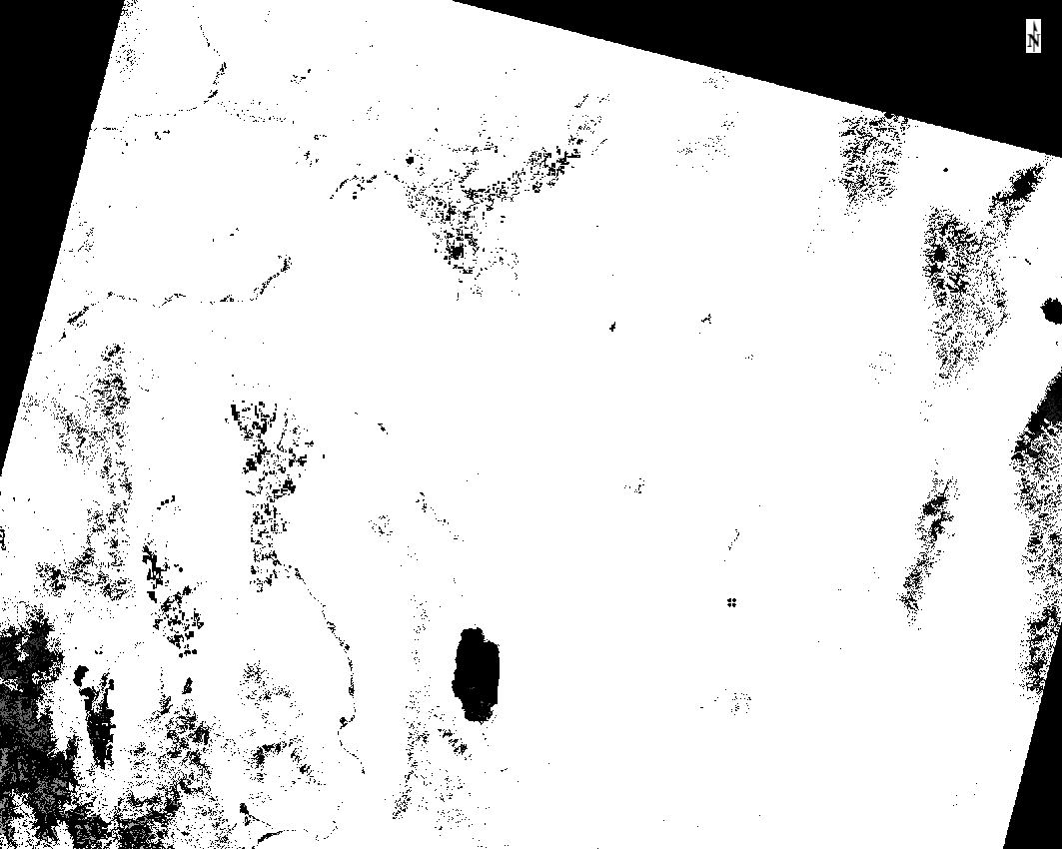
Image Segmentation output Band 3

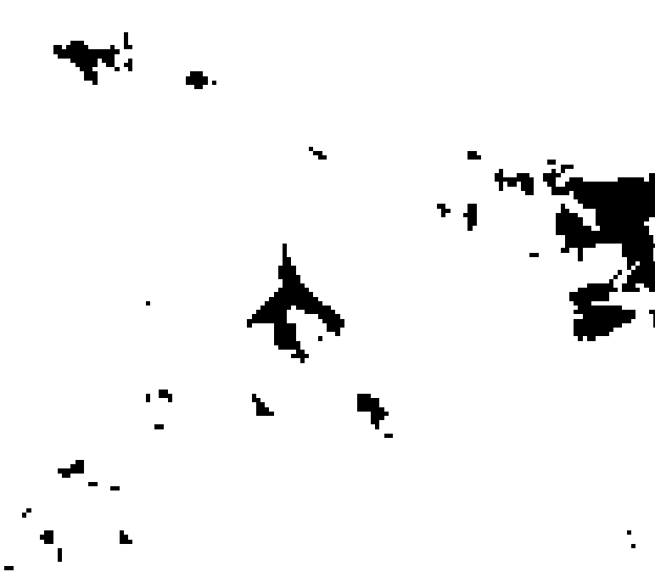
Close up of Image Segmentation output of Oreana Springs, Nevada.

With object-oriented classification, the basic assumption is the image being analyzed consists of homogenous patches or regions that are larger in size than individual pixels. One of the key variables in the image segmentation process is scale, and following the investigators’ methodology, image segmentation was undertaken at various scales to determine the best scale for use in the classification. The optimum scale therefore is dependent upon the particular purpose of the classification, the general scale of the image features being classified, and the resolution of the sensor.
Feature Analyst was used for this classification, inputting the 15-meter pan-merged bands 6, 5 & 4, band 1 of the MNF transformation and the texture transformation from band 5. An NDVI layer was also input. Training was based on one known wetland polygon.
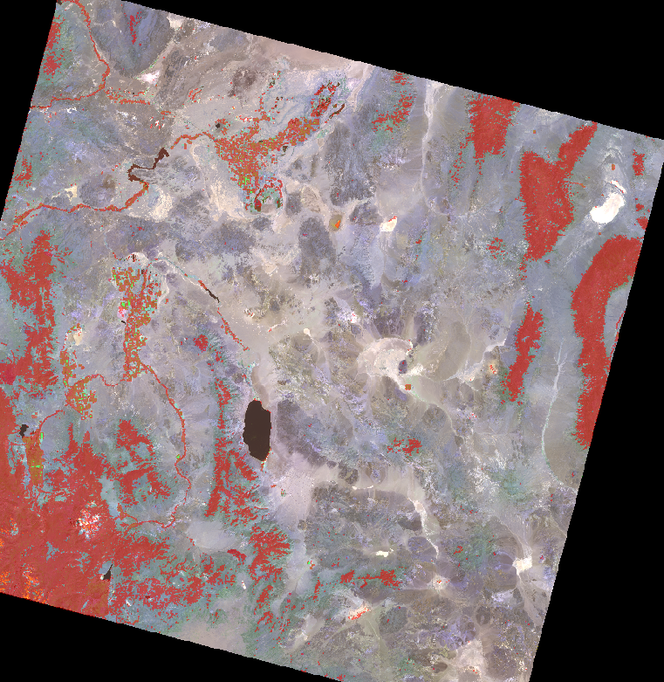
First-run results from classification using Feature Analyst on 15-meter pan merged bands 4, 5 & 6, band 1 of the MNF transformation, & Texture transformation applied to band 5.

RESULTS
Although the results are not completely successful, I believe Feature Analyst could be used for classification, if better image segmentation results were achieved and more known wetlands were used for training. I am at least encouraged to pursue this project further.
Future additional work will include identifying known springs within the area, digitizing them and using the polygons as training polygons within the classification software. ECognition will also be used for the image segmentation and classification methods as is done in the paper emulated. Acquiring a detailed landcover spatial data layer for the area will also be utilized to verify accuracy.

References:
Frohn Robert, Reif Molly, Lane Charles, Autrey Brad. Satellite Remote Sensing of Isolated Wetlands Using Object-Oriented Classification of Landsat-7 Data. In Wetlands, Vol. 29 No. 3, September 2009, pp. 931-941. Society of Wetland Scientists.

