Summary
Remotely sensed images contain a wealth of information with many possible applications. Feature Analyst is a plugin program that provides the user with the ability to perform automated feature extraction from remotely sensed imagery on user identified objects.
Feature Analyst is regarded as a leading remote sensing software plugin product. It is therefore desirable to learn about this tool. The installable trial version available for download for ArcGIS 10.0 only permits the use of the software with the provided imagery. The included imagery is accompanied by tutorials simulating typical workflows. The tutorials serve as guidelines for further experimentation. This report is the result of such an experiment in the use of Feature Analyst to perform feature extraction on remotely sensed imagery of my choosing.
The goal when using Feature Analyst is to identify and extract features. Feature extraction is transforming user identified objects into sets of features, useful in further analysis. This is accomplished through tediously training the software to recognize spatial and spectral classes of features. Feature Analyst requires the user to carefully create a representative training set. Success with Feature Analyst requires the user to understand how to select proper learning parameters and create good training sets. The user must learn to recognize what is and isn’t important to select in an image to train on.
Hierarchical learning is the means by which Feature Analyst works, improving classification results by removing clutter (false positives) and adding missing features. An iterative approach makes this a series of simpler subtasks.
Spatial classes are those pixels that are of interest to the user. Spectral classes are those pixels that contain the uniquely identifying characteristic data (color, reflectance, texture, etc.) corresponding to features. The idea is to sync these two types of classes, through hierarchical learning procedures, and through processing steps, eliminating unnecessary data and retaining desired data. These steps, repeated often, represent a workflow that the user goes through to achieve the final result.
A workflow to use the software is described in detail in the product tutorials and can be generalized as follows:
Image processing
Decide whether single or multi-class approach will be used
Create feature class(es)
Configure learning
Run extraction
Clean up false positives, confirm positives
Post processing

Repeating some of these steps, iterations, allows the user to finally derive the desired features.

Purpose
The purpose of this report is to detail my experimentation using Feature Analyst to extract features from familiar, local imagery. I exclusively selected to use supervised learning methods throughout.

Project Setup
ArcGIS 10.0
Airborne imagery of Sacramento: 8 bit, 3 band, spatially referenced. Delivered as a set of mosaic .sid formatted files with an index grid to simplify their use. Metadata is not detailed. The following image shows the index grid and shows how the user can get oriented to the mosaic set. The dark blue line is the city of Sacramento boundary.
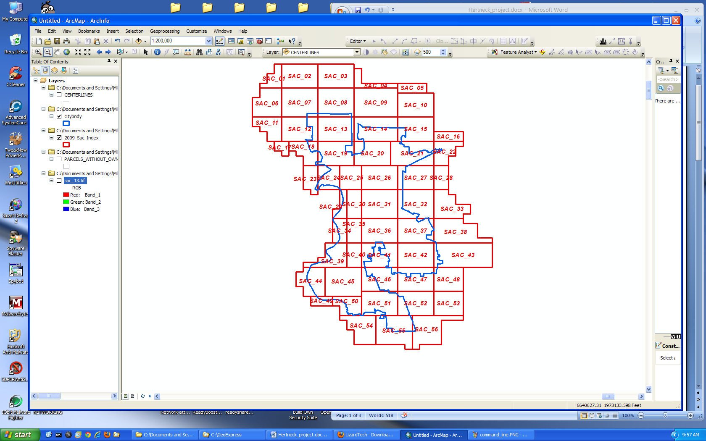

Overlaying a selected shapefile can help further resolve the image selection by allowing the user to recognize details. Here are the parcels in the Natomas area of north Sacramento. I can locate the parks that are interesting to me, ponds etc.
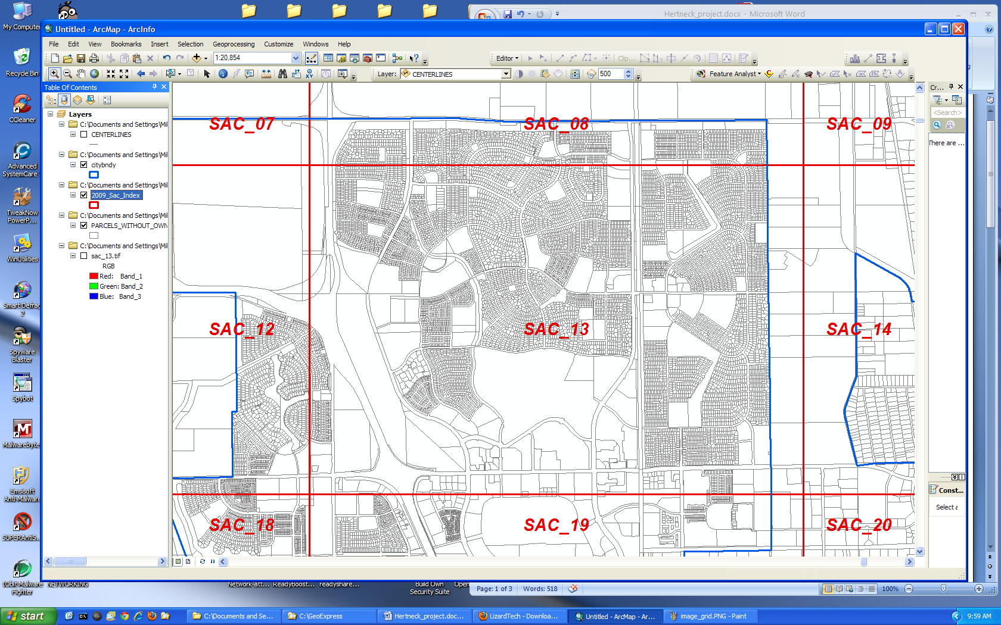

Description of tasks, methods, analysis and image processing
Feature Analyst documentation emphasizes that image simplification and project setup is important in the use of Feature Analyst. The tutorials instruct the user to develop file-naming conventions, folder structure to store the output files, etc. It is necessary to follow this advice because the user can become rapidly overwhelmed with the number of cryptically named files and their disorganization if dumped into a single folder.
Image files can be so large at times that it is necessary to reduce the images by cropping to manageable sized units for processing. If the goal is to use the program for developing .AFE signatures, sampling images is what the user is doing under supervised learning. If the goal is to extract feature to export as a feature class, cropping the image to the area of interest may be the fastest way to accomplish the task.
Image data was obtained in MrSid format. These files are compressed. To execute geoprocessing functions, the files will need to be decompressed before attempting to run geoprocessing commands to improve performance. I attempted to use GeoExpress trial , from LizardTech: used both GUI and command-line utility to convert MrSid formatted files into .TIF format to avoid uncompressing data files while executing geoprocessing functions in ArcMap.
Site: http://www.lizardtech.com/products/geo/
Results: GUI interface didn’t run – error message” file size too large.”
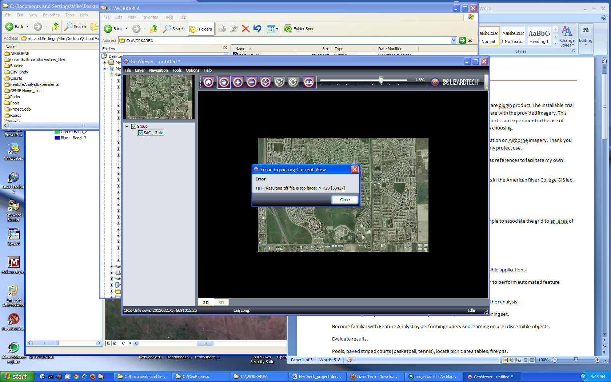
The Command-line utility was a bit more successful.
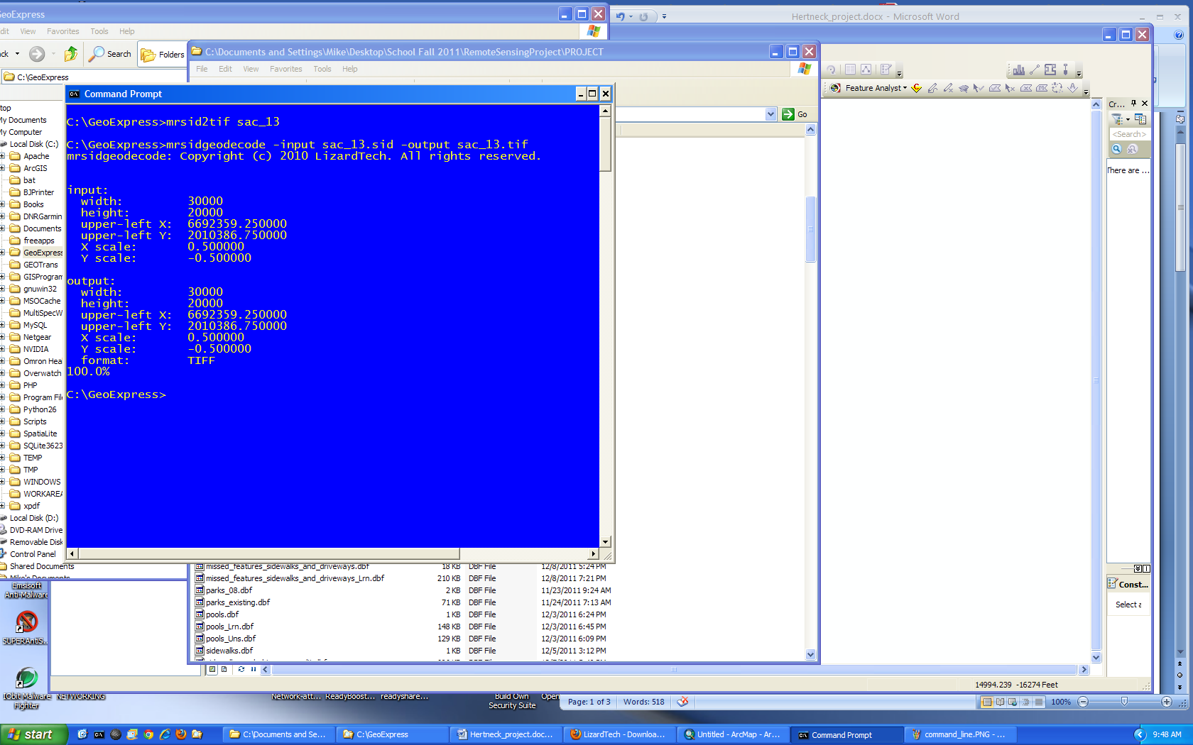
After decompressing, the data file size typically between 1 and 2 Gb, depending on which MrSid file was selected from the index grid.
Projection information wasn’t included in the .tif after conversion (the file wasn’t useful to me). After lengthy trial and error, I resorted to using the MrSid format data set and exported from ArcGIS using Data Export to assign projection information and create an uncompressed .TIF to work with.
The sac_13.sid image cropped using Overwatch’s cropping tool. The cropping tool was added to the toolbar. It is not included by default. Simple to work with. This tool allowed for subsetting data. The image sac_13.sid was cropped to 15398 x 8831 pixels from 30000 x 20000 pixels.
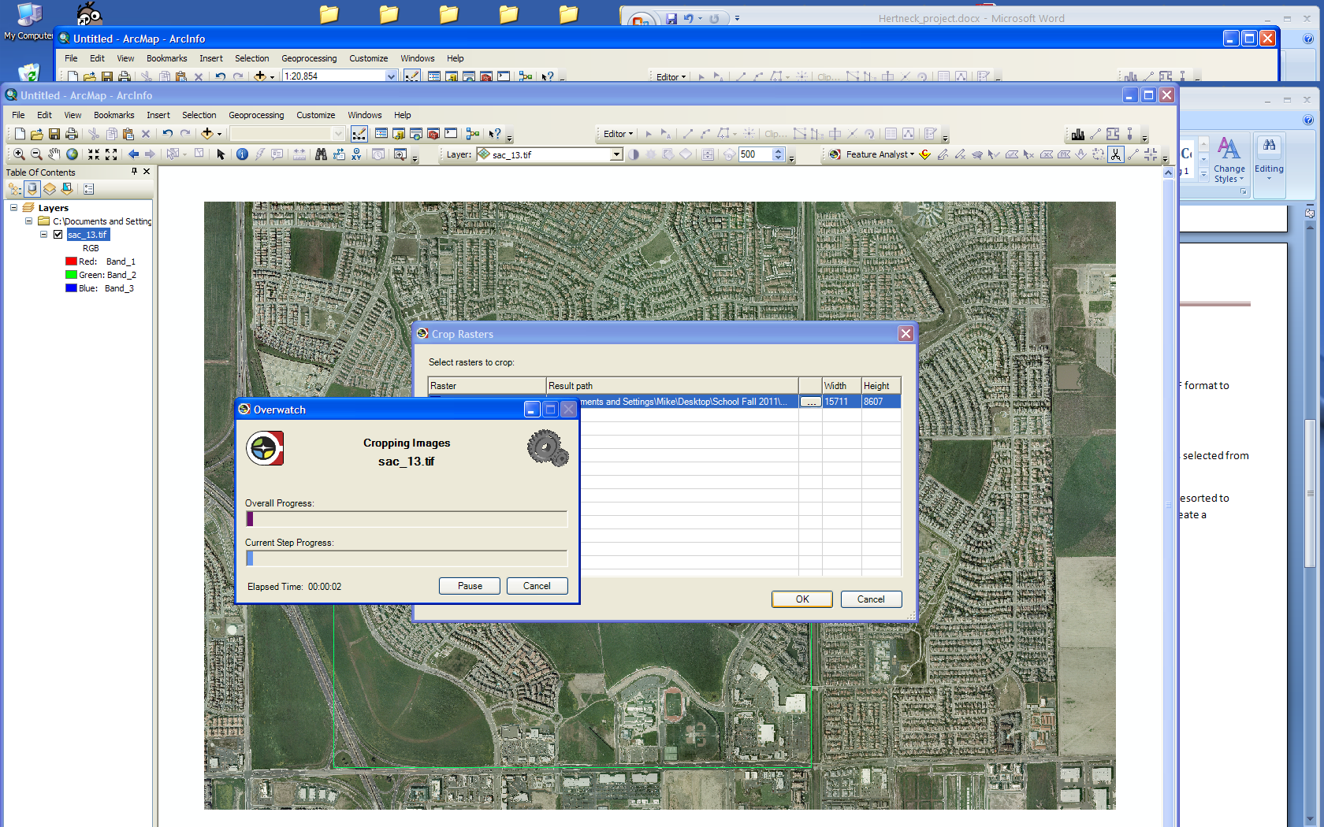

The sac_13.img is now ready to work with.

Following are a few details on experiments to extract features.
Water feature extraction
Lake in Natomas Regional park was selected. It is a large feature, singular, easy to digitize. I created training polygons as in the image that follows. I carefully included the edge of the shoreline, rocky and broken, and an area that included a shadow of a tree (there are several trees that shade the lake surface). I ran the supervised learning tool using default setting after selecting “water feature”.
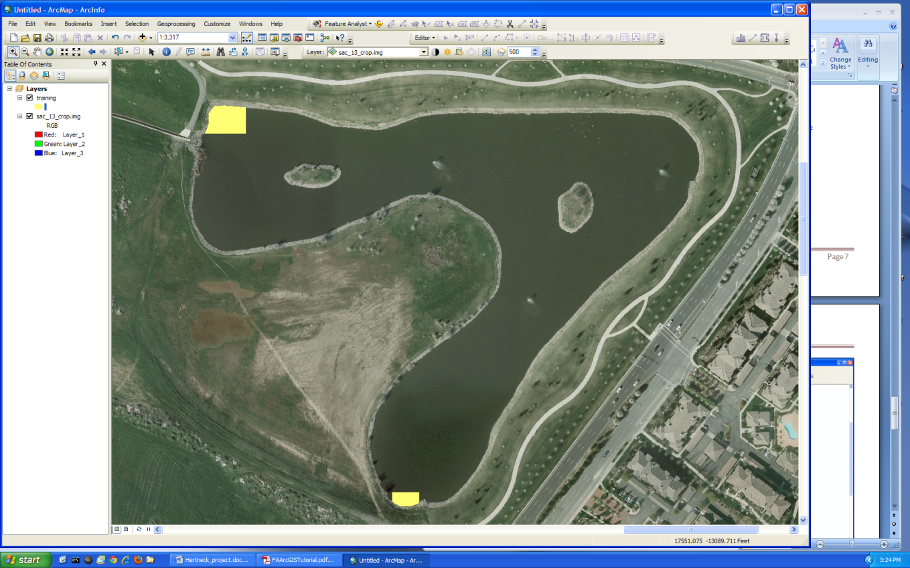
The training polygons are shown in the above image. The result of running the supervised learning on the image is shown in the next image. Many false positive are shown. The image when completely viewed has a great number of these false positives across the entire image. There is also a “hole” in the lake – a missed area that should have been classified with a training polygon. The next step is to reduce the clutter, and reinforce the hierarchical learning mechanism by digitizing correct features.
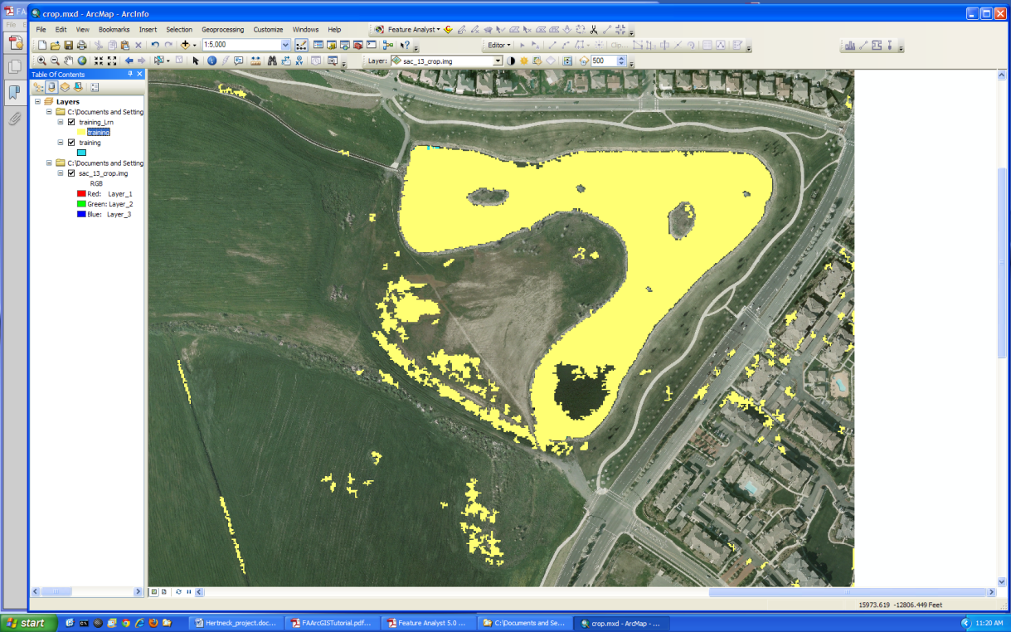

At this point I stopped to review my technique before spending further time. I noted the hole in the lake and decided that I would be better off creating a new training set and begin again. This time I included a training polygon in the area called the hole.
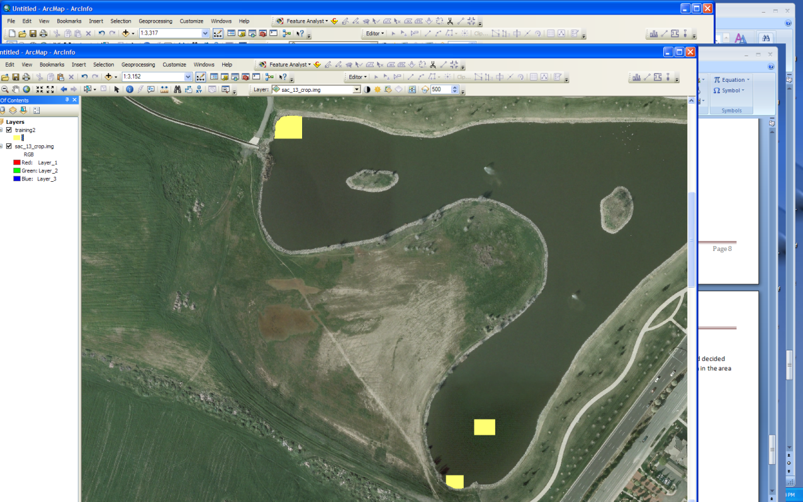
The result was an improvement of sorts. The entire lake surface is included in the resultant set:
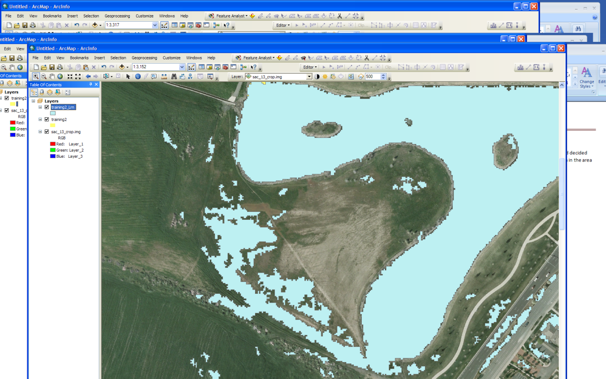
Next I considered if it was worthwhile to continue or try something a bit simpler. There are too many false positive polygons to cleanly remove them all. Fiddling around with the software has taught me this. Why not perform a definition query on the lake, isolate it, export and edit to remove the hole?
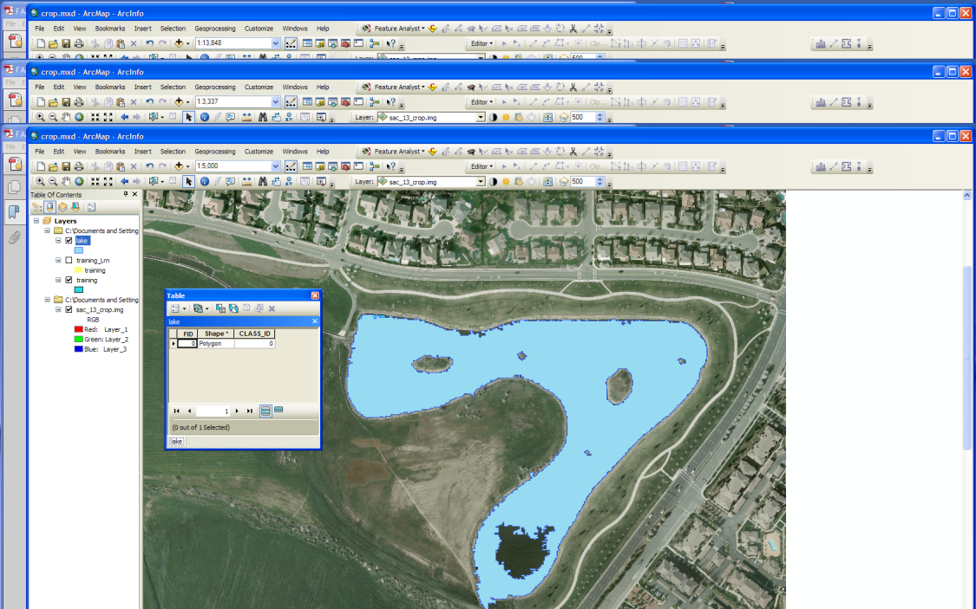

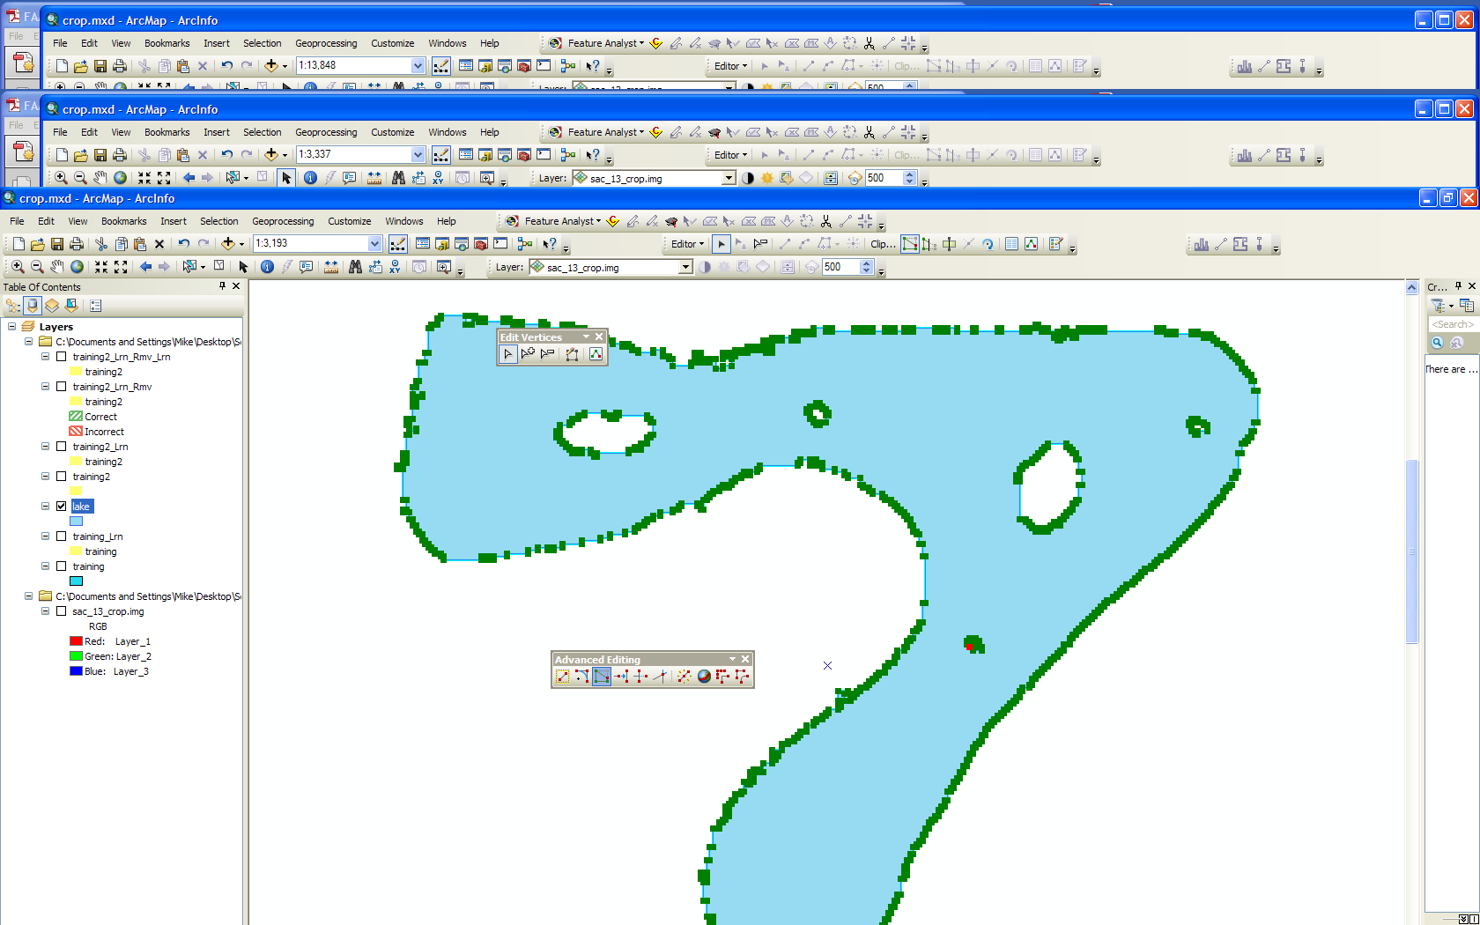

That is the modified workflow with the following result. I have a feature, in a shapefile format. The downside is that there is no .AFE file to use in a future extraction process.

Swimming pool feature extraction
Pools turn out to be tricky. They come in all shapes and size, colors, in and out of the sun and shade, with and without concrete decking, etc. A great degree of variability exists with this feature.
To begin with, I used the entire 30000 x 20000 pixel image to work on this feature extraction. It turns out to be a push. The variability factor of the pool feature would not have allowed the successful extraction of images if I had created an .AFE file on a subset image and run the script against another image. This will be demonstrated. Training sites(18 in number) were selected north of the Natomas Regional park. The training sites are the yellow pixels.
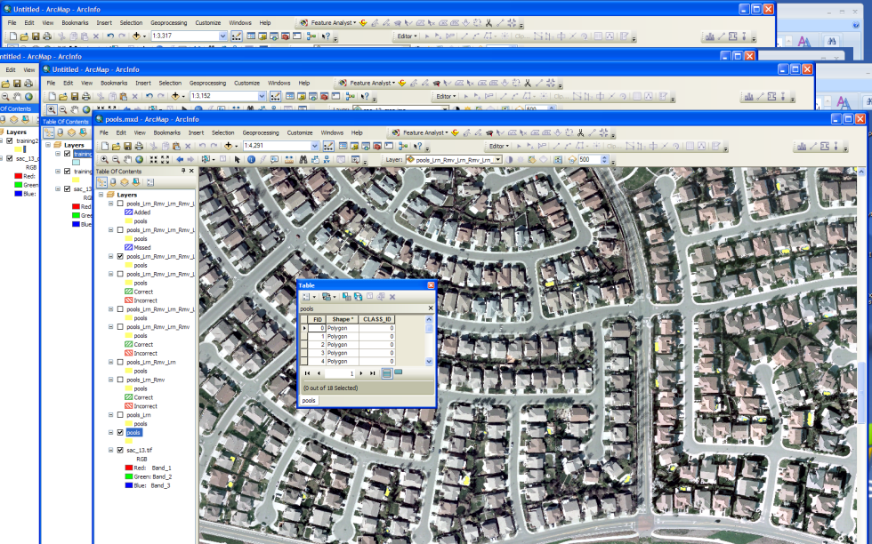
The result – everyone has a pool.
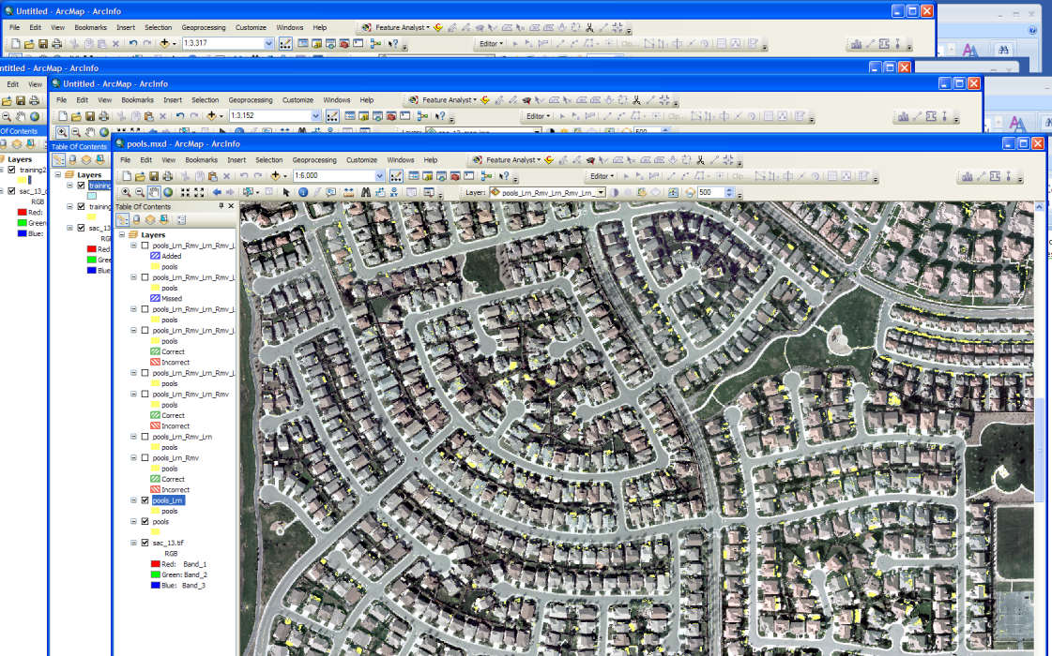
From here the process becomes laborious, taking days to complete by trial and error. The clutter polygons are indicated in the red areas. I covered the area pretty extensively marking a great number of false positives. No correct polygons were chosen.
Clutter removal first pass:
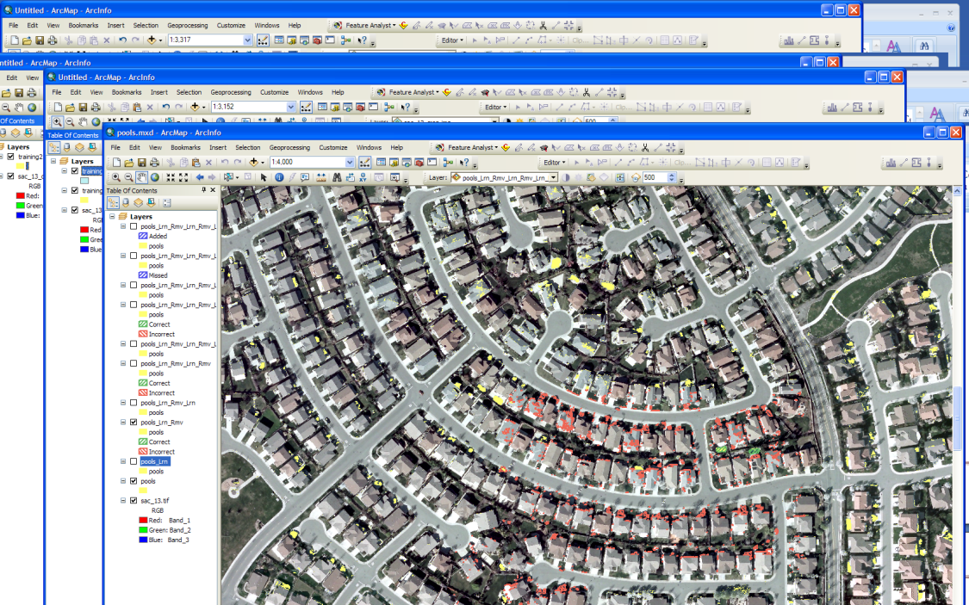
The result – a greatly uncluttered image. Pretty amazing (man-made feature > 5m and default values for the supervised learning tool) :
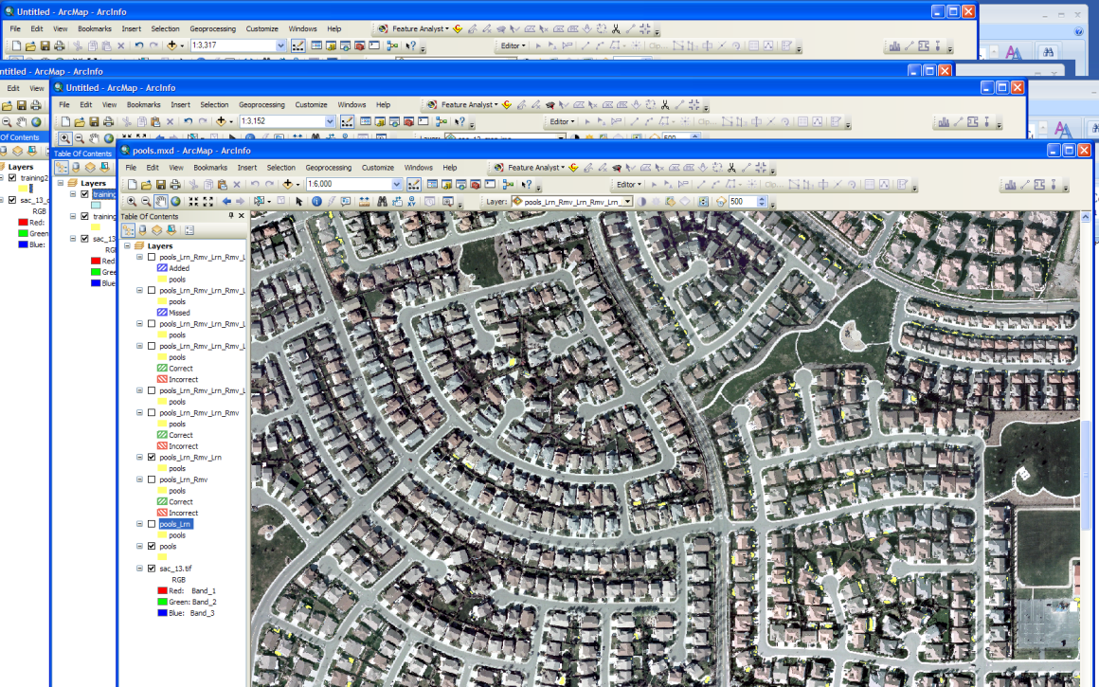

The next step emphasized positive reinforcement. I selected correct polygons, shown in green as well.
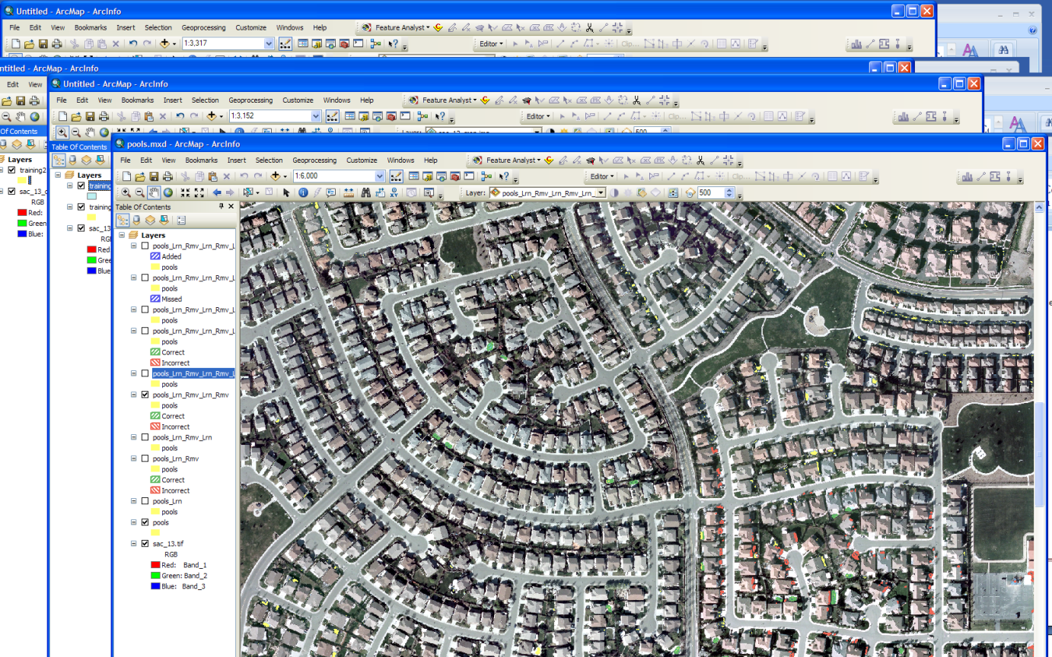
The result is as follows:
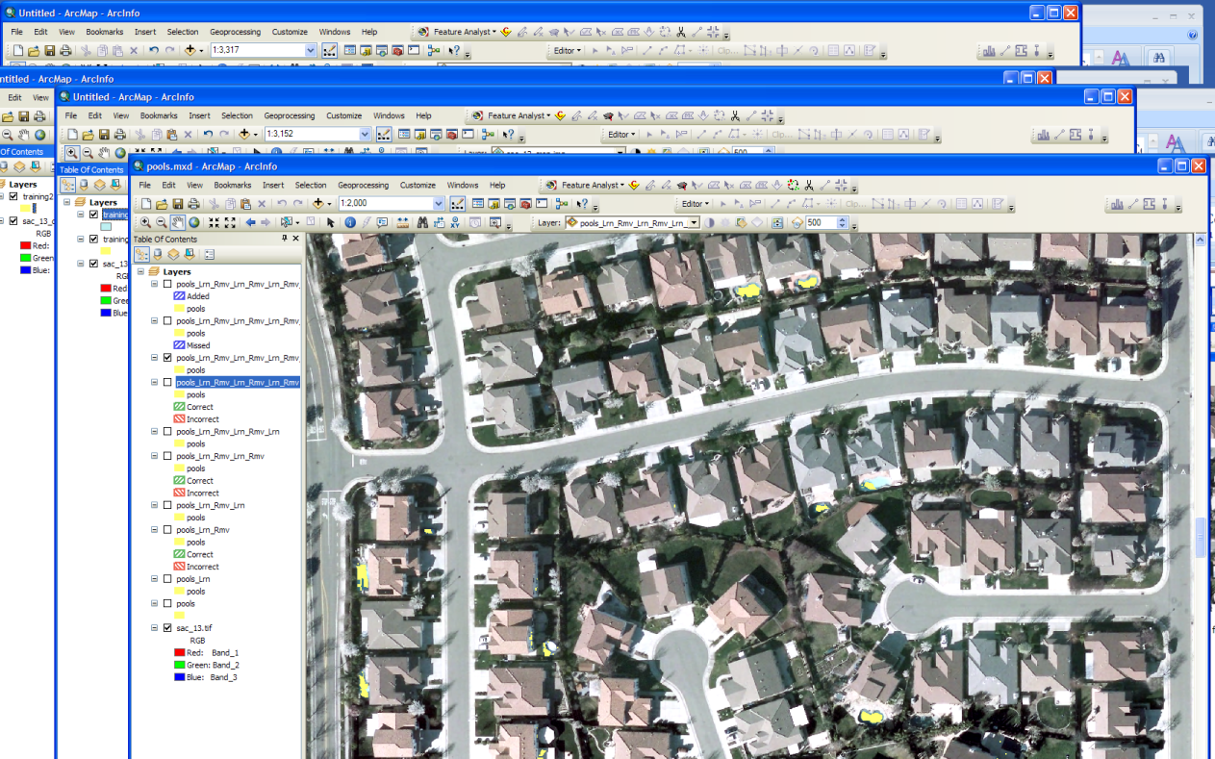
Several pools in this representative area are shown nearly in full, several others are partially pixilated, and a few false polygons remain. I believe that the majority of the false positive were automobiles, either white (or very light) or blue in color. You may note that there are two more layers in the Data frame. I attempted to include the round, plastic inflatable type pools in the signature. They were consistently overlooked, Note that these pools are very blue in color, probably because they are made of blue plastic materials. The results created more unwanted false positives. I abandoned further effort until I have more general knowledge of how to handle this. I thought that another class may be necessary to capture these features.
At this point I decided to create an .AFE file and try the script on another image entirely. I viewed the model and exported out the .AFE file.
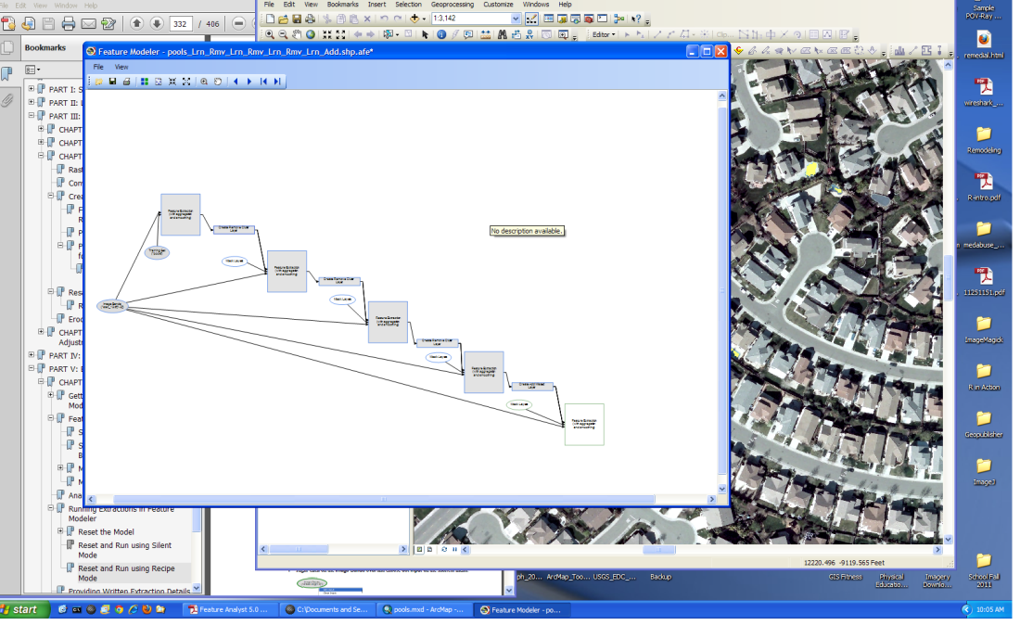
Testing the model before attempting another image:
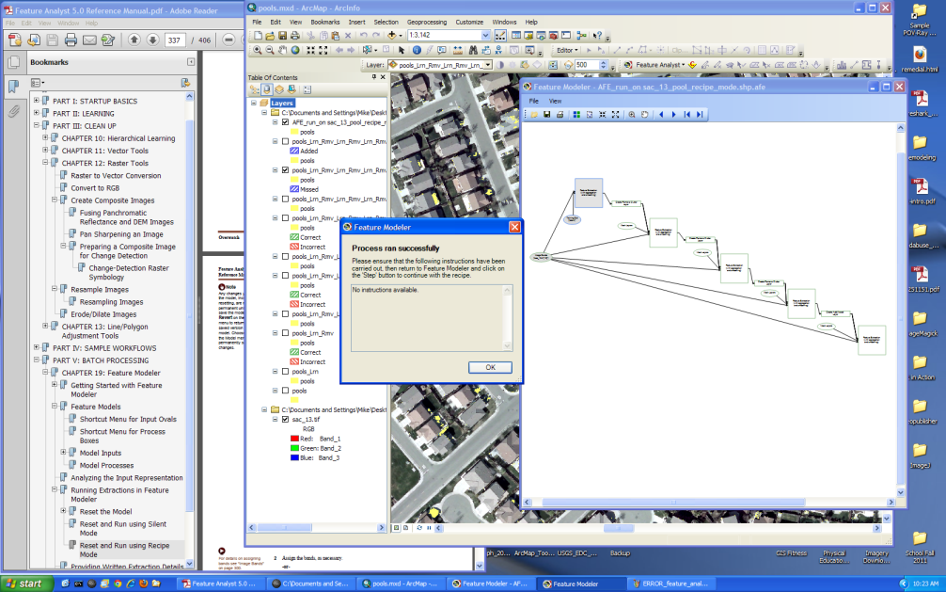
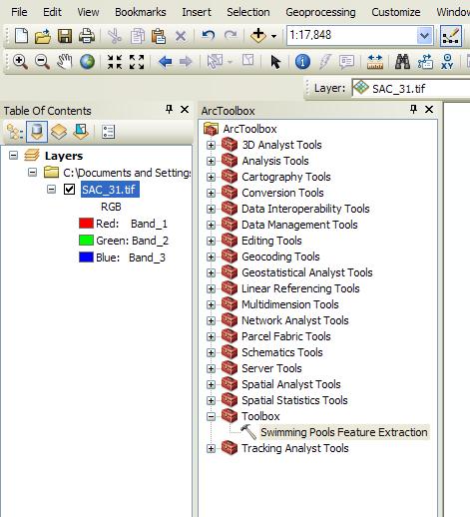
I think the important thing at this point is that the model ran error free. Now to interpret the tutorial and try the model (.AFE) on another image. After tweaking around the script a bit, and dropping the model into the ArcGis Model Builder tool – I was ready to run the model on another image. I selected sac_31,tif, the north of downtown Sacramento, near McKinley Park. There are many pools around the area.
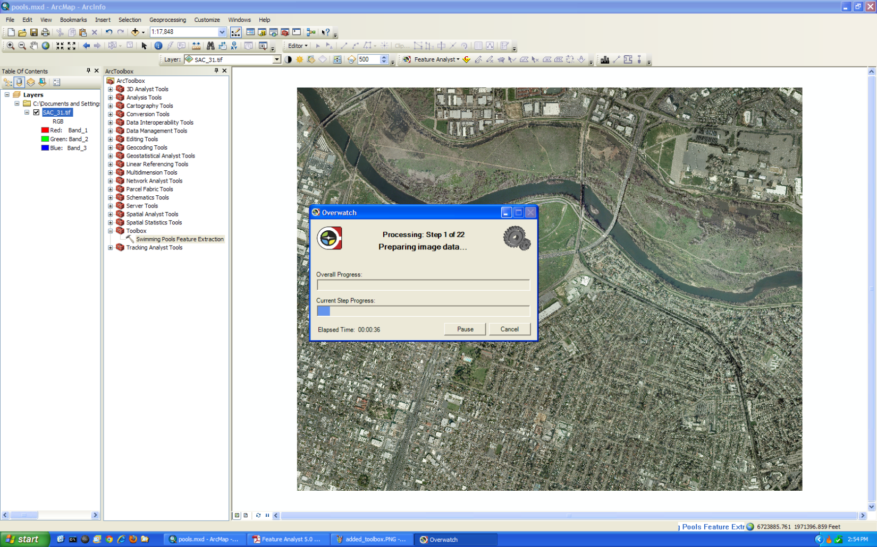
The model ran, error free, but generated many false positives – not the few like the model when ran against the Natomas, sac_13.tif. I was disappointed with the results. This will require a bit more work.

Sidewalks feature extraction
This feature extraction uses line types as the feature data type. Here are the training sites (bold red sidewalks) in the north west corner of the sac_13.tif:
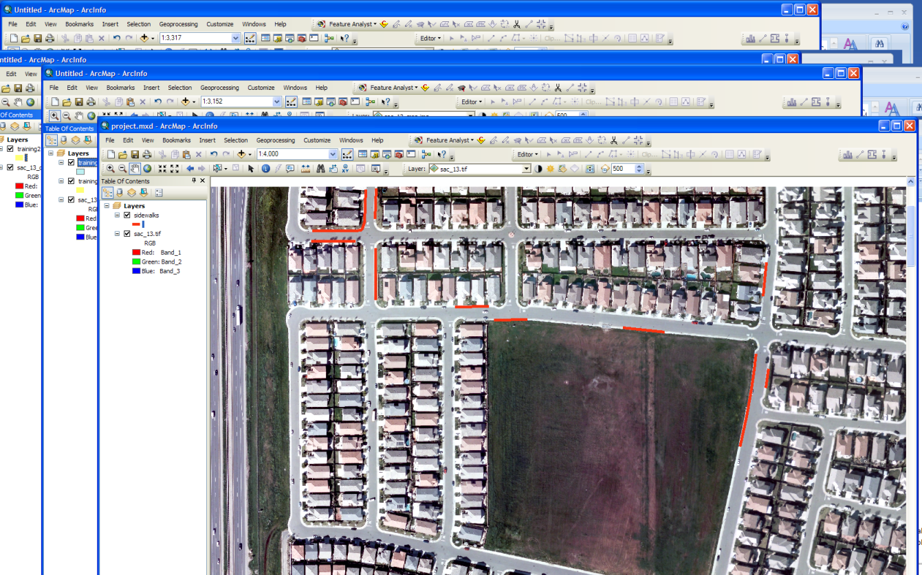
First supervised learning run:
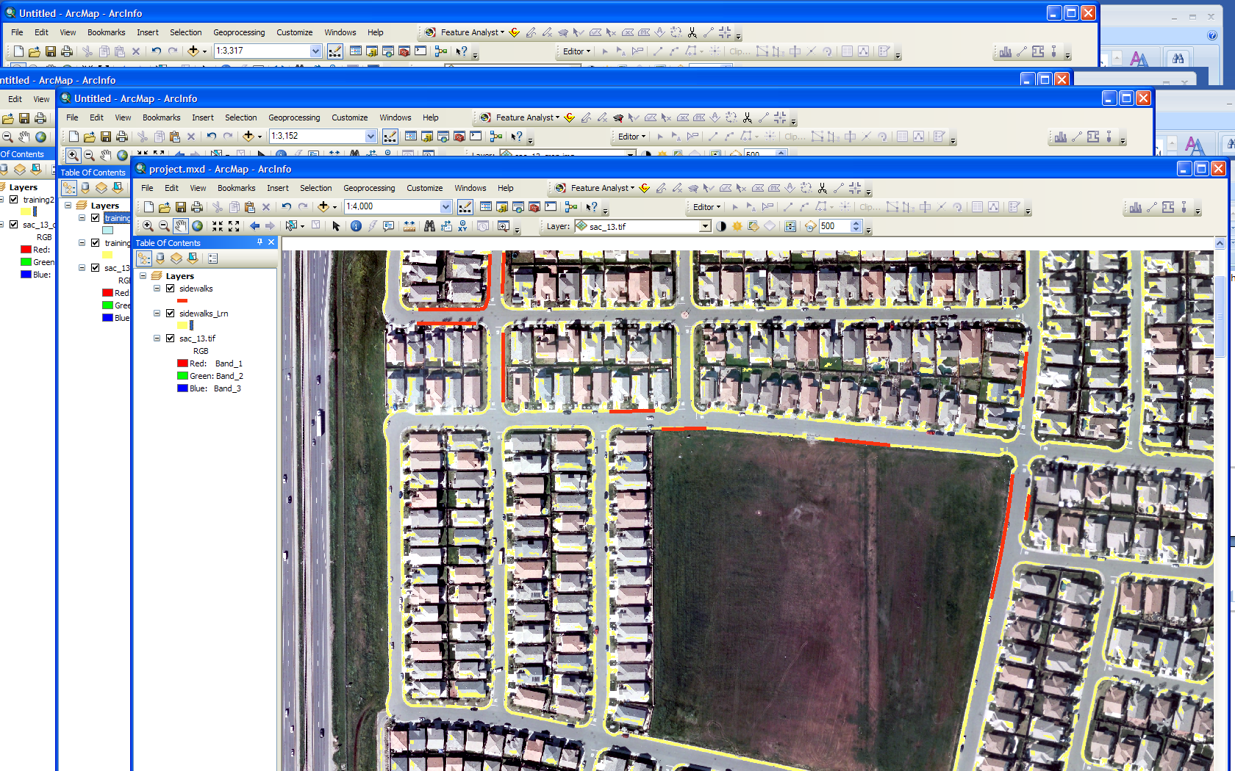

Conclusions

References:
Feature Analyst Tutorials for versions 4.2 and 5.0
http://proceedings.esri.com/library/userconf/proc02/pap0924/p0924.htm
http://www.featureanalyst.com/feature_analyst/publications/success/AFE-Ecog-FA.pdf
http://www.vls-inc.com/feature_analyst/publications/reviews/obrien_asprs.pdf
http://www.jenningsplanet.com/fileadmin/uploads/nj/StudentProjects/Geog342_Spring2010/JSmith_presentation.pdf
http://www.jenningsplanet.com/fileadmin/uploads/nj/StudentProjects/Geog342_Spring2010/JSmith_paper.pdf

