Executive Summary

Idea Submission

The City of West Sacramento has access to a large volume of untapped information in its LiDAR point data and raster imagery. The most recent LiDAR data was delivered with a contour data set which contains erroneous values for bodies of water and only represents the city’s bare earth surface. The scope of this project is to more accurately represent the city’s physical attributes with the data we already have.
I will use the City of West Sacramento’s LiDAR point data to create a bare earth digital elevation model, body of water elevation, and a feature dataset that includes structures and vegetation. If available, LiDAR intensity values of each point will be used to properly categorize each data point. This will generate a shaded relief elevation model which will have color-coded elevations.

Necessary Feature Classes:
- Point features of elevation (LiDAR)
- Imagery
- City Limits
- Bodies of Water (existing dataset)
- Buildings (existing dataset)

There were many iterations of trial and error to achieve the desired outcomes but the following general process helped me to attain most of the desired features.

General Work Flow
1 – LiDAR Terrain Creation
2 – DEM and Hillshade Creation
3 – Tweek imagery and overlay necessary layers for final map.

But the devil is in the details. The following are the images and descriptions of an exploration of West Sacramento through the highly processed eyes of LiDAR data.

1 - LiDAR Terrain Creation
- Attain LiDAR data and relevant feature layers.

Feature layers
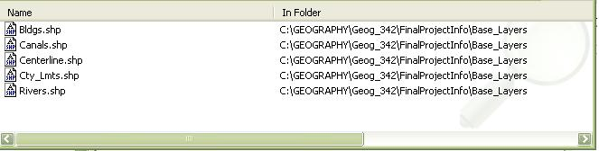

LiDAR data
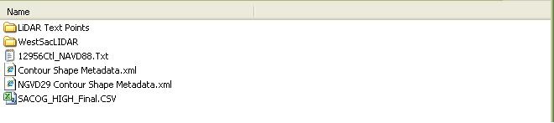

- Import LiDAR point clouds for bare earth (Class code: 5) and vegetation (Class code: 8) into geodatabase.
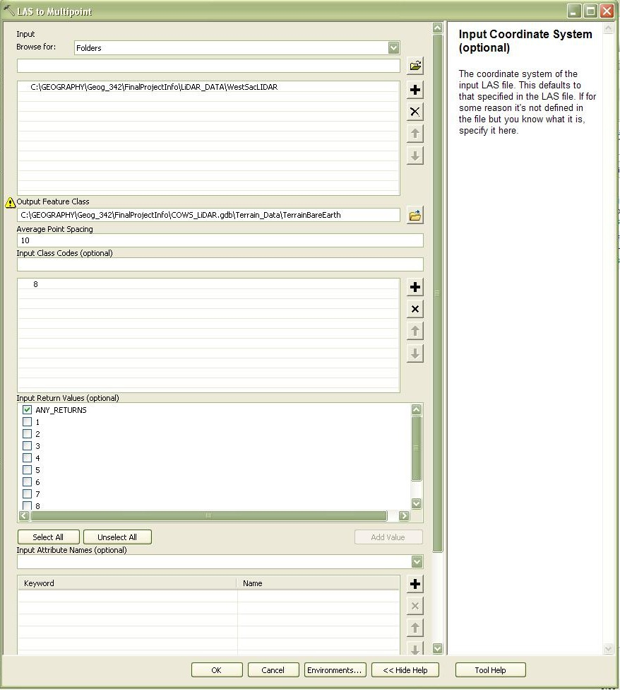

- Generate Terrain Model for bare earth and vegetation LiDAR.
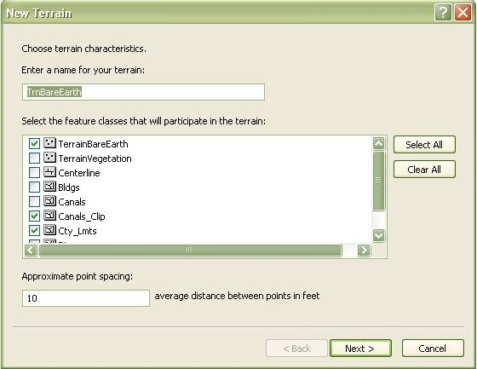

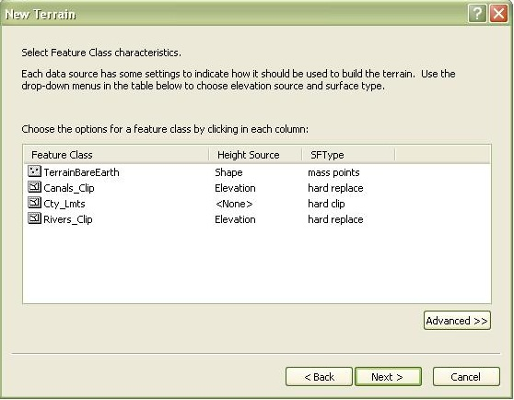

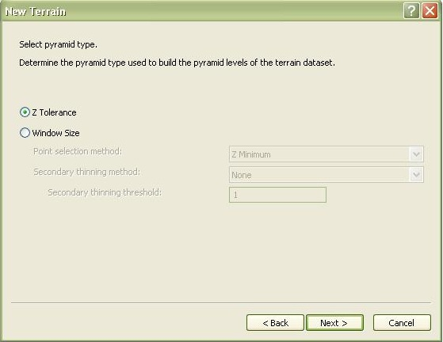

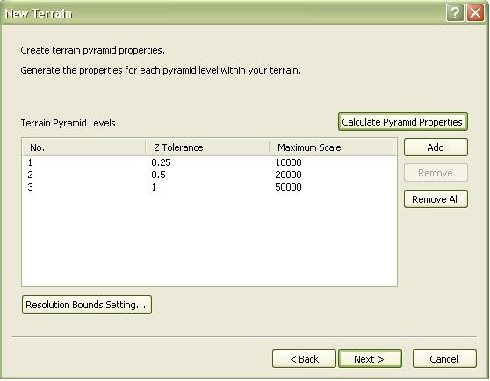

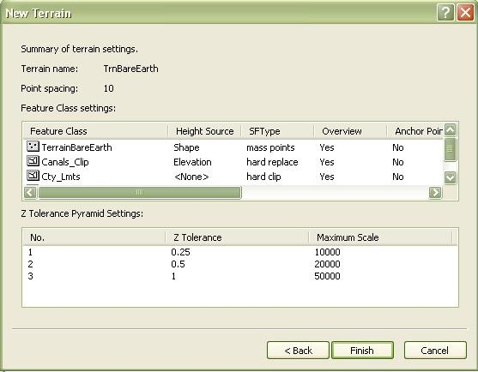

- Overlay polygon features on the bare earth LiDAR
Terrain and use the analysis tools to populate elevation
field of polygon features.
.
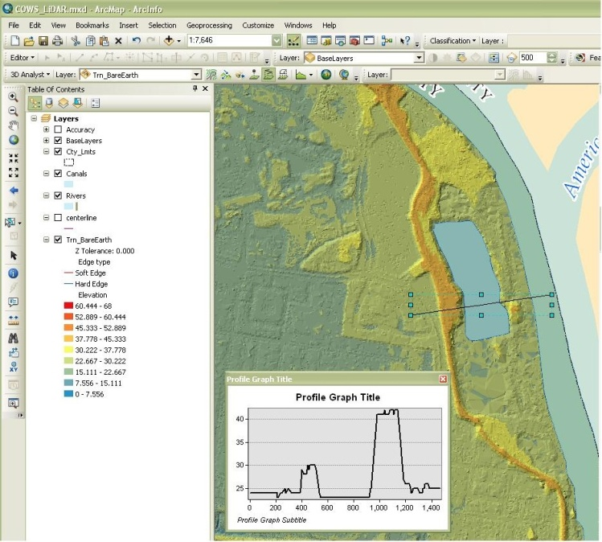

- Update bare earth terrain model with polygon features.

2 - DEM and Hillshade Creation

- Use the bare earth terrain model to generate a raster.
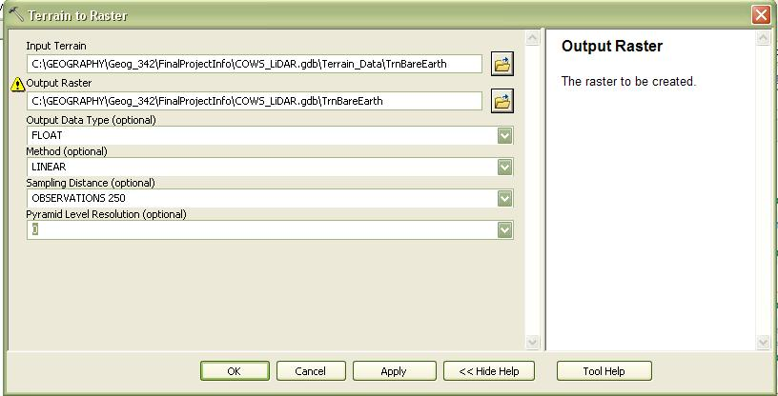

- Now the raster is used to create a hillshade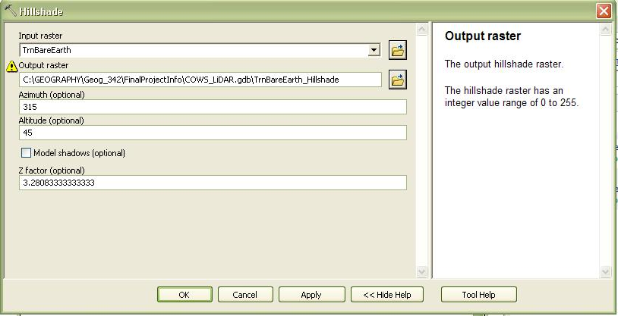

3 – Tweek imagery and overlay necessary layers for final map.

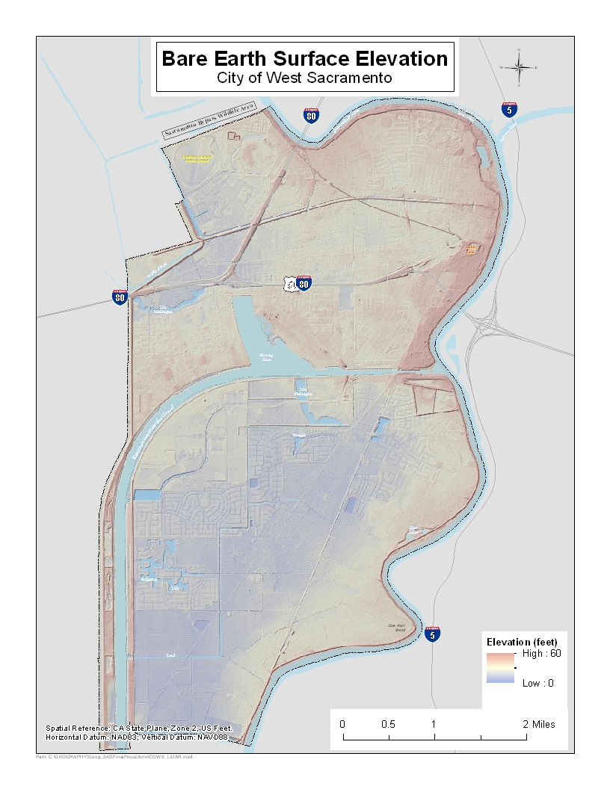

Issues Along the Way

I was unable to properly Add a Feature class to the terrain model. The issues were resolved once I created an elevation field, populated that field, and clipped the geometry with the same feature as the terrain.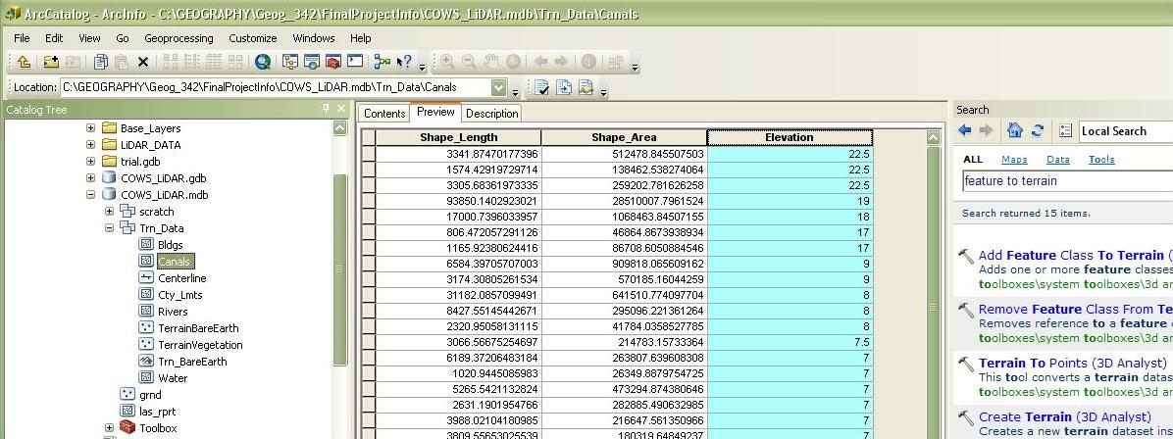

The Model Builder routine below and the execution of the Create Terrain tool in ArcCatalog would routinely crash. The only method that worked was by using the New Terrain tool in ArcCatalog by right clicking on a feature dataset > New > Terrain. This took hours to figure out since I continuesly tried to correct this model and use the Create Terrain tool. 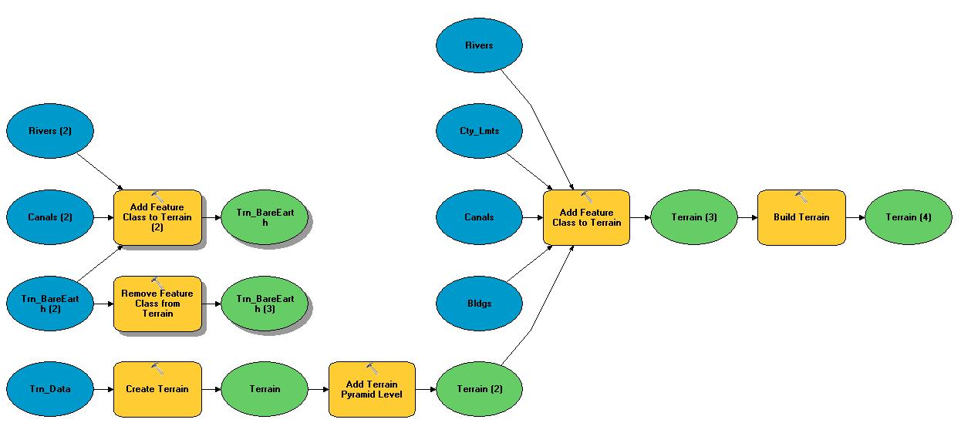

Navigating the importation of the LAS LiDAR data was particularly difficult. The files are proprietary and only being able to achieve a desired outcome by the output itself is problematic. I was finally able to ascertain the available class codes by using the Point File Information tool which reads LAS files and creates a Feature Class of the basic statistics.

Point File Information table.
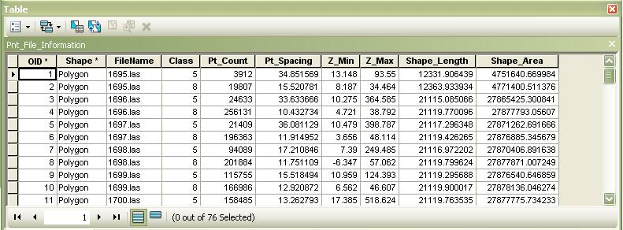

The Results and Expectations

The resulting Terrain and Raster data from this project were highly detailed and will provide the city with a source for further analysis. I was hoping to be able to leverage the points classified as vegetation or first returns from the LiDAR data in more detail. I believe Feature Analyst would have been able to help tremendously with the creation of a Vegetation and Building Footprint Feature classes but Feature Analyst wouldn’t allow me access. I was also impressed with how easily, once conflicts were resolved, that the 3D Analyst tools were able to implement Feature Layers into the Terrain model. I was able to flatten all of the erroneous points over major bodies of water very quickly and could now regenerate a contour data set that reflects those changes. All in all a worth while project.

